Invitation closes at 2:00 pm, Monday 1 June 2020

|  |
| --- |
| Future Management and/or Use of the former Kyneton Primary School  Invitation for Expressions of Interest |
|  |
| 28 February 2020 – Updated 31 March 2020 |

Cover image credit

© 2012 LJ Gervasoni All Rights Reserved

|  |
| --- |
| Acknowledgment  We acknowledge and respect Victorian Traditional Owners as the original custodians of Victoria's land and waters, their unique ability to care for Country and deep spiritual connection to it. We honour Elders past and present whose knowledge and wisdom has ensured the continuation of culture and traditional practices.  We are committed to genuinely partner, and meaningfully engage, with Victoria's Traditional Owners and Aboriginal communities to support the protection of Country, the maintenance of spiritual and cultural practices and their broader aspirations in the 21st century and beyond. |
| © The State of Victoria Department of Environment, Land, Water and Planning 2020  LogoThis work is licensed under a Creative Commons Attribution 4.0 International licence. You are free to re-use the work under that licence, on the condition that you credit the State of Victoria as author. The licence does not apply to any images, photographs or branding, including the Victorian Coat of Arms, the Victorian Government logo and the Department of Environment, Land, Water and Planning (DELWP) logo. To view a copy of this licence, visit <http://creativecommons.org/licenses/by/4.0/>  Disclaimer  This publication may be of assistance to you but the State of Victoria and its employees do not guarantee that the publication is without flaw of any kind or is wholly appropriate for your particular purposes and therefore disclaims all liability for any error, loss or other consequence which may arise from you relying on any information in this publication.  Accessibility  If you would like to receive this publication in an alternative format, please telephone the DELWP Customer Service Centre on 136186, email [customer.service@delwp.vic.gov.au](mailto:customer.service@delwp.vic.gov.au), or via the National Relay Service on 133 677 [www.relayservice.com.au](http://www.relayservice.com.au). This document is also available on the internet at [www.delwp.vic.gov.au](http://www.delwp.vic.gov.au). |

|  |
| --- |
| Future Management and/or Use of the former Kyneton Primary School  Invitation for Expressions of Interest |

|  |
| --- |
| – Updated 31 March 2020 |

|  |
| --- |
| Department of Environment, Land, Water and Planning  Loddon Mallee Region  PO Box 3100 Epsom,  Bendigo VIC 3554  Phone: (03) 5430 4444  Website: www.delwp.vic.gov.au |

Contents

Definitions 1

1. Introduction 2

1.1 Purpose of the Expression of Interest 2

1.2 Structure of this Invitation 2

1.3 Objective of the Expression of Interest 2

1.4 Major stakeholders 2

1.5 Overview and background 3

1.6 Infrastructure and assets 3

1.7 Land ownership, future tenure arrangements and planning 3

2. Background for Registrants 4

2.1 Principles 4

2.2 Condition assessment 5

3. Registrant’s Response 6

3.1 Acceptance 6

3.2 Executive Summary 6

3.3 Site Use and Community Benefits 6

3.4 Capacity 7

4. Conditions of Expression of Interest 12

4.1 Reference Schedule 12

4.2 Invitation 13

4.3 Communication 13

4.4 Submission of a Registrants’ response 14

4.5 Expression of Interest documents 15

4.6 Capacity to comply with the overview of requirements 16

4.7 Evaluation 16

4.8 Next stage of the Expression of Interest process 16

4.9 Registrant warranties 17

4.10 Agency rights 17

4.11 Governing law 17

Appendix A Evaluation Method and Criteria 18

Evaluation of Expressions of Interest 18

Appendix B Maps and Images 20

Definitions

**Agency**: means the Victorian Department of Environment, Land, Water and Planning.

**Closing Time**: means the time specified as such in item 2 of the Reference Schedule.

**Confidentiality Agreement**: means a legal agreement that binds one or more parties to non-disclosure of confidential or proprietary information which is not to be made available to the general public or to competitors.

**Evaluation Criteria**: means the evaluation criteria forming Appendix A to this Expression of Interest document.

**Expression of Interest**: means the response to this invitation expressing an interest in the future management of the former Kyneton Primary School and addressing the Evaluation Criteria.

**Intellectual Property Rights**: includes copyright and neighbouring rights, and all proprietary rights in relation to inventions (including patents) registered and unregistered trademarks (including service marks), registered designs, confidential information (including trade secrets and know how) and circuit layouts, and all other proprietary rights resulting from intellectual activity in the industrial, scientific, literary or artistic fields.

**Invitation for Expressions of Interest or Invitation**: means this document (comprising each of the parts identified in Section 1.2 of this document).

**Preferred Respondent(s)**: means the organisation or organisations that may be invited to respond to future requests for proposals to advance the Project.

**Premises**: means the former Kyneton Primary School (the Premises) located at 7-15 Baynton Street, Kyneton.

**Project**: means the transition of the management of the former Kyneton Primary School site.

**Project Manager**: means the person so designated in Item 1 of the Reference Schedule.

**Registrant**: means an organisation that submits an Expression of Interest.

**Services**: means the services required by the Agency, as specified in Section 2 of this invitation.

# Introduction

## Purpose of the Expression of Interest

The Agency is seeking submissions from parties interested in the future management and / or use of all or part of the former Kyneton Primary School (the Premises). This Expression of Interest is to:

* outline the processes and timetable for the Expression of Interest,
* invite potential Registrants to submit an Expression of Interest,
* identify possible Preferred Respondent(s) with suitable skills and experience to manage, restore and maintain the Premises to be kept in public hands, and
* identify the Evaluation Criteria that may be used by the State to identify and engage with a Preferred Respondent or Preferred Respondents, or to conduct a subsequent formal Request for Proposal process, or undertake more detailed negotiation.

## Structure of this Invitation

This Invitation consists of the following parts:

* Section 1: Introduction – contains an overview of the opportunity presented in, and the objectives of, this Invitation.
* Section 2: Background for Registrants – sets out principles and attributes to guide the Expression of Interest, and information to be provided in the response
* Section 3: Registrant’s Response – specifies the information to be provided in the Expressions of Interest and a template to be completed and included in the Expressions of Interest.
* Section 4: Conditions of Expression of Interest – sets out lodgement details, evaluation criteria and the conditions of the Expressions of Interest.

## Objective of the Expression of Interest

The objective of the Expression of Interest is to attract submissions from interested parties to manage and attract varied uses for the Premises that will provide the Kyneton and wider community with valued, varied, safe and accessible services or facilities to benefit the community.

## Major stakeholders

* Minister for Education – current owner of the site in freehold title.
* Department of Education and Training (DET) – currently managing the site on behalf of the Minister of Education.
* Department of Environment, Land, Water and Planning (DELWP) – leading the Expression of Interest on behalf of Loddon Campaspe Regional Partnership (LCRP), as directed by the Kyneton Primary School Project Control Group (PCG).
* Department of Treasury and Finance (DTF) and Department of Premier and Cabinet (DPC) – to ensure the site remains in public hands
* Macedon Ranges Shire Council – local planning authority
* Kyneton community and organisations – has interest in the ultimate management of the site and the opportunities for its use
* Registrants and potential proponents – demonstrated interest in managing all or part of the site and attracting various uses for the site.

## Overview and background

The former Kyneton Primary School (the Premises) is located at 7-15 Baynton Street, Kyneton. The Premises comprise an area of approximately 1.2 hectares. The site is currently held in freehold title by the Minister for Education and managed by DET through the Victorian School Building Authority for the Minister.

The land was first set aside for school purposes in 1854 and operated as a school for 161 years before closing in March 2018. DET had previously declared the site as surplus to its operational requirements.

In May 2018, the Victorian Government announced that the Premises would be retained in public hands. Between August and October 2018, DELWP on behalf of LCRP sought feedback on the community’s interest in the site and to develop a list of realistic objectives for its future use and management.

The community consultation process found a strong preference for the Premises to become a hub for community use and activities with further work to be conducted through this Expression of Interest to determine the most appropriate arrangements for management and use of the site.

## Infrastructure and assets

The main building on the Premises is a single storey, bluestone, mid-1850s building, with slate and iron roof and timber floors. The main building has five wings arranged side by side running in a north-south direction with a bell tower positioned centrally at the front, northern end.

The building is located centrally on a large square block of land at the front, northern end. Attached at the southern end is a mid-20th century multi storey extension which incorporates a section of bluestone structure, likely an outbuilding of the original school, within it. Services (electricity, water, telephone, sewerage) are connected to the site.

Most of the remainder of the site is outdoor open space.

Registrants will find location maps and images of the site and its structures in Appendix B.

## Land ownership, future tenure arrangements and planning

### Land ownership and future tenure

The Premises are freehold land comprising five allotments. The registered proprietor is the Minister administering the *Education and Training Reform Act 2006*, currently the Minister for Education.

Under current arrangements, the land must be used for state school purposes and cannot be used for a broader range of community purposes. As such, and subject to the outcome of this Expression of Interest, consideration will be given to modify the Premises’ future land status to reflect the preferred future management and use arrangements.

### Planning

The Premises are currently subject to the following zoning and planning overlays under the Macedon Ranges Planning Scheme:

* the site is zoned PUZ2 (Public Use Zone 2) with education uses permitted;
* the site is subject to Heritage Overlay HO8 and Environmental Significance Overlay ESO4.

Further details may be found in the [Macedon Ranges Planning Scheme](https://planning-schemes.delwp.vic.gov.au/schemes/macedonranges).

Dependent on the outcomes of this Expression of Interest, the site may be rezoned with existing overlays and their requirements expected to remain in place.

*Prospective respondents should note that the Minister for Energy, Environment and Climate Change, as the responsible DELWP Minister, makes no commitments in relation to the future use or management of the site. Final selection of a preferred outcome is subject to the approval of current and future landholding ministers.*

Background for Registrants

## Principles

The Expression of Interest process will use following set of principles and attributes to guide the process. This will ensure aspirations identified through a community engagement process conducted by DELWP in 2018 are considered as part of the assessment of any applications.

The following principles and criteria are proposed to be used as a basis for assessing applications submitted through the Expression of Interest.

### Site principles and attributes

These are the qualities the space should preserve or facilitate:

* 1. the site’s heritage trees and bluestone building will be preserved and open space retained, though proposals that include complementary new infrastructure and / or buildings will be considered;
  2. the open space will be kept safe and accessible for passive use and community activities, which may include but are not limited to community gardens, open markets and entertainment;
  3. there will be indoor and outdoor space for community groups to meet and host activities at the site;
  4. proposals for commercial activities which are appropriate to the site and likely community uses are encouraged;
  5. the site will host complementary services and promote active living;
  6. tenants in the site will build social capital between different members of the Kyneton and surrounding district community; and
  7. the site will contribute to a liveable, inclusive and sustainable Kyneton.

### Mandatory information to be addressed in the EOI response

The Expression of Interest should be considered as an abbreviated business case for the long-term management and use of the site. The Expression of Interest will identify proposed roles and responsibilities, potential refurbishment and maintenance funding sources, and should include the following mandatory information in as much detail as possible:

* 1. proposed use of the site including economic, social and environmental benefits to Kyneton in the short and long term, including how the proposal addresses the site principles and attributes listed in section 2.1.1 above, how it supports inclusive growth, generates employment opportunities and attracts investment or partnerships;
  2. proposed measures to fund ongoing maintenance, management and refurbishment of the site, including evidence of secured debt or equity finance to deliver the proposal, funds required from other sources, and evidence of financial viability through provision of three years of audited profit and loss and balance sheets (if financial data is more than three months old, year-to-date profit and loss and balance sheets) and / or provision of reliable and accurate forecast financial outcomes;
  3. the area that is the subject of the application, noting that applications may be submitted for management and use of all or part of the Premises;
  4. proposed governance, operation and management of the site including management structure, roles and responsibilities, and public safety measures;
  5. elements of the site proposed to be retained, modified or removed, bearing in mind the site principles and attributes listed previously and all relevant regulatory requirements;
  6. any proposed third-party use of the site, and possible arrangements to ensure public health and safety and maintenance issues are addressed proactively;
  7. proposed mix of community and commercial uses of the site including intended uses and areas of the site proposed for the intended uses, bearing in mind the site principles listed previously;
  8. administration and management of sub-tenants including conflict resolution between user groups and public safety measures;
  9. how the intended uses will address any regulatory requirements (such as planning, heritage or other relevant legislative requirements); and
  10. previous experience with site or facility management and development, and demonstrated capability for tenancy management.

This information is used as the basis for the EOI Evaluation Criteria in Appendix A.

## Condition assessment

The Victorian Government commissioned a condition assessment of the Premises which was conducted in June 2019 which found that the original bluestone building, and the multi-storey extension, require significant repairs before public access can be restored.

The assessment provided a rating of structures and their components requiring either immediate work essential to secure the site from further deterioration and ensure public safety, and non-essential works deemed cosmetic or involving components likely to be unrelated to future uses.

### Site condition summary

Essential structures and components secure the buildings and prevent further deterioration and include:

* roof, drainage and guttering to stop leaks and prevent further water damage;
* superstructure, including walls, doors and windows;
* walls and floors affected by moisture;
* pest control, moisture-affected walls and some hard flooring; and
* site infrastructure including fire, sanitary, electrical, mechanical and hydraulic systems.

Non-essential components are related to past use of the site or are cosmetic, and include:

* floor coverings;
* interior wall finishes, fixtures and fit outs linked to a school setting;
* outdoor furniture, sheds and pergola; and
* playground equipment, playground shade cloth and shade sails.

In responding to the Expression of Interest, Registrants should acknowledge that the immediate and essential repair and maintenance works must be completed to ensure public safety before the site is reopened for public access.

### Cost estimates

Estimated 2019 costs to remediate the essential structures and components of the Premises are:

* within 1 year: $ 2.720 million
* within 3 years: $ 0.964 million
* total essential: $ 3.683 million

The condition assessment also determined that the southern building has structural defects requiring further investigation to resolve remedial design and cost. These costs are not included in the figures above.

Damaged and degraded nonessential components were priced for repair (rather than removal and disposal) with repairs costed at $ 5.084 million. Where components are agreed to be not essential and negotiable, there will be some removal, demolition and remediation required, which has not been costed.

Subject to execution of a Confidentiality Agreement, further information on the condition of the site, assets and associated costs may be available on request from [FormerKynetonPS_EOI@delwp.vic.gov.au](mailto:FormerKynetonPS_EOI@delwp.vic.gov.au).

*The interim management costs of the site are considerable, and a funding source for essential repairs and maintenance necessary to ensure community safety has not yet been identified. The government has an expectation that Registrants to the EOI would be able to confirm they could contribute to the repair and remediation costs of the site and its infrastructure.*

# Registrant’s Response

## Acceptance

I accept the provisions contained in the Conditions of the Expression of Interest process.

|  |  |
| --- | --- |
| 1. **Registrant’s Authorised Officer** | |
| Name |  |
| Title |  |
| Telephone |  |
| Email |  |
| Date |  |
| 1. **Registrant’s Information** | |
| Name and address of registered office |  |
| Place of registration |  |
| Australian Business Number (or equivalent) |  |
| Your Entity Type (as per the Australian Business Registrar) |  |
| Registration with the Australian Charities or Not for Profits Commission (ACNC) | Yes  No |
| Principal office in Victoria (if any) |  |
| Telephone |  |
| Facsimile |  |
| Email |  |
| Is the Registrant 50% or more Aboriginal owned? | Yes  No |
| Date |  |

## Executive Summary

|  |  |
| --- | --- |
| **Executive summary** | |
| Provide a brief executive summary providing an overview of the Registrant’s Response. |  |

## Site Use and Community Benefits

|  |  |
| --- | --- |
| **Site use and community benefits** | |
| a) Indicate which part of the site you are proposing to use or manage.  Registrants can seek to manage all or part of the site. | All site  Part site  If part site, please attach map to indicate which part(s). |
| b) Proposed use of the site, including proposed mix of community and commercial uses.  Word limit – [250] words |  |
| c) List the benefits and explain how they will be achieved through the proposed uses.  Word limit – [250] words |  |
| d) List the current partnerships in place to deliver on site vision.  Word limit – [250] words |  |
| e) Proposed third party use of the site  Word limit – [250] words |  |
| f) Elements of the site proposed to be retained or modified. How this reflects the site principles listed in Section 2. |  |

## Capacity

The Overview of Requirements contained in Section 2 of this Invitation gives an overview of the Agency’s requirements regarding the Goods and / or Services. Where Registrants believe they will not be capable of providing all Goods and / or Services in full or will only comply with the Overview of Requirements subject to conditions, they must set out clearly below details of where they believe they will not be able to comply with the Overview of Requirements or details of any conditions to which compliance will be subject. Registrants will be taken to represent that in all other respects they can comply with the Overview of Requirements.

### Capability

|  |  |
| --- | --- |
| 1. **Knowledge and Expertise** | |
| a) Provide details of your organisation’s knowledge and experience in the site management, tenancy management, governance and management structure, as it applies to the required Goods and / or Services.  Word limit – [500] words |  |
| b) Provide details of your proposed governance model, management, and operation of the site, including management structure, roles and responsibilities.  Word limit – [250] words |  |
| b) Provide details of your organisation (and location) and support which will be used to provide the requirement.  Word limit – [250] words |  |
| c) Provide a brief curriculum vitae for each member of staff you are proposing for the work including details of qualifications, experience and skills.  Word limit – [250] words per member |  |
| d) Provide details of each proposed sub-contractor (if any) to be engaged in connection with the provision of the Goods and / or Services or any other consortium members. Briefly outline the scope and extent of services to be provided by sub-contractors or consortium members | Name:  Address:  Goods or services to be provided: |
| e) Explain your processes for conflict management between various uses and user groups, grievance and conflict resolution.  Word limit – [250] words |  |
| 1. **Past Performance and Current Work** | |
| a) Detail previous work related to the requirements detailed in the Overview of Requirements.  Word limit – [250] words |  |
| b) Detail current work related to the requirements detailed in the Overview of Requirements.  Word limit – [250] words |  |
| c) Briefly detail all previous public sector and / or community good or service experience during the past three years as it relates to the requirements detailed in the Overview of Requirements.  Word limit – [250] words |  |
| d) Provide two referees that the Agency could contact regarding your ability to provide the Goods and / or Services required under the Overview of Requirements.  **Note: The Agency reserves the right to contact any of the Registrant’s previous customers.** | Client and contract details:  Description of service:  Period:  Client and contract details:  Description of service:  Period: |
| e) Provide details of any other Registrant that is a related body corporate of the Registrant. |  |
| 1. **Quality systems for deliverables** | |
| a) Does your organisation have a certified Quality Management System?  If YES, to which standard are you accredited? | Yes  No |
| b) If you are not currently certified, are you in the process of achieving certification?  If YES:  • To which standard?  • When did you commence?  • Targeted date for completion.  • Accreditation body being used. | Yes  No |
| c) If you are not in the process of achieving certification, provide details of how you intend to ensure that the Goods and / or Services meet the client’s requirements and industry standards for quality.  Word limit – [250] words |  |
| d) If required, are you prepared to undergo a quality assessment by the Agency or its representatives? | Yes  No |
| e) What is the current QA level of any proposed sub-contractors or consortium members? | Sub-Contractor:  Name:  QA level: |
| f) Detail your experience and processes to maintain and manage the site, including ensuring public health and safety are assured.  Word limit – [250] words |  |
| 1. **Environmental Sustainability** | |
| Minimising the environmental impacts of these processes and quantifying the results are key Government priorities. Registrants may be asked to demonstrate their commitment to improving the sustainability of their operations.  All goods and services have some impact on the environment through their production and provision or from their interface with the environment.  An environmental management assessment of a Registrant may be conducted by or on behalf of the Agency. | |
| **Sub-criteria** | **Registrant’s Response** |
| a) Does your organisation have an environmental policy? | Yes – attach copy  No – go to (3)  Under development (expected completion date __/__/__) |
| b) Does your organisation have an environmental management system? | Yes – certified or attach copy  No – go to 3  Under development (expected completion date __/__/__) |
| c) If the response was NO to (1) and / or (2), what approach is your organisation taking towards environmental issues? |  |
| d) Has your organisation undertaken any other initiatives in reducing your environmental impact? |  |
| e) Has any form of enforcement action relating to the environment been taken against your organisation in the last two years and what remedial action was implemented? |  |

### Commercial

Registrants are required to demonstrate that they have the financial capacity to provide, over the term of the contract, all the requirements specified in this Invitation. Accordingly, you are required to provide the following information in your EOI.

If the answer to any of the following questions is yes, provide an explanation.

|  |  |
| --- | --- |
| 1. **Financial viability and forward operation budget** | |
| a) Supply the last 3 years of audited profit and loss and balance sheets.  List the years the requested information has been supplied for. | Yes  No |
| b) Evidence of secured or projected finances to deliver on a) service offer and b) site condition improvements.  This can be in the form of savings, loans, grants and in-kind commitments. |  |
| 1. **Financial risk assessment** | |
| a) Are there any significant events, matters or circumstances which have arisen since the end of the last financial year which may significantly affect the operations of the Registrant? |  |
| b) Are there any mergers / acquisitions either recent (within the past 12 months) or which are imminent? |  |
| c) Are there any actual or threatened proceedings against the Registrant, its parent or associated entities or any director of the Registrant, its parent or associated entities or have there been any such proceedings within the past five years? If so, what (if any) remedial action has been taken in respect of such proceedings? |  |
| d) Are there any bankruptcy actions against a director of the Registrant, its parent or associated entities, or has there been within the past five years? |  |
| e) Are there any de-registration actions against the Registrant, its parent or associated entities on foot, or have there been any within the past five years? |  |
| f) Are there any insolvency proceedings, actual or threatened (including voluntary administration, application to wind up, or other like action) against the Registrant, its parent or associated entities on foot, or have there been any within the past five years? |  |
| g) Is the Registrant, its parent or associated entities currently in default of any agreement, contract, order or award that would or would be likely to adversely affect the financial capacity of the Registrant to provide the Goods and/or Services contemplated by this Invitation? |  |
| h) Are there any other factors which could adversely impact on the financial ability of the Registrant to successfully perform the obligations contemplated by this Invitation? |  |
| i) Is the Registrant solvent and able to meet its debts as and when they fall due in the normal course of business? |  |
| j) In addition to the information required above, Registrants are required to undertake to provide to the Agency upon request all such information as the Agency reasonably requires to satisfy itself that Registrants are financially viable and have the financial capability to provide the Goods and / or Services for which they are submitting an EOI and to meet their obligations under any contract which may be entered into with the successful Registrant.  **Response required:** Noted and confirmed. | |
| 1. **Risk and insurance** | |
| **a) Schedule of insurance information**  The Agency requires appropriate insurance provisions for the supply of Goods and / or Services contemplated under this Invitation (e.g. public, professional liability). Provide details of all relevant insurances maintained by the Registrant. | Name of insurance companies:  Policy type(s):  Policy number(s):  Expiry date(s):  Limit of liability:  Relevant exclusions: |
| **b) Risk management strategies**  Provide details of all risk management strategies and practices of the Registrant that would be applicable or relevant in the context of the supply of Goods or Services. |  |
| 1. **Conflict of interest** | |
| a) Provide details of any interests, relationships or clients which may or do give rise to a conflict of interest and the area of expertise in which that conflict or potential conflict does or may arise, and details of any strategy for preventing conflicts of interest. |  |
| b) Outline the processes you have in place to handle any future conflicts of interest (actual or perceived). |  |

### Financial

|  |  |
| --- | --- |
| 1. **Pricing principles** | |
| a) Provide details of the pricing principles which you will adopt in determining the pricing for the Goods and / or Services the subject of this EOI (i.e. demonstrate how you propose to ensure pricing is competitive and how you are a market leader in relation to pricing). |  |
| b) Provide details of your proposed measures to fund site refurbishment. |  |
| c) Provide estimates of ongoing management and maintenance costs of the site. Outline proposed measures to fund ongoing costs. |  |
| 1. **Any other matters** | |
| a) Detail any matters which have not been covered in previous sections, and you believe need to be taken into consideration when your EOI is evaluated. |  |

Conditions of Expression of Interest

## Reference Schedule

|  |  |
| --- | --- |
| **Item 1: Project Manager** | |
| Name and title | Jane McQueenie, Program Manager Community Partnerships and Programs, DELWP Loddon Mallee Region |
| Address for correspondence by post | DEWLP Loddon Mallee Region  PO Box 3100 Epsom,  Bendigo Victoria 3554 |
| Email Address | [FormerKynetonPS_EOI@delwp.vic.gov.au](mailto:FormerKynetonPS_EOI@delwp.vic.gov.au) |

## 

|  |  |
| --- | --- |
| **Item 2: Indicative Timetable** | |
| **Activity** | **Date** |
| Invitation issued | Friday 28 February 2020 |
| Register by email for site visit | Friday 6 March 2020 |
| Site visit | Friday 13 March 2020  Friday 17 April 2020 |
| End of period for questions or requests for information | Friday 15 May 2020 at 2:00pm |
| **Closing Date and Time** | Monday 1 June 2020 at 2:00pm |
| Intended completion of evaluation of EOIs | Monday 29 June 2020 |
| Intended execution of agreement(s) | TBA |
| Intended project commencement | TBA |

## 

|  |  |
| --- | --- |
| **Item 3: Lodgement Details** | |
| **Email address** | [FormerKynetonPS_EOI@delwp.vic.gov.au](mailto:FormerKynetonPS_EOI@delwp.vic.gov.au) |
| Other requirements | Please submit your responses before the closing time allowing sufficient time to upload, and, if necessary, reload your response.  For support queries the email address above. |

## Invitation

### Status of invitation

This invitation is not an offer. It is a formal request for Registrants to submit a Registrant’s response for the supply of services set out in Section 2. Nothing in this Invitation is to be construed as creating any binding contract for the supply of services (express or implied) between the Agency and any Registrant.

### Accuracy of invitation

The Agency does not warrant the accuracy of the content of this invitation and will not be liable for any omission from the Invitation documents.

### Additions and amendments

The Agency reserves the right to change any information or to issue an addendum to this Invitation.

### Representation

No representation made by or on behalf of the Agency in relation to this invitation (or its subject matter) will be binding on the Agency unless the representation is expressly incorporated into any contract(s) ultimately entered into between the Agency and a Registrant.

### Licence to use Intellectual Property Rights

Persons obtaining or receiving this Invitation and any other documents issued in relation to this Invitation may use the documents only for the purpose of preparing a Registrant’s response. Such Intellectual Property Rights as may exist in this Invitation and any other documents provided to the Registrants by or on behalf of the Agency in connection with the Expression of Interest process are owned by (and will remain the property of) the Agency except to the extent expressly provided otherwise.

## Communication

### Project Manager

All communications relating to this Invitation and the Expression of Interest process must be directed to the Project Manager.

### Requests for clarification

* 1. Any questions or requests for clarification or further information regarding this Invitation or the Expression of Interest process must be submitted to the Agency contact in writing at least 5 working days prior to the Expression of Interest closing time.
  2. The Agency is not obliged to respond to any question or request for clarification or further information.
  3. The Agency may make available to other prospective Registrants the details of such a request together with any response, in which event those details shall form part of this Invitation.

### Site visit

The Agency will hold a site visit for all prospective Registrants at the Kyneton site in March 2020. It is preferable that Registrants attend the site visit.

The site visit will be available to authorised representatives of an organisation eligible to respond to the EOI. For participant safety, numbers will be capped at two people per eligible organisation. A Registrant will need to register for the site visit and supply the two names of their nominated representatives.

Registration for the site visit can be made by emailing [FormerKynetonPS_EOI@delwp.vic.gov.au](mailto:FormerKynetonPS_EOI@delwp.vic.gov.au).

To register your interest in the site visit please email the name of your organisation, two nominated representatives and a contact phone number for the day.

### Unauthorised communication

* 1. Communications (including promotional or lobbying activities) with staff of the Agency or consultants assisting the Agency with the Expression of Interest process are not permitted during the Expression of Interest process except as provided in clause 2.1 and 2.2 above, or otherwise with the prior written consent of the Agency contact.
  2. Nothing in this clause 2.4 is intended to prevent communications with staff of, or consultants to, the Agency to the extent that such communications do not relate to this Invitation or the Expression of Interest process.
  3. Registrants must not engage in any activities or obtain or provide improper assistance that may be perceived as, or that may have the effect of, influencing the outcome of the Expression of Interest process in any way. Such activities or assistance may, in the absolute discretion of the Agency, lead to disqualification of a Registrant.

### Anti-competitive conduct

Registrants and their representatives must not engage in any collusion, anti-competitive or similar conduct with any other Registrant or person in relation to the preparation, content or lodgement of their Registrant’s response. In addition to any other remedies available to it under law, the Agency may, in its absolute discretion, disqualify a Registrant that it believes has engaged in such collusive or anti-competitive conduct.

### Consortia and trustees

Where the Registrant is a member of a consortium, the Registrant’s response must stipulate which parts of the services that each entity comprising the consortium would provide and how the parties would relate to each other to ensure full provision of the required services. All consortium members are to provide details relating to their legal structure and where applicable provide details of their special purpose vehicle established for the supply of the services.

### Complaints about this Invitation

A Registrant with a complaint about this Invitation or the Expression of Interest process which has not been resolved in the first instance with the Project Manager must follow the complaints process of the Agency as detailed on [DELWP’s ‘Contact us’ webpage](https://www2.delwp.vic.gov.au/our-department/contact-us).

## Submission of a Registrant’s response

### Lodgement

* 1. The Registrant’s response must be lodged electronically by the Expression of Interest closing time. The closing time may be extended by the Agency in its absolute discretion by providing notice to Registrants.
  2. All Registrants’ responses lodged after the Expression of Interest closing time will be recorded by the Agency. The determination of the Agency as to the actual time that the Registrant’s response is lodged is final.

### Late Registrant’s response

If a Registrant’s response is lodged after the Expression of Interest closing time, it will be disqualified from the Expression of Interest process and will be ineligible for consideration unless:

* 1. the Registrant can clearly document to the satisfaction of the Agency that an event of exceptional circumstances caused the Registrant’s response to be lodged after the Expression of Interest closing time; and
  2. the Agency is satisfied that accepting a late submission would not compromise the integrity of the Expression of Interest process.

The Agency will inform a Registrant whose Registrant response was lodged after the Expression of Interest closing time as to whether the Registrant’s response is ineligible for consideration.

## Expression of Interest documents

### Format and contents

It is the Registrant’s responsibility to:

* 1. understand the requirements of this Invitation, the Expression of Interest process and any reference documentation;
  2. ensure that their Registrant’s response is in the correct format, complies with all requirements of this invitation and is accurate and complete;
  3. make their own enquiries and assess all risks regarding this invitation and the Expression of Interest process;
  4. ensure that it did not rely on any express or implied statement, warranty or representation, whether oral, written or otherwise made by or on behalf of the Agency or its representatives other than any statement, warranty or representation expressly contained in this Invitation;
  5. ensure that they comply with all applicable laws in regard to the Expression of Interest process;
  6. be responsible for all costs and expenses related to the preparation and lodgement of its Registrant’s response, any subsequent negotiation, and any future process connected with or relating to the Expression of Interest process.

### Obligation to notify errors

* 1. If a Registrant identifies an error in their Registrant’s response (excluding clerical errors which would have no bearing on the evaluation), they must promptly notify the Agency.
  2. The Agency may permit a Registrant to correct an unintentional error in its Registrant’s response where that error becomes known or apparent after the Expression of Interest closing time, but in no event will any correction be permitted if the Agency reasonably considers that the correction would materially alter the substance of the response.

### Use of a Registrant’s response

Upon submission, all Registrant’s responses become the property of the Agency. The Registrant will retain all ownership rights in any Intellectual Property Rights contained in the Registrant’s response. However, each Registrant, by submission of their Registrant’s response, is deemed to have granted a licence to the Agency to reproduce the whole, or any portion of their Registrant’s response for the purposes of enabling the Agency to evaluate their Registrant’s response.

### Withdrawal of a Registrant’s response

A Registrant who wishes to withdraw a previously submitted response must immediately notify the Agency of the fact. Upon receipt of such notification, the Agency will cease to consider the Registrant’s response.

### Preparation of Expressions of Interest

The Agency will not be responsible for, nor pay for, any expense or loss that may be incurred by the Registrant in the preparation of the Expressions of Interest document.

### Status of Registrant’s response

Each Registrant’s response constitutes a non-binding proposal by the Registrant to the Agency to provide the goods and / or services required under and otherwise to satisfy the requirements in accordance with Section 2 of this Invitation.

### Disclosure of Expression of Interest contents and Expression of Interest information

Registrant’s responses will be treated as confidential by the Agency. The Agency will not disclose the information contained in a Registrant’s response, except:

* 1. as required by law (including, for the avoidance of doubt, as required under the *Freedom of Information Act 1982* (Vic))
  2. for the purpose of investigations by the Australian Competition and Consumer Commission or other government authorities having relevant jurisdiction;
  3. to external consultants and advisers of the Agency engaged to assist with the Expression of Interest process;
  4. to other government departments in connection with the subject matter of the Expression of Interest process; or
  5. general information from Registrants required to be disclosed by government policy.

## Capacity to comply with the overview of requirements

Section 2 details the Agency’s requirements for the services which are the subject of this Invitation. The assumption is that each Registrant will be capable of providing all the services in full. Where a Registrant believes it will not be capable of providing all the services in full or will only comply with Section 2 subject to conditions, it should either not apply or set out potential limitations in their Registrant’s response.

Registrants who are invited to participate in subsequent Expression of Interest processes (should such eventuate) will be provided with a full specification for the relevant goods and / or services at that time.

## Evaluation

### Evaluation process

Registrant’s responses will be evaluated in accordance with the evaluation criteria stipulated in Appendix A.

A Registrant’s response will not be deemed to be unsuccessful until such time as the Registrant is formally notified of that fact by the Agency.

The Agency may in its absolute discretion:

* 1. reject any Registrant’s response that does not include all the information requested or is not in the format specified in Section 3;
  2. after concluding a preliminary evaluation, reject any Registrant’s response that in its opinion is unacceptable;
  3. disregard any content in a Registrant’s response that is illegible and will be under no obligation whatsoever to seek clarification from the Registrant;
  4. disqualify an incomplete Registrant’s response or evaluate it solely on the information contained within it;
  5. alter the structure and / or the timing of the Expression of Interest process; and
  6. vary or extend any time or date specified in this Invitation for all Registrants.

## Next stage of the Expression of Interest process

### Options available to the Agency

After evaluating all Registrant’s responses, the Agency may without limiting other options available to it, do any of the following:

* 1. prepare a short list of Registrants and invite clarification from those Registrants where necessary;
  2. conduct a subsequent procurement process calling for the goods and / or services or any similar related services;
  3. enter into pre-contractual negotiations with one or more Registrants; or
  4. decide not to proceed further with the Expression of Interest process or any other procurement process for the services.

### No legally binding contract

Being short listed does not give rise to a contract (express or implied) between the preferred Registrant and the Agency. No legal relationship will exist between the Agency and a preferred Registrant relating to the supply of services unless and until such time as a binding contract is executed by both parties.

## Registrant warranties

By submitting a Registrant’s response, a Registrant warrants that:

* 1. in lodging its Registrant’s response, it did not rely on any express or implied statement, warranty or representation, whether oral, written, or otherwise made by or on behalf of the Agency or its representatives other than any statement, warranty or representation expressly contained in the invitation documents;
  2. it has examined this Invitation, and any other documents referenced or referred to herein, and any other information made available in writing by the Agency to Registrants for the purposes of submitting a Registrant’s response;
  3. it has sought and examined all necessary information which is obtainable by making reasonable enquiries relevant to the risks and other circumstances affecting its Registrant’s response;
  4. it otherwise accepts and will comply with the rules set out in this Invitation; and
  5. it will provide additional information in a timely manner as requested by the Agency to clarify any matters contained in the Registrant’s response.

## Agency rights

Notwithstanding anything else in this Invitation, and without limiting its rights at law or otherwise, the Agency reserves the right, in its absolute discretion at any time, to:

* 1. vary or extend any time or date specified in this Invitation for all or any Registrants; or
  2. terminate the participation of any Registrant or any other person in the Expression of Interest process.

## Governing law

This Invitation and Expression of Interest process is governed by the laws applying in the State of Victoria. Each Registrant must comply with all relevant laws in preparing and lodging its response and in taking part in the Expression of Interest process.

1. Evaluation Method and Criteria

## Evaluation of Expressions of Interest

Expressions of Interest will be evaluated by a panel composed of suitably qualified members of DELWP Loddon Mallee Region, DELWP Land Management Policy, DTF and DPC.

### Description of evaluation criteria

Registrants’ Expressions of interest will be evaluated by the panel using the following criteria and weighting.

|  |  |  |
| --- | --- | --- |
| **EVALUATION CRITERIA** | **CRITERIA WEIGHTING** | **RESPONSE** |
| **Mandatory Requirements** | | |
| Preferable – attendance at site visit | Yes / No |  |
| **Scored Requirements** | | |
| **1. Site use and benefits to the Kyneton community** | | |
| Proposed use of the site.  Partnerships to deliver on site vision – established and in discussion.  Benefits to Kyneton community in short and long term (benefits are economic, environment and social), for example responds to community needs, supports inclusive growth, generates jobs (supply chain and indirect also), attracts investment or partnerships).  Proposed mix of community and commercial uses of the site:   * intended uses and areas of the site proposed for the intended uses, bearing in mind the site principles listed previously; * If commercial uses are proposed, what administration and management requirements would be required and how would compliance with any such requirements be monitored and enforced. | **5** | Section 3 |
| **2. Site operation and tenancy management capability** | | |
| Proposed governance, operation and management of the site – management structure, roles and responsibilities.  Proposed third-party use of the site and role.  Capability for tenancy management.  Conflicts management between various uses and user groups would be addressed and resolved.  Infrastructure and other support. | **5** | Section 3 |
| **3. Past performance and current work** | | |
| Current and previous work as it relates to the EOI.  Facilities management experience.  Tenancy management experience.  References. | **5** | Section 3 |
| **4. Financial viability** | | |
| Proposed measures to fund site refurbishment, and ongoing management and maintenance of the site.  Evidence of secured or projected finances (indicate which) to deliver on management of the site.  Financial risk assessment outcome – a financial risk assessment will be required to understand the respondent’s capacity and risk level to Government should it agree to support the proposal / investment:  Provision of 3 years of audited profit and loss, and balance sheets. If the financial data is more than three months old, the year to date profit and loss, and balance sheets, will be requested.  The reliability, accuracy and risk outcomes associated with the required financial forecasts will also be assessed. | **5** | Section 3 |
| **5. Facility development** | | |
| Previous experience with site or facility management and development.  Elements of the site proposed to be retained or modified, bearing in mind the site principles listed previously and all relevant regulatory requirements.  How the intended uses will address any regulatory requirements (such as planning, heritage or other relevant legislative requirements). | **3** | Section 3 |
| **6. Management systems for delivery** | | |
| Public health and safety and maintenance.  Certified Quality Management System.  Process of achieving certification.  Meeting Requirements and Standards.  Quality Assessment.  Current QA Level. | **3** | Section 3 |
| **Non-scored requirements** | | |
| **1. Commercial risk analysis** | | |
| Financial viability.  Insurance and Risk **–** Public liability insurance.  Conflict of Interest. | This contributes to overall value for money, and is scored yes or no | Section 3 |
| **2. Environmental sustainability** |  |  |
| Commitment to improving sustainability of operations. | This criterion is not weighted or scored | Section 3 |

### Expression of Interest evaluation and decision

The Expression of Interest will be evaluated by individual assessors who will score each response against the criteria above. Scores will be collated, discussed and a final score and ranking of all Registrants will be produced.

### Timing of evaluation

Evaluation of the Expressions of Interest will start on Thursday 4 June 2020 and be completed by Friday 26 June 2020.

The evaluation is aimed at determining a Preferred Respondent or Preferred Respondents assessed as being capable of managing the former Kyneton Primary School site for the long-term benefit of the community.

*The Preferred Respondent(s) will be identified to the relevant landholding Minister for further consideration of the appropriate land ownership model, noting that the government has committed to retaining the site in public hands, that is, in government ownership on behalf of the community.*

One approach being considered is transferring the site from freehold to Crown land ownership administered by a government department and appointment of an appropriate land manager.

When a decision has been made on the future of the site, the Preferred Respondent(s) will be notified and supplied soon after with details of the proposed next steps.

The names of the Preferred Respondent(s) will be communicated to the community. Internal working documentation related to the evaluation will not be publicly released.

1. Maps and Images

1A. Location map

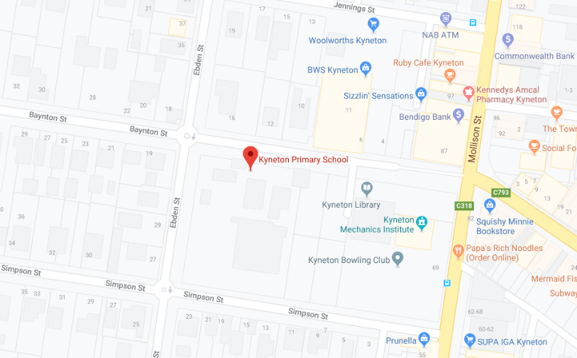

1B. Aerial image, former Kyneton Primary School site in blue box

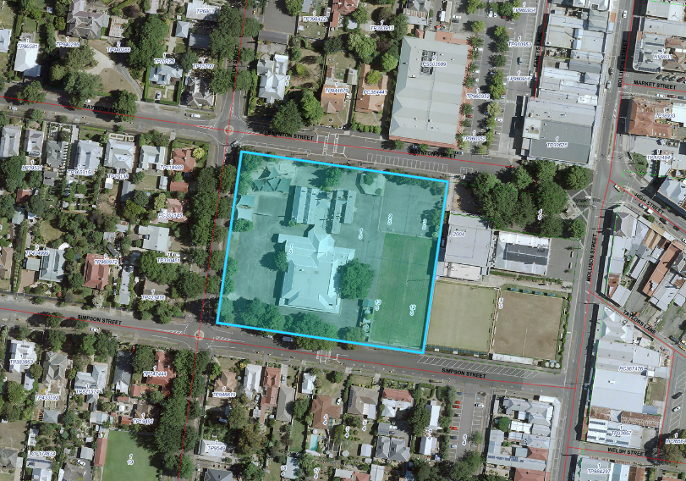

2A. Old bluestone school building



2B. Playing fields and modern shed

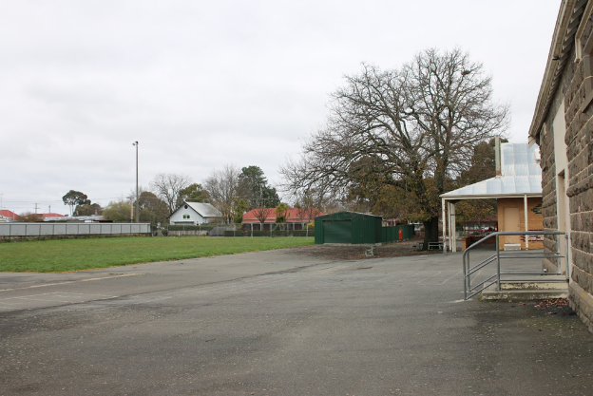

2C. Playground equipment and shade sails

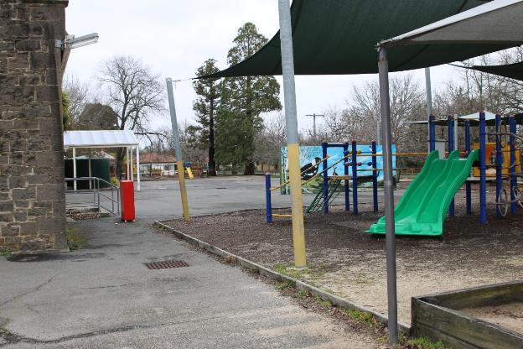

2D. Newer building extension and old bluestone school building

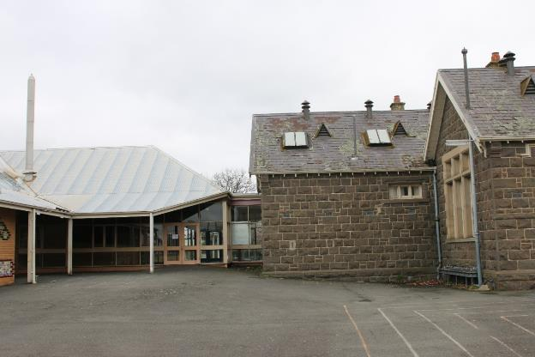

2E. Newer building extension behind old bluestone school building

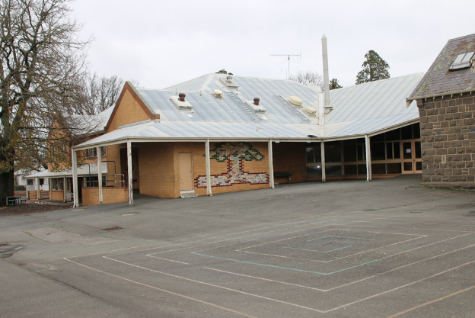

2F. Newer building extension

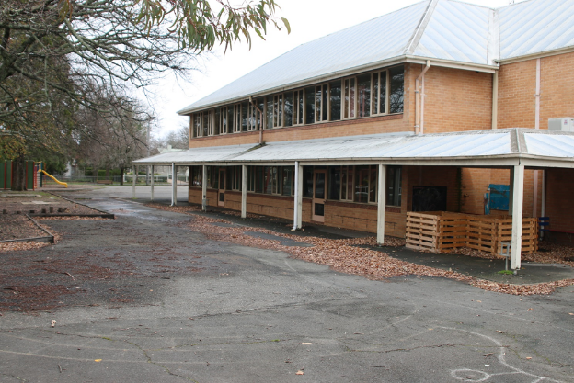

2G. Inside newer building extension

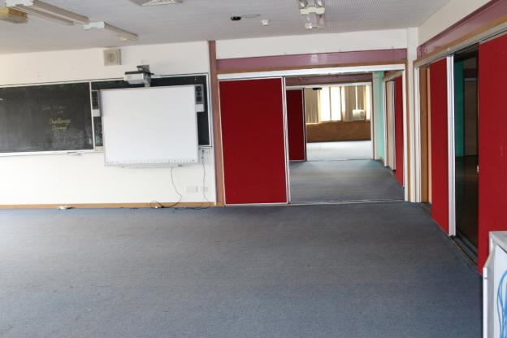

2H. Inside newer building extension

