
  - Volunteer Committees of Management
  - Targeted Asset Maintenance and Upgrades:
  - Public Access, Use and Amenity

FAQs
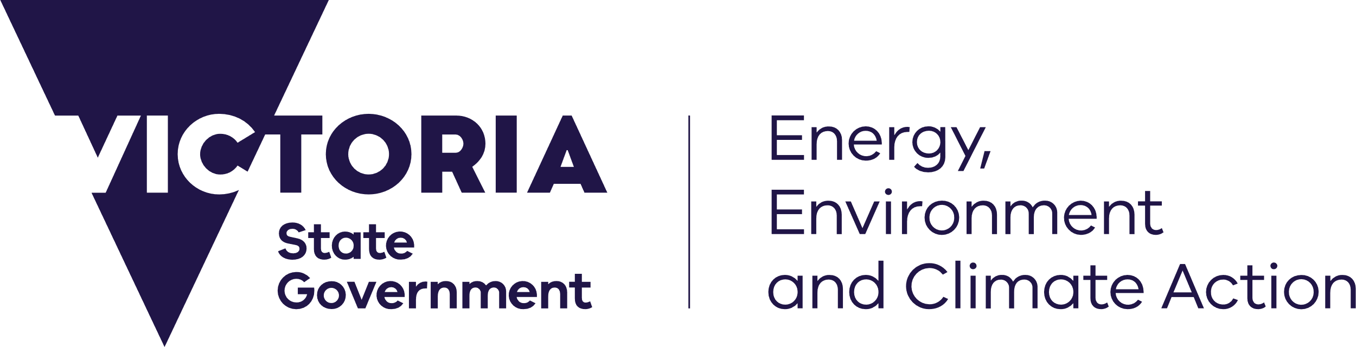

deeca.vic.gov.au




We acknowledge and respect Victorian Traditional Owners as the original custodians of Victoria’s land and waters, their unique ability to care for Country and deep spiritual connection to it.
We honour Elders past and present whose knowledge and wisdom
has ensured the continuation of culture and traditional practices.
DEECA is committed to genuinely partnering with Victorian Traditional Owners and Victoria’s Aboriginal community to progress their aspirations.
© The State of Victoria Department of Energy, Environment and Climate Action June 2023.

Contents
1. Our project won’t result in full levels of compliance, will this affect chances of receiving funding? 3
2. Can I apply for retrospective funding? 3
3. Our banking details have changed since our last payment, or what is the process to update these? 3
4. We are a new supplier, is there a process to set up our account with DEECA? 3
5. Our most recent payment from DEECA was over a year ago, will our account still be active? 3
6. Our committee hasn’t yet applied for grants or has limited experience, where can we go for support? 3
7. We have not heard back from our Council regarding what permits we need to apply for ? 3
8. What supporting information does our application need to provide? 3
9. What is the process if we need to extend a milestone or request a financial variation? 3
10. We are looking to re-apply for a second time, is this possible? 3
11. Our committee received funding from Round 1, will this affect our chances of receiving Round 2 iiiiiii funding? 4
12. What contributions do we need to make? 4
13. I would like to leave feedback, is there a link to do this? 4
14. Our committee is keen to promote our volunteers work, our upgrade projects and upcoming events, iiiiiiiii can DEECA support this? 4
15. My question isn’t listed here – what should I do? 4

Our planned stream 2 upgrade project will not result in full levels of DDA compliance, will this affect our chances of receiving funding?
- Victorians face barriers in accessing all parts of community life. Within this stream of funding DEECA is investing funding for projects that take action to remove these barriers on land managed by voluntary committees of management relating to buildings, structures, assets and facilities, and thereby making more Victorian community spaces inclusive and accessible for everyone.
- Projects will increase the level of compliance to improve accessibility of the premises that you manage.
- DEECA understands that there is a likelihood that due to unjustifiable hardship, attaining full DDA compliance and removing all barriers may not be possible.
- Projects that take to meaningful steps in removing barriers and reducing discrimination on public land reserves will be considered for funding.

Can I apply for retrospective funding?
- No retrospective funding is available for this round of the Program.

Our banking details have changed since our last DEECA payment, or what is the process to update these?
- Please email asset.upgrades@deeca.vic.gov.au and let us know. A project officer will issue your committee with a form to amend details.
- Please do this early in the application process to avoid delays down the line.

We are a new supplier, is there a process to set up our account with DEECA?
- Please email asset.upgrades@deeca.vic.gov.au and let us know. A project officer will issue your committee with a form to fill out and return to this email. You will be notified when your account is activated.

Our most recent payment from DEECA was over a year ago, will our account still be active?
- If your last payment from DEECA was over 12 months ago, it will likely need updating and to be reactivated, please follow steps in answer 3.

Our committee hasn’t applied for grants in the past or has limited experience, where can we go for more support?
- DEECA can offer support and help guide you through the process.

We have not heard back from our Council regarding what permits we need to apply for – can DEECA support us?
- While DEECA can’t expedite council permit processes, we encourage you to contact us if delays arise. We can provide a letter of support, liaising with local government (where appropriate), offering advice and guidance on next steps. We understand these delays are often outside your control.

What supporting information does our application need to provide?
- As well as completing all sections of the correct application form for the stream your projects are eligible for, you will be required to provide at a minimum, written quote(s) in date for at least 21 days after submitting to DEECA, all signed council and DEECA permits/approvals/consents, site and asset photos.
- Depending on the scale and complexity of the project you may be required to provide elements including a project plan, risk management plan, maintenance plan, designs, professional assessments or reports, letters of support and a schedule of how the community will be informed and engaged throughout the project.

What is the process if we need to extend a milestone or request a financial variation?
- If your project is delayed or the budget needs adjusting, please contact your DEECA program contact as early as possible. The process is similar for both milestone extensions and financial variations:
- Notify DEECA in writing: explain the reason for the change, whether it’s a delay, cost increase, or change in project scope.
- We do understand that some delays and cost changes are unavoidable. .

We are looking to re-apply for a second time, is this possible?
- Each committee can enter into two funding agreements with DEECA per financial year. The first funding agreement must be successfully acquitted before a second agreement can be entered into. All applications are assessed on merit with priority given to projects that address health and safety issues, relate to the improvement of high priority assets and enhance equitable community use.

Our committee received funding from Round 1, will this affect our chances of receiving Round 2 funding?
- No, all applications are evaluated based on merit and alignment to project objectives and in line with the assessment criteria.

What contributions do we need to make?
- Monetary contributions are always welcomed and will likely increase the value for money assessed criteria score.
- Committees that have had a net revenue from ordinary activities of over $100,000 are obligated to contribute a minimum of 15% of the total project costs – this is to ensure that the funding can be allocated to more reserves across the region for the benefit of more Victorians.

I would like to leave feedback, is there a link to do this?
- We welcome feedback at any time, please scan this QR code below, email asset.upgrades@deeca.vic.gov.au or follow this link to access a 2 minute survey to submit feedback.


Our committee is keen to promote our volunteers work, our upgrade projects and upcoming events, can DEECA support this?
- Thank you for your committee’s interest in sharing information about the hard work of your committee, your project and/or events that are upcoming, if capacity allows DEECA is always happy to support your committee in sharing your success and elevating community events. Please reach out to asset.upgrades@deeca.vic.gov.au with information about what you would like to achieve and how we can use our media and communications team to help.

My question isn’t listed here – what should I do?
- If you can’t find the answer to your question in this FAQ, please get in touch with us directly. We are here to help and can provide advice specific to your project or situation.
  - Contact: asset.upgrades@deeca.vic.gov.au

