Hanging Rock Precinct Master Plan

Issued August 2023
Connection to Country
“When we talk about traditional ‘Country’…we mean something beyond the dictionary definition of the word.
For Aboriginal Australians…we might mean homeland, or tribal or clan area and we might mean more than just a place on the map. For us, Country is a word for all the values, places, resources, stories and cultural obligations associated with that area and its features. It describes the entirety of our ancestral domains. While they may all no longer necessarily be the title holders to land, Aboriginal and Torres Strait Islander Australians are still connected to the Country of their ancestors and most consider themselves the custodians or caretakers of their land.”
— Professor Mick Dodson

Quality Assurance
Hanging Rock Precinct Master Plan
Prepared for
Department of Environment, Land, Water and Planning (DELWP)
Project Number
321-0244-00-U-02 RP01
Issue | Date | Description | Prepared By | Reviewed By | Project Principal
04 | 18 August 2023 | Final | MR, NC | MR, NC | MR
03 | 25 October 2022 | Final | MR, NC | MR, NC | MR
02 | 13 October 2022 | Final | MR, NC | MR, NC | MR
01 | 09 June 2022 | Final | CW, MR, NC | CW, MR, NC | CW
00 | 28 April 2022 | Draft | CW, MR, NC | CW, MR, NC | CW

Acknowledgement of Country
We would like to acknowledge the traditional custodians of the land on which our work is based and pay our respects to their Elders past and present. We extend that respect to all First Nations people.
We appreciate the involvement and contribution by the following organisations to this project:
DELWP
Macedon Ranges Shire Council
Wurundjeri Woi Wurrung Cultural Heritage Aboriginal Corporation
Taungurung Land and Waters Council
Djaara (Dja Dja Wurrung Clans Aboriginal Corporation)
This project would not be possible without expert services provided by:
Tract
Practical Ecology
Eco Logical Australia
Urban Enterprise
Wallbridge Gilbert Aztec: WGA
Contents
Chapter 1. Introduction 4
1.1 The Place 4
1.2 Project Background 4
1.3 The Role of the Master Plan 5
1.4 The Story of Hanging Rock 7
1.5 The Study Area 8
1.6 The Regional Context 9
1.7 The Regional Network 12
Chapter 2. Context 14
2.1 Master Plan Foundations 14
2.2 Planning Policy 19
2.3 Visitor Experience 22
2.4 Nature Based Tourism 25
2.5 Events and Gathering 27
2.6 Cultural Heritage 29
Chapter 3. Vision and Guiding Principles 31
3.1 Vision 31
3.2 Summary Diagram 31
3.3 Guiding Principles 32
Chapter 4. The Master Plan 43
4.1 Master Plan Overview 43
4.2 Master Plan Key Area Descriptions 45
4.3 Master Plan Systems 55
Chapter 5. Delivering the Master Plan 70
5.1 Consultation Strategy Summary 70
5.2 Summary of Engagement Activities and Outcomes 73
5.3 Delivering the Master Plan 85

- Introduction
  - The Place
Hanging Rock is a place that represents an ‘ideal’ to local residents and visitors, but it is a place that is under pressure from climate change, ageing infrastructure, competing uses and the impact of increasing visitor numbers.
The Traditional Owner groups who have thousands of years of connection to this land must also be acknowledged and celebrated in a way that reflects the importance and enduring nature of that relationship. This is long overdue.
This Master Plan works alongside Traditional Owners, so that design and management of the Precinct better reflects and responds to their shared history and ongoing role as custodians of the land. A greater focus on Indigenous perspectives and cultural values will bring immense benefits to all users of the site.
This Master Plan aims to protect the location’s significant natural and cultural assets; whilst at the same time providing a unique and memorable 'place-specific' visitor experience.
  - Project Background
In 1990, Council purchased the area known as the ‘East Paddock’ from private landowners in order to protect and enhance the landscape values of the Hanging Rock Precinct. Since then, there have been multiple attempts to integrate the new parcel of land with the existing infrastructure, which was established in 1869 for picnicking and local events.
As outlined in the ‘Hanging Rock Management Plan’ (1993: Loder & Bayly) ‘The problem with designing around 150 years of established site occupation (post-contact), is that the original use didn't plan for 21st century modes of transport, increased visitation numbers, concerts, modern design and compliance standards; or had any regard for cultural and environmental values’.
The issues that Loder and Bayly highlighted in their 1993 Management Plan are the same key issues that still need to be addressed today.
There have been numerous attempts to rationalise, expand, define and control the existing and any potential uses for the expanded 98 hectare site. However, to date none have managed to balance the protection of 'place', while incorporating an upgraded visitor experience and new infrastructure.

Hanging Rock Strategic Plan
In November 2018, the Victorian State Government and Macedon Ranges Shire Council released the Hanging Rock Strategic Plan and committed funding to begin its implementation. The Strategic Plan required three additional technical studies:
- An update to the 2015 Environmental Management Plan (endorsed 2021).
- An Aboriginal Cultural Heritage Landscape Conservation Management Plan (ACHLCMP) (endorsed 2021).
A Hanging Rock Precinct Master Plan (this report).
The development of a Master Plan for the Hanging Rock Precinct was completed in partnership with the three Traditional Owner groups – Wurundjeri Woi Wurrung, DJAARA and Taungurung, who were involved in the key stages of the design phase.
  - The Role of the Master Plan
The Strategic Plan outlines the role of the Master Plan as “Implementing a detailed plan that ensures the long-term development and management of Hanging Rock is sustainable” (Hanging Rock Strategic Plan, 2018; pg 80).
Specifically, the role of the Master Plan is to outline an agreed approach to long term change. Recognising this, the Master Plan approach will:
- Be consistent with the iconic nature of the Precinct.
- Recognise the precinct as a special gathering place with state significance.
- Challenge the status quo and deliver a new site philosophy founded on recognising cultural, landscape and environmental values.
- Enable a high-quality visitor experience whilst protecting the natural environment and cultural assets.
- Ensure that the long-term development and management of the Precinct is sustainable.
Resolve conflicting values and prioritise place specific uses.
The Master Plan will not:
- Establish governance and management structures.
- Provide resolution to boundary negotiations between Traditional Owners.
- Resolve site specific design and technical details, including local traffic management requirements. These will be addressed through further detailed studies and management plans.
- Outline strategies to manage visitation to the Precinct to ensure sustainable tourism. These strategies will be developed through management plans.
- Address operational needs such as fire management requirements, maintenance needs. These strategies will be developed through management plans.
- Provide technical manuals for facility design or ecological rehabilitation strategies. These will be addressed through further detailed work.
- Provide event management guides. These requirements will be developed as a part of the overall site management system.
- Undertake site specific risk assessments.
- Confirm transition plans for any existing activities that move off site.
Provide a business case for planned facilities and/or infrastructure.
The 2018 Strategic Plan outlined the key objectives for the future precinct. As such it is the foundation for this Master Plan. The specific objectives that can be addressed within the scope of this master planning project are outlined in the table opposite.
Strategic Plan Objective | Master Plan Design Response
Governance and Management  - Implement a detailed plan that ensures the long-term development and management of Hanging Rock is sustainable | Governance and Management  - The Hanging Rock Master Plan establishes a design framework for the precinct with consideration of long term land use and development of the Precinct
Environmental  - Improve and protect the environmental values of the Precinct  - Improve and protect the visual landscape values of the Precinct | Environmental  - The Hanging Rock Master Plan is based on principles of environmental sustainability and ecological integrity  - The Hanging Rock Master Plan takes a light touch to development
Cultural Heritage  - Protect Traditional Owners’ heritage and cultural values  - Build visitors' knowledge and awareness about the heritage and importance of the place to the Traditional Owners  - Recognise and preserve the significant post-European contact heritage and historical associations with the Precinct. | Cultural Heritage  - The Hanging Rock Master Plan prioritises agreed cultural heritage values  - The Hanging Rock Master Plan recommends that the detailed design stage of works is informed by Traditional Owner expertise in the management of tourism destinations and provision of cultural educational experiences  - As outlined above
Tourism and Recreation  - Manage sporting and recreational activities to reflect the role and significance of the Precinct  - Support the continuing association of Hanging Rock as a place of gathering accessible for all visitors  - Foster the tourism role of the Precinct in both the region and the state | Tourism and Recreation  - The Hanging Rock Master Plan prioritises the cultural and environmental significance of the Precinct  - The Hanging Rock Master Plan prioritises the provision of facilities that enable the general public to access and enjoy the precinct  - The Hanging Rock Master Plan supports the tourism role of the precinct wihin the wider region

  - The Story of Hanging Rock
Hanging Rock is the physical result of a volcanic eruption, with dating of Hanging Rock lava and that of nearby similar eruption points indicating a Late Miocene age (about 6 million years). The lava is of a higher viscosity than most other Tertiary volcanoes in Victoria and its greater resistance to flow caused the growth of a dome or tholoid around the eruption point, producing a steep-sided, fractured mass of lava rather than the thin sheets or flows resulting from the basaltic volcanoes. This structure is known geologically as a mamelon.
Cooling of The Rock produced numerous vertical features which shape the cliff faces and have been enlarged by weathering to produce a complex of pinnacles, craggy overhangs, small caverns and boulders on the slopes of Hanging Rock.
This rare volcanic formation has been exposed to considerable weathering and erosion, resulting in a conglomeration of unusual rock formations.
Hanging Rock is located near the traditional boundary between three Aboriginal Traditional Owner groups – the Woi Wurrung (Wurundjeri), the Djaara and the Taungurung. Archaeological evidence found at Hanging Rock demonstrates Aboriginal use and occupation of the place for at least 10,000 years. As a prominent, culturally significant landmark near tribal boundaries with a reliable source of water, The Rock is likely to have been used for Ngargee ceremonies (Corroborrees) and other traditional business that involved gatherings.
Whilst each of the Traditional Owner groups assert custodianship of Hanging Rock, the place has important ongoing connections and cultural values to all three groups and there are important shared values and attachments to Country.
Hanging Rock is set in a broader cultural landscape, with important connections to culturally significant places and story lines at Camel’s Hump on Mt Macedon to the south, to traditional stone sources located at Coliban Dam to the north west, to Brock’s Monument and the headwaters of Deep Creek in the east, the Goulburn River to the north and Mt William to the north-east.
Originally surveyed in 1843 by Robert Hoddle and named Diogenes Mount, the first map was made in 1844. In 1857, the lot containing the majority of the Hanging Rock was purchased and in the 1860s it was developed for a ‘pleasure resort’. Hanging Rock once again became a popular site for gatherings, this time for picnics. The Hanging Rock Racing Club was formed in 1885, conducting biannual races which continue to this day.
Several local sporting facilities are located in the Precinct, including a cricket oval and facilities, tennis courts and facilities and a petanque ‘piste’ with associated storage.
Since the 1970s upgrades to facilities, paths, tracks, toilets and additional picnic shelters has ensured that the Precinct continues to be a popular place for visitors to gather and picnic.
- Hanging Rock Precinct Aboriginal Cultural Heritage Landscape Conservation Management Plan (ELA, 2021)
In recent decades, Hanging Rock has become widely popular for its mystery and stories, due in part to the international success of the film "Picnic at Hanging Rock" in 1975.
Since 2011 music concerts have been held at in the East Paddock, often featuring international acts. These concerts have become a major drawcard for Hanging Rock and the Macedon Ranges.
  - The Study Area
Hanging Rock is an iconic and significant feature of the Victorian landscape, that was formed over 6 million years ago. The Precinct is located approximately 62km north-west of Melbourne within the Macedon Ranges Shire, and near the townships of Woodend and Mount Macedon.
The Hanging Rock Precinct is bound by Colwells Road to the north, Straws Lane to the east, South Rock Road to the south and the cessation of Maxted Road and The Rock itself to the west.
The Rock formation is Crown land that was gazetted in 1870. The Hanging Rock Precinct was permanently reserved for the purpose of ‘‘Public recreation and for affording access to water’’ in the government gazette dated November 28, 1884.
In the Macedon Ranges Planning Scheme, the Hanging Rock Reserve is zoned Public Conservation and Resource Zone, which provides for the protection and conservation of the natural environment, natural processes and heritage, scientific, landscape, habitat or cultural significance.
The East Paddock was purchased by the former Newham and Woodend Shire Council in 1990. This land is zoned Public Park and Recreation Zone, which recognises land for public recreation and open space.
The Department of Environment Land, Water and Planning has successfully negotiated the purchase of East Paddock from the Macedon Ranges Shire Council.
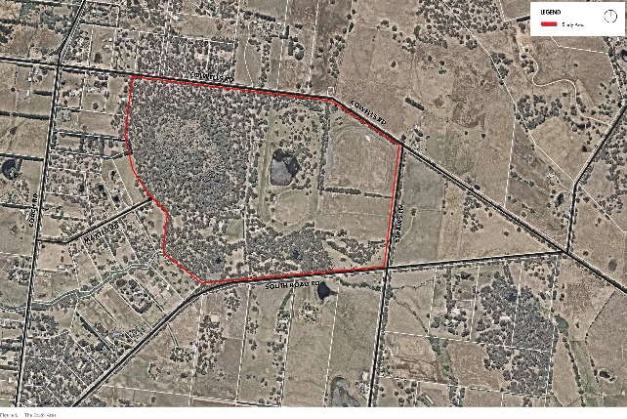
  - The Regional Context
Hanging Rock is a significant cultural and tourism destination in the Macedon Ranges Shire and Victoria. Located within an easy day-trip distance from Melbourne, it sits alongside Mount Macedon as a key nature-based tourist destination. The Rock is used in branding and promotion of tourism in the region and supports the visitor economy through attraction of visitors and events.
The Macedon Ranges Visitor Economy Strategy 2019-2029 supports developing Hanging Rock as a world-class destination featuring Aboriginal cultural experiences and interpretation. To achieve this outcome, The Rock requires careful planning and investment, sustainable management and enhancement of the visitor experience.
The Visitor Economy Strategy recommends the prioritisation of the implementation of the Hanging Rock Strategic Plan. Released in 2018, the Strategic Plan sets out a 50-year vision for the Precinct and provides objectives and strategies to guide its protection and development. The tourism strategies and objectives of the Strategic Plan provide the basis for further tourism advice and preparation of the Master Plan.
The Macedon Ranges is a popular visitor destination, highly regarded for its rural landscapes and natural environments. With its iconic landmarks of Hanging Rock and Mount Macedon, heritage villages, restaurants, wineries, and the local artisan culture.
These landscape, environmental and cultural values were officially recognised when the Macedon Ranges was declared a distinctive area and landscape under state planning policy in 2018. Specific to the visitor economy the State Planning Policy (SPP) includes in its vision that, ‘Macedon Ranges has a flourishing and environmentally sustainable visitor economy that respects the area’s environmental and cultural values, providing locals and visitors with a variety of high-quality natural attractions and experiences'.
Visitation from the regions is also critical, with a large number of significant regional locations proximate to Hanging Rock from a day trip/overnight stay perspective. These include:
- Geelong (260,000+ estimate).
- Ballarat (105,000+ estimate).
- Bendigo (100,000+ estimate).
- Shepparton (50,000+ estimate).
- Echuca/Moama (20,000+ estimate).
- Torquay (15,000+ estimate).
- Castlemaine (10,000+ estimate).
Benalla (10,000+ estimate)
In 2016 the Macedon Ranges attracted 1.67 million visitors, with over 1 million day-trip visitors and 654,000 overnight visitors. Macedon Ranges has grown 47% in overnight visitation, 74% in day-trip visitation and 62% in total visitation since 2009 (Macedon Ranges Visitor Economy Impact Study 2017).
Visitation is concentrated predominantly to Kyneton and Woodend sub-regions, which together attract 68% of total visitation to the Macedon Ranges. This highlights that visitor dispersal towards the east of the Shire should be a key consideration in order to strengthen business opportunities.
Visitation projections show that the Macedon Ranges may attract an additional 1 million visitors by 2025 using a mid-point growth scenario.
The visitor economy contributes to the lifestyle of residents by providing local employment opportunities, a greater quantity and mix of retail businesses, quality restaurants and experiences throughout the region.
The Daylesford and Macedon Ranges tourism region promotes its brand of ‘wellness’. The potential and strength of the Macedon Ranges within the region is in the broader interpretation of wellness as health and relaxation, creativity and a strong connection with nature and people.
The Macedon Ranges is defined by the character of its historic artisan villages and townships connected by the overarching theme of the ‘makers’ – as defined by the creative arts, artisanal food, wine and agricultural products and the increased popularity of workshops.
The historic heritage of townships of Kyneton and Woodend provide a strong motivator for visitation.
Emerging products for the Macedon Ranges include accommodation, Aboriginal cultural heritage experiences, wellness and mineral springs, weddings, conferences and agritourism.
– Macedon Ranges Visitor Economy Strategy 2019-2029 (Urban Enterprise, 2019)
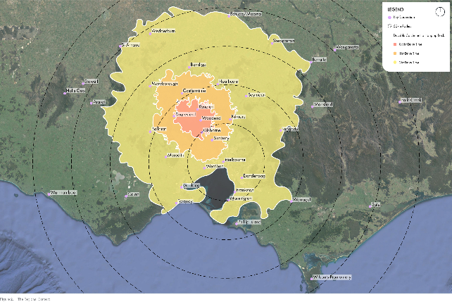
  - The Regional Network
A key strength of the Macedon Ranges nature-based visitor experience is the diversity of outdoor activities that are available in a variety of natural settings.
There are many opportunities for active recreation experiences such as bushwalking, trail running, cycling, rock-climbing and horse riding. The abundance of nature reserves, parks, gardens and rural landscapes support many passive recreation activities such as general sightseeing, birdwatching, visiting farms, educational tours (flora and fauna), photography and picnicking.
Hanging Rock is the major visitor destination in the Macedon Ranges. The rare volcanic formations are a majestic and inspiring scenic landscape. A site of Indigenous significance, Hanging Rock is on the edge of three Traditional Owner group boundaries and is considered a shared place and site for gathering.
The Master Plan seeks to reaffirm the significance of Hanging Rock as a premium nature and recreation destination. Key to this project, is understanding the future use and visitation of the site.
Due to its proximity to Melbourne, day-trip visitation is understandably high and with Melbourne’s projected population growth, visitation figures will continue to rise. In the decade prior to the COVID-19 pandemic, general visitation has doubled from approximately 60,000 to nearly 120,000 per year – exclusive of events, concerts, race days and other events that are ticketed separately.
Assuming a continued increase in visitation, Hanging Rock will need careful management to prevent future overcrowding, and congestion. Current congestion and a perceived reduction in visitor experience on peak visitation days will be exacerbated in the future as visitation numbers increase.
A method to re-frame the question of 'What is Hanging Rock?' is to look at other nearby open space and leisure locations, that can carry some of the recreation and picnic load that are highly sought after at Hanging Rock. Whilst Hanging Rock may be ‘the jewel in the crown’ of the Macedon Ranges, there are other highly valued destinations that can also distribute the visitor load.
Mount Macedon and surrounds is the next most popular outdoor destination with the major attractions being the parks and gardens, walking trails, the Harbisons Picnic Area, tearooms and Memorial Cross (Victoria’s most significant war memorial after the Shrine of Remembrance in Melbourne) on Mt Macedon.
Other outdoor destinations and experiences include:
- Wombat State Forest and Lerderderg National Park.
- Black Hill and Bald Hill Reserves.
- Upper Coliban, Lauriston and Malmsbury Reservoirs.
- Campaspe River Walk and Kyneton Town walk (Kyneton).
- Conglomerate Gully Walking Track (Riddells Creek).
- Five Mile Creek Walk (Woodend).
- Malmsbury Viaduct.
Kyneton, Gisborne and Malmsbury Botanic Gardens.
Cycling is a growing activity across Victoria and the Macedon Ranges has strong cycling credentials in both road and mountain biking.
— Hanging Rock Master Plan Tourism Advice (Urban Enterprise, 2021).
In regards to active recreation, there are a number of existing nearby facilities and proposed facilities that can cater for the growing demand of active sporting groups in the area.
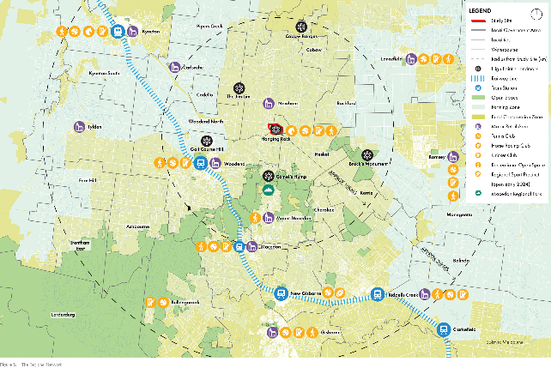
- Context
  - Master Plan Foundations
The Master Plan builds upon the work that has been completed over the past two decades to ensure that a robust, considered and deliverable program of works is accomplished. Master planning and management options have been developed in 1993 and 2017.
The completion of more recent investigations in relation to ecological management, cultural heritage conservation management and tourism advice are the key drivers that have guided the development of this most recent plan.

Hanging Rock Precinct Draft Master Plan Options for Consultation (Aspect Studios/Village Well, August 2017)
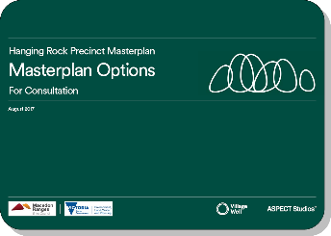
Aspect and Village Well prepared multiple design scenarios based on community consultation to understand the qualities that the local community and tourist community value at Hanging Rock. The options posed short and medium-term options, that looked at a range of ways to reconfigure the existing uses in a way that would benefit the user experience and functionality of the site.
Smaller design changes included a range of ecological improvements, infrastructure upgrades and updated signage/wayfinding design, such as:
- Enhanced trail network – suggested upgrades to various trails around the site.
- Environmental improvements – a variety of suggested improvements consistent with or in addition to the adopted Hanging Rock Environmental Management Plan.
- Service infrastructure improvements.
- Improving the park amenity.
- Sport facility options.
- Event opportunities.
Rationalise events zones.
Before the report was finalised, the Macedon Ranges Shire Council (MRSC) put the master planning process on hold, as there were concerns the process did not adequately capture the precinct's significance of the environmental and cultural heritage values. This led to the commissioning of the Hanging Rock Strategic Plan and the subsequent EMP/ACHLCMP documents. The investigations and methodology undertaken through this 2017 report are still valid and appropriate today.

Hanging Rock Strategic Plan (Ethos Urban, September, 2018)
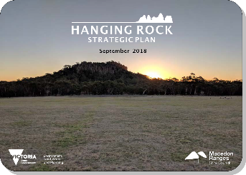
The Strategic Plan recognises the iconic nature of the Hanging Rock Precinct for its cultural, geological and ecological values and sets a 50-year vision for the precinct:
"Hanging Rock will be renowned for its importance to our First Peoples, its dramatic geological form and (its wider landscape setting within the Macedon Ranges). The role of The Rock throughout history as a place of gathering, reflection and intrigue will be understood and celebrated.
The re-vegetated bushland environment will enhance the secluded ambience and provide a habitat for native wildlife. Activities around The Rock will reflect its historical uses centred on recreation and education and its State and National significance".
It also provides objectives, strategies and actions to support implementation of the Vision, and also a management plan to inform a governance model and identify action priorities and time frames.
The different user groups for Hanging Rock include:
- Aboriginal Traditional Owners.
- Environmental interest groups (including flora, fauna and Landcare groups).
- Local sports clubs.
- Macedon Ranges Shire Council.
- Regular event or special event attendees.
- Local residents engaged in a variety of leisure activities
- Local businesses
- The wider Victorian community engaged in ‘day trip’ leisure activities
- National and international tourists

Strategic Plan Objectives
The Strategic Plan identifies the following objectives arising out of the common values and issues for consideration:

Governance and management objective
Implement a detailed plan that ensures the long-term development and management of Hanging Rock is sustainable

Environmental Objectives
- Improve and protect the environmental values of the Precinct
Improve and protect the visual landscape values of the Precinct

Culture and Heritage Objectives
- Protect Traditional Owners’ heritage and cultural values
- Build visitor’s knowledge and awareness about the heritage of the place, and importance of the place to the Traditional Owners
- Recognise and preserve the significant Post-Contact heritage and historical associations with the Precinct
Recognise and reflect the national and state role and significance of Hanging Rock in management and legislative arrangements

Tourism and Recreation Objectives
- Manage sporting and recreational activities to reflect the role and significance of the Precinct
- Support the continuing association of Hanging Rock as a place of gathering accessible to all visitors
Foster the tourism role of the Precinct in the region and state
The Strategic Plan recommends that a revised management approach is required to recognise the ongoing connection of Traditional Owners to this important place for their culture.
This new governance structure is proposed to be a joint management approach, with a formal partnership arrangement between Aboriginal Traditional Owners and the relevant government land management body, whereby both share their knowledge to manage the Hanging Rock Precinct as partners.
The Victorian Government and Macedon Ranges Shire Council approved the Strategic Plan in 2018. The Plan provides the basis on which this Master Plan has been developed and the key objectives, strategies and actions have been used to guide the Master Plan for the Hanging Rock Precinct.

Hanging Rock Environmental Management Plan (EMP) 2021 (Practical Ecology, July 2021)
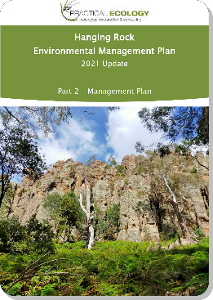
The aim of the Hanging Rock Environmental Management Plan update is to build on the progress made in recent years through the implementation of the 2015 EMP. By developing a robust and refined framework elevates protection of ecological values in future decisions about management of the Precinct.
Part 2 of the Hanging Rock Environmental Management Plan (EMP) Update 2021 establishes Management Zones for the Precinct, along with recommended actions for the next 5-10 years of management, dependant on the completion and implementation of the Hanging Rock Master Plan.
The development of this plan includes:
- The updating of contents from the 2015 EMP to respond to the vision and objectives of the Strategic Plan (DELWP 2018).
- Provision of an updated assessment of the environmental and recreational values of the Hanging Rock Precinct, as identified through a review of relevant literature and databases, site assessments and stakeholder engagement.
- Identification of the current threats to these values, as determined through integration of the information sources listed above.
- Prescription of management opportunities that can address these threats and guide ongoing management of the Precinct providing guidance for the development of a future Master Plan for the Precinct.
Incorporation of recommendations of cultural heritage assessments by DELWP, in line with the Strategic Plan for management identified cultural heritage values within the Precinct.
The EMP is meant to be read in conjunction with this Master Plan, as a way to bridge the gap between design and management.
The Master Plan builds on the work completed in the EMP, which looks at the current condition of The Rock environment and ways that the Master Plan can improve and expand upon the conservation goals and outcomes proposed in the EMP.

Hanging Rock Aboriginal Cultural Heritage Landscape Conservation Management Plan (ACHLCMP) (Eco Logical Australia, July 2021)
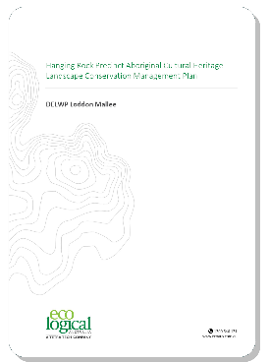
As part of the implementation of the Hanging Rock Strategic Plan, the Victorian Department of Environment, Land, Water and Planning (DELWP) Loddon Mallee region commissioned the preparation of an Aboriginal Cultural Heritage Landscape Conservation Management Plan (ACHLCMP) that assesses the Aboriginal cultural values of the precinct and requirements for management of the area.
The methods used during the preparation of this ACHLCMP included:
- Desktop assessments and database reviews investigating the:
- Environmental and archaeological context of the Hanging Rock Precinct.
- Historical and ethnohistorical accounts of Aboriginal occupation at Hanging Rock.
- Past and present land use of the Hanging Rock Precinct.
- Archaeological ground surface pedestrian surveys.
- Formal and informal consultation with Taungurung, Wurundjeri Woi Wurrung and DJAARA representatives during the archaeological survey and onsite cultural values recording sessions.
This Aboriginal Cultural Heritage Landscape Conservation Management Plan (ACHLCMP) presents the results of a range of desktop investigations and oral history interviews into the Hanging Rock Precinct as a location, a locale and a place that has a strong emotional connection for the Traditional Owners. The information assembled during these investigations will be structured in line with this thematic approach of location, locale and sense of place.
  - Planning Policy

Heritage Listing
The Hanging Rock Reserve is included on the Victorian Heritage Register as a state heritage listed place and permits are required from Heritage Victoria for works or activities impacting its state heritage values. The heritage listing covers the Hanging Rock Reserve, excluding the land known as East Paddock.
The following extract from the Victorian Heritage Database outlines the statement of significance, for the precinct.
The Hanging Rock Reserve is of historical, aesthetic and social significance to the State of Victoria. Hanging Rock Reserve is significant at the State level for the following reasons:
- Hanging Rock Reserve is historically significant as an early and popular recreational destination and meeting place for Victorians. The distinctive and rare geological formation of Hanging Rock attracted large numbers of visitors from as early as the 1860s to congregate, be entertained, climb the Hanging Rock formation and participate in outdoor sport and leisure activities, in a unique and highly picturesque setting. The Hanging Rock Reserve illustrates the great popularity of outdoor pursuits, particularly in the nineteenth and early twentieth century.
- Hanging Rock Reserve is historically significant for its long association with horse racing in Victoria from the 1860s to the present day. The site of the present racecourse, in use since 1878, demonstrates the importance of this form of sport as a recreation activity to the rural communities of Victoria.
- Hanging Rock Reserve is of aesthetic significance as an outstanding, distinctive and unusual place of natural beauty. The Hanging Rock formation has been recognised and enjoyed since the 1860s for its natural beauty, for its provision of spectacular views of the surrounding countryside, and as a backdrop to the variety of recreational activities conducted at its base. Visitors have climbed the formation since the 1860s, enjoying its unique spatial and aesthetic qualities and the experience of being within it, and exploring the formation and the surrounding woodland. The importance of its aesthetic qualities is demonstrated in the popularity of the reserve as a Victorian tourist destination over a long period. The picturesque qualities of the place, which unfold from a number of viewpoints, impart a sense of mystery and evoke a strong emotional response from the viewer. From the 1850s the unusual and distinctive physical features of the Hanging Rock formation have stimulated innumerable written and artistic responses, including sketches, paintings, photographs, writing, film and music.
Hanging Rock Reserve is socially significant for its continuous use and appreciation by the wider Victorian community as a popular gathering place for recreational purposes since the mid-1860s. This enduring association with tourists was reinforced by the production of the book (1967) and the film (1975) of "Picnic at Hanging Rock", which resulted in an increase in the popularity of the Hanging Rock Reserve as a destination for local, Australian and overseas visitors.

Zones and Overlays
Land within the Hanging Rock Precinct is currently zoned under the Macedon Ranges Shire Planning Scheme as follows:
- Public Conservation and Resource Zone (PCRZ) – Hanging Rock Precinct.
- Public Park and Recreation Zone (PPRZ) – East Paddock.
- Planning scheme overlays that apply to the Hanging Rock Precinct include:
- Heritage Overlay (HO88).
- Bushfire Management Overlay (BMO).
- Vegetation Protection Overlay – Schedule 9 (VPO9).
- Significant Landscape Overlay – Schedule 1 (SLO1).
Environmental Significance Overlay – Schedule 4 (ESO4).
Activities requiring permits under these overlays all have the potential to impact on Aboriginal cultural values.
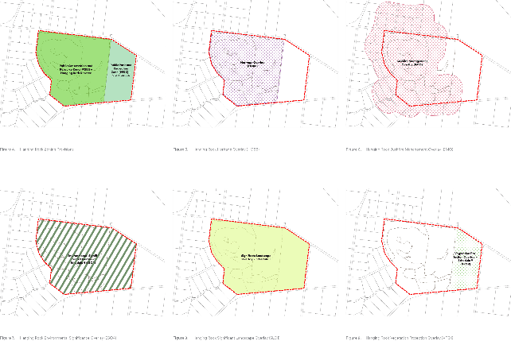

Macedon Ranges Statement Planning Policy
The Statement of Planning Policy provides a framework to ensure the outstanding landscapes, layers of settlement history, impressive landforms, and diverse natural environment of the Macedon Ranges are protected and conserved and continue to be of special significance to the people of Victoria.
In regard to the Hanging Rock Precinct, the statement aims to support efforts to:
- Recognise the connection and stewardship of Traditional Owners in relation to land in the declared area
Identify and protect significant landscapes and environmental and cultural heritage features within the declared area
- Enhance conservation of the area’s unique habitats, ecosystems and biodiversity
Provide greater certainty about the landscape values and rural land to be conserved for current and future generations
The Hanging Rock Masterplan will ensure that the key outcomes from the Statement Planning Policy as they relate to the Precinct will be identified and acknowledged through the relevant planning and approvals processes as development begins.
  - Visitor Experience

Overview
The quality of visitor experience is at the heart of the Master Plan. Hanging Rock is a unique setting with special landscape, environmental and cultural heritage values. It must not be seen as a generic park venue that caters for every leisure activity and community need. The visitor experience must always be immersive and place specific and the landscape of the site must always be a dominant part of the visitor experience.
There are a range of opportunities to improve the quality of visitor experience throughout the duration of a site visit or special activity.
The site must offer a range of destinations that cater for different needs. These will include places for picnicking, walking, education, site interpretations and cultural heritage interpretations. Vehicle access, parking and other support services will be present in a number of settings, but they will never dominate the visitor experience. The Hanging Rock reserve is a relatively small site and visitor numbers will inevitably be limited by the range of available settings. This will be a place for people and for nature. Day to day visitors should never be overwhelmed by excessive crowds, cars and infrastructure.
The site will also cater to a range of temporary uses including special music events, markets and other community-based activities. These will utilise multi-purpose spaces that function on a daily basis as general leisure settings but can be transformed to meet the needs of a special community event without diminishing other site values. These multi-purpose spaces allow the site to adapt to a range of current and future community needs without imposing fixed infrastructure on the site.
Other opportunities to improve the visitor experience relate to the development of a more suitable visitor centre facility (Discovery Centre) and arrival area that is capable of meeting a wider range of community and educational needs than the existing visitor centre facility, in addition to management changes such as easy to use online booking systems, excellent customer service, high quality site design and infrastructure systems, improved site maintenance systems and visitor information systems.

Café and Gift Shop
The current visitor hub consists of a café, shop, Discovery Centre (interpretive centre), visitor information stand and car parking ticketing facilities. The infrastructure is ageing and is in need of maintenance and/or renewal to address compliance with current day building standards.
The licensed café is generally open six days a week, from 11am-3pm weekdays and 10am-4pm on weekends. Souvenirs are also available from the gift shop. The current operators of the Hanging Rock Café have held the lease since 2013. The café contributes to the tourism experience through provision of food and beverages. The café also caters for private functions.
The café includes an outdoor seating area, with views toward the south of the Precinct. There are no views of The Rock from the café seating area, which is a missed opportunity to capitalise on the unique setting and location.

Visitor Discovery Centre
A key part of the visitor experience is the initial impression. The main entrance to the Precinct is located at Racecourse Road via South Rock Road and entry leads to the main car park, located adjacent to the Café and Discovery Centre. The current orientation of the visitor access from South Rock Road limits the sense of arrival to the Precinct, with views of The Rock obscured.
The location of the current visitor hub also potentially limits opportunities for greater dispersal of visitors throughout the Precinct, as visitors are funnelled to the base of The Rock and are naturally drawn to the Summit Walk.
Congestion around this area is an issue that has been highlighted in the past. The Discovery Centre, located adjacent to the café and gift shop, provides a self-guided tour, primarily via a single walkway that takes visitors along the history of The Rock and key moments in history.
It includes some static interpretative displays and soundscapes about the Precinct’s geological and settlement history, as well as exhibits on the 'Picnic at Hanging Rock' film. The centre is free for visitors to the Precinct and also includes a viewing deck, with views primarily to the south of the Precinct and close up views of the base of The Rock. The Discovery Centre is unstaffed, reducing ongoing operating costs.
The interpretive content and experience within the Discovery Centre is generally outdated, provides only a limited understanding of the site and the story telling lacks in diversity and depth.
There is a notable lack of educational content around the Indigenous significance of Hanging Rock to Traditional Owners and the environmental values of the site. Traditional Owners have commented that visitors actively seek these stories. Further interpretation of this information would appeal to both general visitors and the education sector.
There are 334 schools within a one-hour catchment of the Hanging Rock Precinct, including 26 schools with almost 9,000 students in the Macedon Ranges Shire. Hanging Rock is also within a comfortable day-trip distance from Melbourne, providing strong opportunity to capture day-trip school excursions.

Master Plan Considerations
The site arrival experience for visitors is critical. It allows visitors to orientate themselves, to understand the structure of the site and the various leisure options available to them, as well as to use services that would be available through a visitor centre and arrival area (visitor hub).
A new visitor hub could address the following:
- Relocation of the visitor hub towards the east of the Precinct to create an improved sense of arrival for visitors. This location would provide feature views to the Hanging Rock formation and locate infrastructure in a less sensitive environment that did not intrude on the primary walking areas. This location would provide an opportunity for improved dispersal of visitors to various walking tracks and picnic areas around the Precinct and limit the funnelling of visitors to the base of The Rock.
- A new visitor centre / Discovery Centre could provide a multi-function space for educational activities and temporary event space for group activities and environmental education. The intention of a new visitor centre would be to provide services that support visitor site use and interpretation. The facility would be expected to make a commercial return that helps to fund overall site maintenance, but the facility would not be designed to maximise commercial returns alone or to provide uses that were not related to the Hanging Rock reserve.
- A space for Traditional Owner ceremonies.
- A hub for ticketing, information / access to digital interpretive content (with a focus on provision of Indigenous and environmental interpretive content, as well as links to the more recent history of activities at Hanging Rock).
- A place for school groups and others to meet for education purposes.
- A hub for commencement of walking tours.
- Clearly delineated trail head with access to the various walking trail networks.
- A new café and dining space that provides views towards The Rock. This would enhance the food and beverage offering as a destination dining experience, encourage extended length of stay and visitor expenditure. There would be a potential opportunity to use Indigenous ingredients across the menu.
- An open outdoor space/counter, where visitors can purchase takeaway picnic hampers from the café.
- A new co-located gift shop with high quality products from the region, including local produce and Indigenous made products.
- Consideration of an Indigenous art gallery space with a small supporting retail component.
- Co-location of administration offices and workshop, with a viewing/educational component for visitors and groups to see what is involved in the day-to-day management of the Precinct and its ongoing environmental conservation.
Building services that represent the highest standards of environmental performance and sustainability.
  - Nature Based Tourism
Hanging Rock is a nature-based destination, with its unique geological history, picturesque setting and cultural and environmental values.
As noted in the Strategic Plan, passive recreation is the main reason why the site is such a popular destination for families, as it provides a unique, healthy and low-cost experience for day-trips.
Visitor data provided by Macedon Ranges Shire shows that over the past decade, general attendance has increased from 60,000 to 120,000 per annum prior to COVID-19 pandemic, which resulted in a decrease in visitors due to lockdowns with the Precinct being closed to visitors.
Anecdotally, Melbourne is the primary market for visitors to Hanging Rock and attracts a range of market segments and demographics including families, young couples and older visitors. Visitors are generally interested in experiencing and exploring the natural Precinct, with the walking experiences forming the core component of this experience.
The Rock has grown in prominence in recent years due to increased market awareness through major events and the remake of the Picnic at Hanging Rock mini-series in 2018.
Visitation to The Rock is variable throughout the year. The warmer seasons (spring and summer) are popular particularly on weekends, along with school holidays. Visitation during colder months and mid-week tends to be lower, with limited activity at the Precinct. Stakeholders noted that there is a need to encourage greater visitation in the quieter months of the year and improve the distribution of visitation over the week.
Currently, walking trails are the primary nature-based experience and the key driver of visitation to the Precinct. There are a number of nature walks throughout the precinct. The Summit Walk, of approximately 1.8km in length, traverses The Rock to the summit, providing stunning views across the surrounding landscape and opportunities for wildlife sightings. Other walks include the Base Walk (1.8km) and the Creek Walk (2.3km).
The Summit Walk is highly popular and the key motivator for people to visit. The Base Walk is also popular, particularly for those seeking a more gentle walk, whilst the Creek Walk was noted as currently being the least popular.

Master Plan Considerations
Tourism and economic considerations that have informed the development of the Master Plan include:
- Support the development of Hanging Rock as a nature-based destination, providing a range of opportunities and experiences that enable visitors to engage with nature and the Precinct.
- Increase and improve walking trails and walking experiences to better disperse visitors throughout the Precinct. A range of walking experiences would improve the nature-based offering of the Precinct and encourage repeat visitation. This could include:
- Improvements to trail infrastructure, including 'all abilities' access walks, wayfinding signage, viewing platforms (offering unique and discreet views of The Rock) and trail types (eg. formalised trails, raised walkways/sections of boardwalk).
- Improved interpretive content and materials for self-guided walking experiences. Interpretive materials could be provided through signage that links to digital channels, so that it is available on handheld devices and accessible at key points of interest along walking journeys.
- Improvements to trail heads and a reorientation of the commencement of walks to provide for a “lead in” to The Rock through relocating the visitor hub to the East Paddock.
- Opportunities to better link existing and future walking tracks.
The Strategic Plan notes the potential to manage access to the Rock through the use of guided walks, to ensure less intrusion and erosion in the more environmentally sensitive areas. A change in the access arrangements to The Rock would have implications for both Traditional Owner groups and operational systems. There is a need to consider the level and frequency of demand (including factoring in seasonality), staffing requirements, booking/ticketing services, operations funding and physical control of pedestrian movement etc. Any changes to access to The Rock should aim to improve the visitor experience including preventing overcrowding, providing high-quality and themed guided tour content, and improving the walking experience.
Improved access to the Rock could include:
- A management system that deals specifically with ecological, environmental and cultural heritage impacts on the Rock with current patterns of use. Any future limitations on access would be subject to a detailed design and management planning process.
- Increased formalisation of guided walking tours, telling stories of the site, including its connection and significance to Indigenous people and its environmental and geological significance. Stakeholders have commented that there is a substantial gap in the current cultural heritage and educational product offering at the Precinct, which could be in part improved through further development of guided tours. School groups would be a key target audience for guided walking tours, with potential to explore opportunities to align content with the school curriculum.
- Upgraded trail infrastructure to better manage areas of visitor access, reduce environmental degradation and improve the visitor experience.
Improved connections to the Precinct via shared trails and cycling connections. Macedon Ranges currently promote the Woodend-to-Hanging Rock ride for families. The ride is approximately 26.6km, taking around 1 hour and 20 minutes to complete. The Strategic Plan notes the potential for an off-road connection from Woodend and connection further afield to Daylesford. Promotion of active transport connections to Hanging Rock would reduce reliance on car parking and provide for an improved visitor experience. Cycling infrastructure, such as bicycle parking and a place to refill on water, grab a coffee or bite to eat would enhance the experience for visitors accessing the site by bike.
Any changes to access to The Rock should aim to improve the visitor experience including preventing overcrowding, providing high-quality and themed guided tour content, and improving the walking experience.
  - Events and Gathering

Concerts and Other Community Activities
Hanging Rock is also a popular location for events and social functions of all scales, from large scale music events to picnics and weddings.
Major events provide the second highest source of income for the Precinct behind general admissions and assist in offsetting the management costs of the Precinct. Visitor data shows the major concerts attract around 20,000 paid event attendees annually.
Music concerts are held on the East Paddock and offer stunning views of Hanging Rock as a backdrop to the amphitheatre. Nine concerts have been held at The Rock, since 2010. These events have been managed through an agreement with the Macedon Ranges Shire Council.
The majority of infrastructure is brought in to cater for events. This includes toilets, food and beverage vendors, ticketing, stage, sound and lighting, fencing and other infrastructure. The significant requirement to bring in temporary infrastructure for events places limits on the financial return for event organisers.
Stakeholders have noted the significant economic value of major touring concerts to the local economy. Economic value is realised through expenditure in local food and accommodation businesses, retail, tours and other businesses. It was noted that limited commercial accommodation in the region can inhibit the full economic value of the events being realised within Macedon Ranges Shire.
In addition to major concerts, Hanging Rock hosts a number of other key events. Based on the events held in the 2018/29 financial year (pre-COVID-19), this included:
- Macedon Ranges District Motor Club Car Display (8,694 attendees);
- Craft Markets – held throughout the year in March, April, October and December (3,391 combined total attendees);
- Annual ‘Run The Rock’ Fun Run (1,359 attendees);
- Film Night – Annual outdoor screening of the iconic film ‘Picnic at Hanging Rock’ (297 attendees);
- Camp Out Event (354 attendees); and
Horse racing events (New Year’s Day Races and Australia Day Races) (5,781 combined total attendees).
Visitor data shows these events have relatively consistent levels of attendance year on year. The car rally and race events being the most visited, followed by the craft markets. These events are an important component of Hanging Rock’s association as place for activities and gathering, as well as being an important contributor to revenue to offset management of the site.
The first official race meeting was held at Hanging Rock on New Year's Day 1886, however thoroughbred racing has been taking place at the base of The Rock on an unofficial basis from at least the 1870s. The state heritage listing recognises this – refer to section 2.2 for an outline of the statement of significance for the precinct.
The racing events attract around 2,500 to 3,500 spectators per event and are noted as being a unique and fun experience. Two major racing events are still run at Hanging Rock (New Year’s Day and Australia Day). The Kyneton and Hanging Rock Race Club have a maintenance agreement with MRSC for Council to maintain the course and annual Usage Agreements for use of the reserve for race days on New Year’s Day and Australia Day.

Master Plan Consideration
Hanging Rock has a long history as a place of gathering from small family groups to regular market activities to major music and racing events. The Master Plan recognises the value of events and other organised community-based activities at Hanging Rock, including their economic contribution to the region, direct contribution to revenue to offset management costs, social value and promotion of the Precinct and the region to domestic and international markets. The Plan supports facilitation of events within the precinct with consideration of:
- Ensure major events are culturally appropriate, including incorporating an Acknowledgement or Welcome to Country at major concerts and events.
- Use of the site for events should be appropriate to the scale and capacity of the site. Activities should never damage the environment or cultural heritage values of the site.
- Improving shuttle transport arrangements to the precinct to reduce the requirement for on-site car parking. On-site parking levels will be limited to a number that is compatible with other site values and visitor activities.
- New events that celebrate Indigenous cultural activities.
  - Cultural Heritage

Traditional Owners
Hanging Rock is a place of continuing cultural practice and learning and also a place to educate the wider community. It is a place that facilitates a connection to Country and to Traditional Owners both past and present. It is a place where people would have gathered in large numbers in the past, camping around The Rock as they prepared to renew old acquaintances, pursue trade and exchange and plan for important ceremonies.
The Hanging Rock Precinct is significant to Djaara, Taungurung and Wurundjeri Woi-wurrung peoples both past and present. It is located on the traditional cultural boundaries of the three language groups and holds a multitude of cultural values as a ceremonial place, a gathering place and a place with spiritual and sacred connections.
Hanging Rock would have formed part of a wider network of places that connected the Traditional Owners to their Country and to other Aboriginal groups – where they travelled, hunted and gathered according to season, water, ceremony, lore and trade.
The landscape of the Hanging Rock Precinct is extremely evocative and The Rock formation creates a sense of mystery which has been tapped into by both Traditional Owners and European settlers alike.
Traditional ceremonies, including initiation ceremonies, are known to have occurred at Hanging Rock and The Rock formation would have made a compelling backdrop to these events. Aesthetically, the Precinct is also significant as a location of remnant vegetation including on The Rock itself, giving an insight as to the nature of the place prior to European settlement. Furthermore, Hanging Rock forms part of a series of culturally important viewsheds and view lines across the surrounding landscape, between the East Paddock, Camels Hump (at Mount Macedon) and Brock’s Monument at Romsey.
The Precinct is a place where plant and animal resources would have been procured for food, medicine and the manufacture of tools and other products. It also links to historical interactions between Aboriginal people and early European settlers.
Cultural heritage is often considered in terms of both the tangible and intangible ways that people create, live, express and understand themselves and their place in the world. As would be expected, tangible and intangible cultural heritage varies from culture to culture.

Tangible Heritage
Tangible cultural heritage includes moveable or immovable objects, property, sites, structures or groups of structures which have archaeological, historical, cultural, artistic or religious values. It can also include unique natural features or tangible objects that embody cultural values, such as lakes, ponds, outcrops, rocks and waterfalls.

Intangible Heritage
In contrast, intangible forms of cultural heritage include knowledge, innovations and beliefs – the traditions and living expressions inherited from ancestors and passed on to descendants. Intangible heritage includes cultural practices, oral traditions and language, skills, techniques and knowledge including dance, stories, crafts, medicines and designs.
Aboriginal intangible heritage is communicated from generation to generation and is constantly recreated by communities in response to their environment and their history. It provides communities and individuals with a sense of identity and continuity. In Victoria, Aboriginal intangible heritage includes: ceremony, creation stories, skills involved in the creation of cultural items; knowledge and skills associated with medicinal plant use, and also language, dance and song.
Oral tradition sites are places of intrinsic contemporary cultural significance or are associated with specific forms of contemporary cultural knowledge (this aspect being tangible). They are identified primarily on the basis that people alive today possess knowledge of these places (including their location, the stories behind them and the reasons why they are of cultural importance) and that the places exist as physical entities in the landscape.
While some of these places may contain physical (i.e. tangible) evidence of the human behaviours that relate to them, it is not an essential requirement in order for the place to be identified as a cultural heritage site. The fact that people have an extant oral tradition that identifies the place as being associated with a cultural activity or belief (i.e. intangible heritage) is sufficient. These may include places associated with ceremonial or ritual activities, burial sites, and places where people lived or undertook important social activities.
- Vision and Guiding Principles
  - Vision
Hanging Rock will be renowned for its importance to our First Peoples, its dramatic geological form and its wider landscape setting within the Macedon Ranges. The role of The Rock throughout history as a place of gathering, reflection and intrigue will be understood and celebrated.
The re-vegetated bushland environment will enhance the secluded ambience and provide a habitat for native wildlife. Activities around The Rock will reflect its historical uses centred on recreation and education and its State and National significance.
  - Summary Diagram
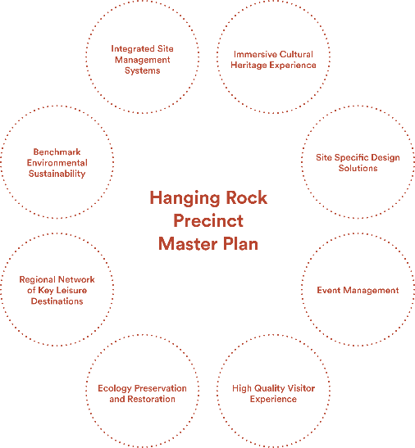
Hanging Rock Precinct Master Plan:
- Immersive Cultural Heritage Experience
- Site Specific Design Solutions
- Event Management
- High Quality Visitor Experience
- Ecology Preservation and Restoration
- Regional Network of Key Leisure Destinations
- Benchmark Environmental Sustainability
Integrated Site Management Systems
  - Guiding Principles
Principles and Guidelines provide a site-specific foundation for the Master Plan site planning and design approach.
Principles provide a high-level planning and design direction for issues of major significance.
Guidelines provide more detailed recommendations for design and decision-making processes and preferred outcomes.
This section outlines the nine guiding principles that have been used to assess and evaluate the iterative development of the Master Plan. The principles should also be used to guide the detailed design phase of works.
- Cultural Heritage as a Foundation

Overview
- Along with the iconic landscape of the site, cultural heritage is a defining site quality. Indigenous cultural heritage values and designated post-colonial contact cultural values must be conserved in accordance with ACHLCMP requirements and expressed within the site where possible.
Cultural heritage must be seen as a core site value which shapes and informs the visitors' experience of place.

Guidelines
  - Comply with all state and federal cultural and heritage legislation and regulations.
  - Work with Traditional Owners to ensure that cultural values are protected, appropriately acknowledged, interpreted and celebrated.
  - Use Indigenous culture and ways of seeing the landscape as a foundation for site use and interpretation.
  - Ensure Indigenous culture is connected to the wider region. Cultural traditions and stories will relate to many places and should be told in those places.
  - Ensure that the role of the Precinct as a place that draws people together, and as a place that has special cultural value to both Indigenous and non-Indigenous people, is recognised and maintained.
What This Means for the Master Plan
- The Master Plan consolidates and connects ecological conservation areas and protects cultural heritage assets.
The site plan provides for a new network of ‘destinations and journeys’ represented through the idea of Indigenous ‘songlines’- stories and place-markers related to Hanging Rock and its Indigenous history. These songlines are represented by pathways through the site. Hanging Rock will be seen as a place that is interpreted through story, landscape and activities.

- Environmental Sustainability and Ecological Integrity

Overview
- The Hanging Rock site must be recognised for its diverse ecological values. Those physical attributes must be optimised within the site and form an integral part of the visitor experience.
- Ecological systems must be supported by controlling direct visitor impacts and through increased connectivity and consolidation of ecological areas.
- Environmentally sensitive and responsive design principles must be applied to all projects within the site to promote the protection and enhancement of the Hanging Rock Precinct and encourage ongoing site appreciation, learning and understanding.
- The assets and infrastructure should meet the principles of the Green Council of Australia Green Star Rating, where applicable, throughout the design and development phases.
The site will be subject to an Integrated Environmental Management System that establishes the highest standards of environmental management across the site.

Guidelines
  - Comply with all state and federal environmental and cultural heritage protection legislation and regulations.
  - Translate the ecological values and protection measures identified in the Environmental Management Plan, 2021 into a framework of actions that relate specifically to the Master Plan.
  - Re-establish a connected, consolidated and expanded network of high-quality ecological areas that are specifically protected by the control of visitor activities and the design of facilities.
  - Protect the contextual connections between natural site features and Indigenous cultural heritage.
  - Construct all buildings, structures and facilities to the highest possible environmental standards, in accordance with the Green Star Rating system, reflecting their context within a major park setting.
  - Use FSC (Forestry Stewardship Council) approved timber with a clearly audited supply chain.
  - Develop an Integrated Environmental Management System for the site.
What This Means for the Master Plan
- A significant improvement in ecological values, environmental sustainability and ecological connectivity. As a result, the setting will have more robust ecological values that are more able to support viable ecological systems and respond to climate change effects.
- The site and all site facilities and activities will be subject to an Integrated Environmental Management System.
The Hanging Rock Precinct and its facilities must be seen as a benchmark in ecological and environmental design and management.

- A Special Place With Unique Values

Overview
- The Hanging Rock Precinct site is a unique landscape with distinctive physical features and cultural associations. It must be seen as a special place that supports site specific uses and activities that are intrinsically linked to the place and its environmental and cultural values. It should not be seen as, or function as a general park setting with generic recreation activities.
- The precinct is of State and National importance and should provide a unique and immersive visitor experience. The visitors’ experience must be authentic and memorable. Visitor numbers and activities should be controlled to ensure the quality of the visitor experience.
Apply a ‘visual management’ based approach to site design. The siting of infrastructure should maintain the quality of significant views within and beyond the site.

Guidelines
  - Ensure the site landscape is the ‘hero’ and remains the dominant site feature. Site planning and design must respond to the site’s unique qualities, its sense of place and its national profile. Site uses should never diminish the natural qualities of the site.
  - Place limits on user numbers. The visitor experience must always be dominated by the landscape and cultural stories. It must not be dominated by crowds, vehicles or infrastructure.
  - Design pedestrian movement to provide a range of curated ‘journeys’ through the landscape. Each journey should provide a narrative, a sense of curiosity, anticipation, exploration and cultural or ecological story to maximise the experience of the natural landscape and cultural settings.
  - Ensure the level and quality of facilities and services matches the nature and supports the visitor experience. The facilities and services model should exceed a typical municipal park standard and reflect the special nature of the site.
  - Minimise the use of built assets. Design for assets that are absolutely necessary and where they perform a specific and necessary function. Eliminate superfluous clutter in the landscape.
  - Respond to the site's potentially inhospitable weather by providing adequate shade and shelter for all seasons.
What This Means for the Master Plan
- The Master Plan retains key site uses that are intrinsically linked to the Hanging Rock site as a result of natural site features or historical patterns of use. Generic sporting uses are relocated to the wider park network to enable their further development and growth in participation.
- The site as it currently exists is an amalgamation of two separate land use areas. The new Master Plan design must seamlessly integrate both east and west and create a logical functional layout that makes best use of the whole site.
- The ability to access the Rock and the nature of that access is subject to a range of other considerations, including Traditional Owner cultural values and physical conservation of the site, but the special visual qualities associated with the Rock are universally recognised and must be an ongoing part of the visitor experience.
- Picnicking and walking are traditional activities that have been a part of the site since colonial settlement. Aboriginal seasonal gathering, camping and ceremony have been linked to the site for millennia. The Hanging Rock site has always been a place for meeting, leisure and special activities.
The unique visual identity of the Hanging Rock site and its landscape amenity have always supported special community events. The concept of ‘special events’ is a part of the site's identity.

- A Regional Network of Destinations

Overview
- Hanging Rock Precinct should be seen as part of a regional landscape with a network of special places and natural attractions.
- It should support site specific uses that are intrinsically linked to the natural qualities of the site, not provide a venue for generic leisure and sporting activities or sustain unlimited levels of site use that diminish the quality of the visitor experience.
The network should be seen in terms of both ‘destinations’; key places that provide for high level leisure and sporting activities; and ‘journeys’; road and trail touring routes that showcase the best of the region. An integrated and effective regional network of leisure destinations allows for individual sites to become the best and most place specific version of themselves and not to become overwhelmed through over-use.

Guidelines
  - Present the Hanging Rock Precinct as one of many locations within a network of landscapes and cultural places.
  - Relocate existing sporting facilities over a period of approximately five years to other nearby locations, working in partnership with affected sporting clubs to develop a transition plan enabling them to develop to their full potential.
  - Use other network venues to take peak season visitor pressure off the Hanging Rock site.
What This Means for the Master Plan
- The Hanging Rock Master Plan approach retains site specific activities within the site and designs those settings to achieve the best relationship to the site itself. Sporting facilities such as tennis and cricket are not site-specific uses. By working in partnership with these clubs to develop a transition plan, these facilities and associated infrastructure (parking, structures, fencing, signage, spectator areas) can be relocated to other places within the regional park network over approximately five years, where direct site impacts can be removed and new sporting facilities developed in places that have the capacity to provide better and higher capacity facilities and long term growth potential.
Hanging Rock must be seen as a special place for leisure activities that are linked to the site. Other destinations within the regional parks and leisure network will provide alternative venues that take the pressure off Hanging Rock to be ‘all things to all people’.

- Landscape Character and Views

Overview
- Hanging Rock is a visually striking landscape with unique geological features. Its visual character should be the starting point for a deeper exploration of Indigenous cultural stories, post-colonial stories and site ecology.
- Maintain, enhance and promote the unique and iconic landscape character by retaining the existing pattern of viewing. This will include designated views to and from The Rock and more intimate views associated with the base of The Rock and the Smokers Creek ecological reserve.

Guidelines
  - Maintain all important views and key visual settings within the site.
  - Provide new patterns of viewing and visual perspectives of the site that relate to the cultural and environmental values of the site and its unique stories.
  - Infrastructure and facilities contribute to visitors’ enjoyment of the natural and cultural qualities of the landscape, but they must not visually dominate the setting. Nature and its related cultural values must always dominate.
What This Means for the Master Plan
- A restructuring of the site and relocation of the main vehicle arrival point and visitor centre facilities allows for visitors to experience the key eastern view of the Hanging Rock formation.
- The major trail network (the Songline Trail System) connects all ecological and cultural heritage areas and allows users to experience the full range of landscapes and views that characterise the Hanging Rock site.
The intention is to draw picnicking and parking uses into a central spine, north of Smokers Creek which will allow for a connected ecological reserve system as well as a clearer pattern of access and wayfinding for first time visitors.

- Accessibility

Overview
- Vehicle access will be strategically designed to provide access to ‘hub’ locations and to provide emergency and service vehicle access, but pedestrian movement will be the primary means of experiencing the site.
The site and site facilities must, wherever possible, achieve Universal Access standards that allow for the widest range of users. Design considerations will include age, ability, ethnicity and cultural background.

Guidelines
  - Provide a high-quality network of trails and supporting infrastructure designed to support the different specific needs of walkers and cyclists. Consider the separation of different users where necessary, in order to provide a safe and intimate landscape experience.
  - Facilitate an intuitive reading of space and connections for ease of accessibility and navigation, minimising the need for signage and physical interpretation.
  - Support alternative modes of use for both daily levels of use and peak periods.
  - Consider how existing and future sustainable transport technologies, such as electric bike share systems, transporter vehicles and their functional design requirements can integrate into the precinct.
What This Means for the Master Plan
- Vehicle access is still provided to ‘hub’ locations, but the focus of the new site plan is on pedestrian movement and pedestrian-based activities.
- The major trail network (the Songline Trail System) connects all ecological and cultural heritage areas and allows users to experience the full range of landscapes and views which characterise the Hanging Rock site.
- The site is designed to maximise universal access to all major facilities, picnic and creek settings.
A formal visitor centre will provide support services, including specialist exhibitions, interpretations, toilet facilities and education / cultural interpretation services.

- Adaptability

Overview
- The Hanging Rock Precinct draws a wide range of visitors. It must function as a place for individuals, families, groups and event goers. It must be adaptable to a range of user needs, without leading to adverse impacts on the qualities that make it special.
- Indigenous culture recognises six seasons and a mosaic of changes associated with each season. The Hanging Rock Precinct should respond to seasonal variation through activities and changes in presentation. Change should be an integral part of how Hanging Rock is understood.
Site design should allow for a range of alternate site uses, but with a minimum of facilities.

Guidelines
  - Design the precinct to operate effectively in different modes of use and in different seasons.
  - Design structures, buildings and facilities with a ‘long life — loose fit’ approach to allow for flexibility in use and change over time to meet future needs.
  - Design facilities and infrastructure for potential climate change impacts.
What This Means for the Master Plan
- The Hanging Rock Precinct must meet the needs of many different visitors and many modes of use and yet it is important that the site always provides an engaging and immersive visitor experience that is not overwhelmed by infrastructure and services. The Master Plan is designed to maximise the adaptive use of spaces that are capable of operating in different modes of use and different numbers of people.
Site Management Plans will be developed to provide specific limits to user numbers and to monitor the impacts of use. The site must be sustainable physically and in terms of the quality of the visitor experience.

- Safety and Risk

Overview
Promote and ensure the principle of ‘safety first’ through every facet of the design and development of the project to ensure a safe workplace for staff and a safe environment for visitors.

Guidelines
  - Ensure primary sites are designed to control visitor access and circulation within defined boundaries to mitigate risks to both personal safety and impacts on the natural and cultural values of the landscape. Allow for the separation of people and vehicles as far as practicable.
  - Provide a consistent approach to managing visitor access and promote the need for visitors to be aware of and manage their own personal safety.
  - Utilise the natural landscape and sensitively design and integrate facilities to minimise the need for regulatory risk signage, fencing or other obtrusive measures that negatively impact on the natural experience, wherever possible.
  - Maintain a sense of ‘perceived risk’ where possible, so as not to compromise the sense of awe and drama by sanitising the experience to meet safety requirements.
What This Means for the Master Plan
The Hanging Rock site will be used by a wide range of visitors, including people of all ages and abilities. The site must also cater to non-English speaking people who may have limited or no knowledge of the site and its environment or weather. Design must anticipate and manage risk.

- Integrated Design and Management

Overview
- Each design component should reflect an integrated design and management approach that maintains the authentic and place-specific qualities of the site. This approach will be supported through site management and facilities design manuals.
- The natural landscape and environment must be paramount for the visitor experience and built elements are to be considered secondary, but supportive of the core experience.
New site planning should look to establish a more balanced arrangement of site uses across the Precinct that match activities to locations that are best able to support those activities.

Guidelines
  - Maintain unobstructed key views.
  - Strong design or architectural expression will only be considered at high profile visitor sites and only where the approach contributes to or enhances the visitor experience of engaging with the natural environment in that location.
  - Limit building and structure heights to minimise visual impacts from key viewpoints and visitor sites. Views from the Hanging Rock must be specifically considered in the siting and design of structures.
  - Design facilities at secondary or tertiary sites to be restrained in form – receding into the surrounding natural landscape. The primary purpose of these facilities is to provide the necessary conditions for visitors to access the viewing point, sites or attractions.
  - Submerge, subsume or screen ancillary infrastructure such as car parking or utilities.
What This Means for the Master Plan
- The Master Plan will establish a design framework for the site, but will not deal with all the design and management standards, day to day and event management issues that will be a part of the site. The site will require a series of management plans that control site design, maintenance and use. This suite of management plans is likely to include, but not be limited to the following:
- Ecological and environmental management and monitoring.
- Facilities design.
- Site maintenance.
- Event management and programming.
Integrated environmental management, including building systems, water management etc.

- The Master Plan
  - Master Plan Overview
The following section provides an overview of the Master Plan design, highlighting the major design drivers that shape the precinct. Detailed site descriptions and plan enlargements are provided in section 4.2.

Reconfiguration of the site to achieve a more balanced use
The Master Plan process allows for the full integration of the western and eastern parts of the Precinct. The site Master Plan moves the main entrance to Straws Lane to the east and locates the Visitor Centre and related parking east of the racetrack in a location with panoramic views of the Hanging Rock formation and abundant space for parking and visitor services. This configuration locates leisure areas and parking more evenly across the Hanging Rock site and deals more effectively with peak period visitor numbers.

Site specific leisure uses
Existing general sporting uses will be relocated to alternative offsite regional locations that will provide higher quality and capacity facilities that increase participation. The relocation process and facility development model will be subject to a separate MRSC design process. The Hanging Rock racetrack will remain in use as a part of the heritage of the site.
The relocation of sporting facilities over a transition period of approximately five years will help enable the comprehensive environmental rehabilitation of the Smokers Creek corridor; and also the relocation of picnicking and parking areas to less ecologically-sensitive locations.

A restoration of site ecological systems
Ecological systems across the Precinct will be restored and reconnected to provide the highest and most sustainable ecological and environmental values. Cultural heritage values, including Traditional Owner values will be recognised and maintained as a part of this process.

Understanding the Place through story telling
Hanging Rock is a place with many histories and cultural stories, from the formation of The Rock to the generations of Traditional Owners post-colonial settlement, and more recent community traditions and special events. The Master Plan uses a network of ‘songline’ trails to mark special places and views within the site and to tell, through story and art, the cultural significance of the place.

A new visitor centre
A new visitor centre facility will be developed in the East Paddock / eastern arrival area. This facility will provide a range of interpretation and education services, along with Traditional Owner support services, food and beverage, toilets and a multi-purpose space that could support educational activities and special exhibitions.

Multiple-purpose areas
The site plan retains a number of small, multi-purpose grassed outdoor spaces in addition to the existing major event space. The Hanging Rock site should provide for a wide range of community activities and uses, but without cluttering the site with infrastructure.
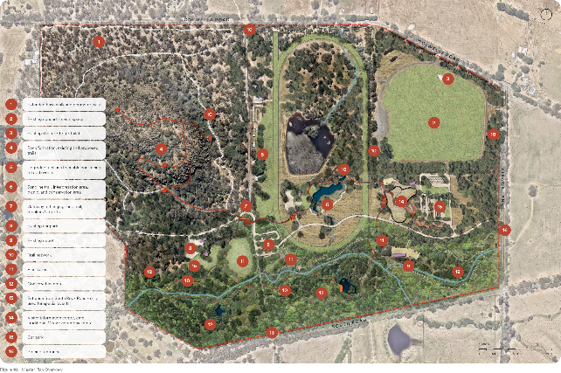
  - Master Plan Key Area Descriptions

Visitor Entrance
The visitor arrival area provides visitor support services through the visitor centre, the major parking area for cars, coaches and larger vehicles and a large woodland/grassland conservation area. The entrance road is designed to allow for key views to the Hanging Rock formation.
The existing South Rock Road access point will be maintained for temporary event access only. Ad-hoc parking within the Smokers Creek corridor is removed to allow for environmental rehabilitation works.
Refer to Figures 39–41 for the artists impressions of the Straws Lane arrival view and the view from the Summit towards Straws Lane.
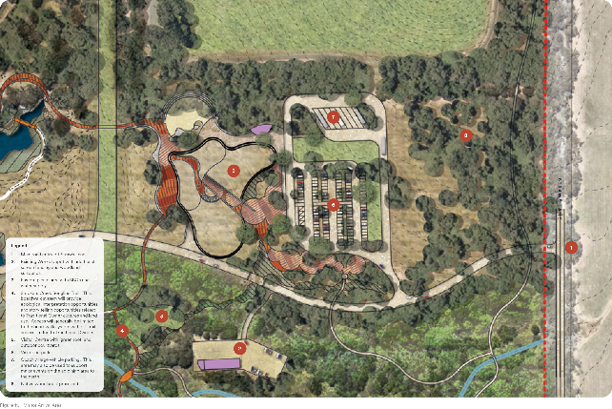

The Visitor Centre
The existing Discovery Centre and setting will be demolished and replaced with an outdoor setting focussed on site interpretations and Traditional Owner story telling. The new visitor centre will provide support facilities and services for visitors, along with specialist services related to art, education and site-specific tours.
A site specific design response is recommended for the new visitor centre. The building should be designed to sit within the landscape and sensitively respond to the natural slope of the land, existing vegetation and the key views. Images on the following pages demonstrate useful examples of how this can be achieved.
The Master Plan outlines an approximate building footprint based on high level assessment of potential uses. The internal building uses that are likely to be included are:
- A central site interpretations / exhibitions space
- Visitor information
- Café and dining area (licensed)
- Coffee/takeaway kiosk
- Kitchen
- Toilets and 'All-Abilities' change facility to suit expected levels of use
- An administration centre that includes site management and special tours
- Traditional Owner administration offices that support educational activities and Traditional Owner tours
- Multi-purpose education and function room
- Small retail outlet supporting local produce and art sales
- Utilities and storage
High level ESD systems (the facility will be an exemplar)
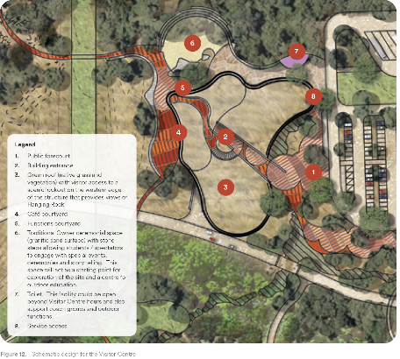
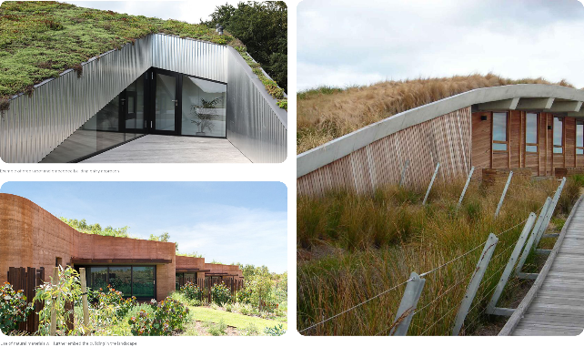
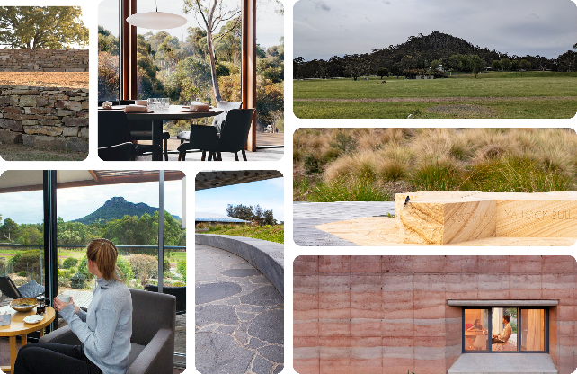
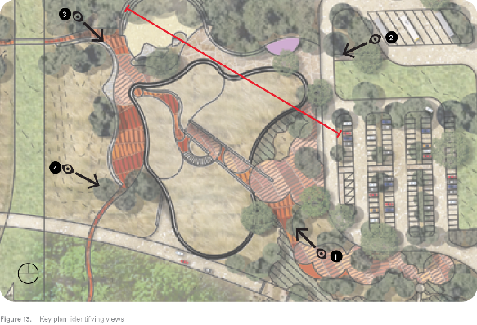
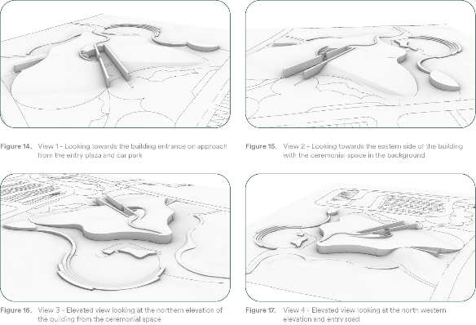
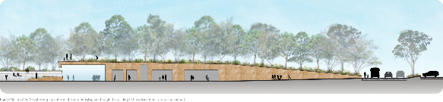

The Songline Network
‘Songlines’ refer to the traditional Aboriginal walking routes that cross the Country, linking important sites and locations. Before colonisation, these walking routes were maintained by regular use, the practice of burning off and clearing.
The term ‘Songline’ describes the features and directions of travel that were included in a song that had to be sung and memorised for the traveller to know the route to their destination. Certain Songlines were referred to as ‘Dreaming Pathways’ because of the tracks forged by Creator Spirits during the Dreaming. These special Songlines have specific ancestral stories attached to them.
Hanging Rock is a key destination for three Traditional Owner Groups – the Djaara, Taungurung and Wurundjeri Woi-wurrung people.
The Hanging Rock Songline Trail network is intended to be a representation of the songline system that tracks across the Macedon region and beyond. It is a way of telling traditional stories, representing Aboriginal language and a graphic reminder of the layers of cultural meaning that have come before and extend to the present day. The broader Victorian community also form part of the story of Hanging Rock and have a place within this story telling framework.
The pathway system will include three branches (the names may change after further consultation with Traditional Owner groups):
The Woodland Songline Trail runs through the centre of the site and connects the main arrival point and visitor centre setting with the Hanging Rock. This trail provides a major framework through which Traditional Owner values, Dreamtime stories and culture will be presented to visitors.
The Smokers Creek Songline Trail runs to the south and connects the main arrival setting with the Smokers Creek corridor and the base of Hanging Rock to the west. This songline will focus on environmental interpretation, food gathering and hunting stories.
The Hanging Rock Songline Trail connects the base interpretations and trail junction area with The Rock summit. This songline will focus on stories related to The Rock itself and to the ceremonies, special activities and meanings which are attached to this place, including contemporary values.
Note: New management requirements may potentially limit access to parts of The Rock for environmental management purposes, or limit access in certain locations to Traditional Owner escorted visits.

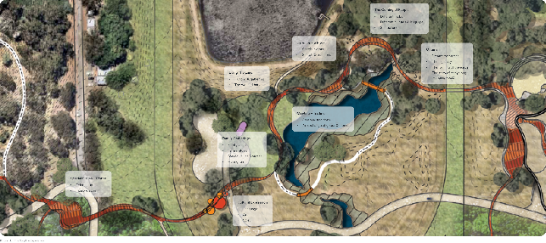

The Woodland Songline Trail and Picnic Area
This area provides a central picnic and BBQ area for visitors. The Grassy Woodland setting connects the existing woodland to the north with the Smokers Creek woodland to the south. The Songline Trail will function as a pathway between key destinations and as a major 'interpretations' route.
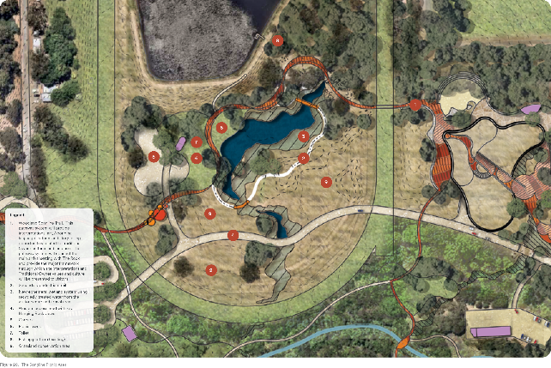

The Smokers Creek Woodland
The Smokers Creek Woodland is a dedicated conservation zone with links to the central Grassy Woodland and Hanging Rock conservation areas. The zone will be completely rehabilitated and extended from its current form. Pedestrian and vehicle access will be strictly controlled.
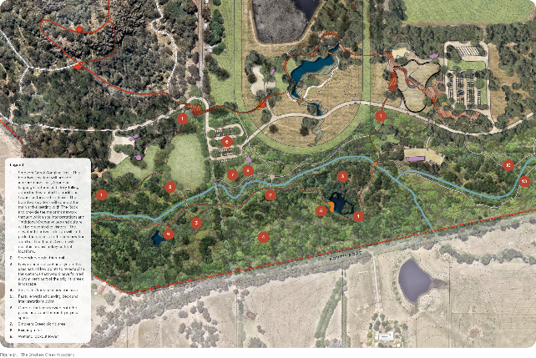

The Western Picnic Area
This area provides a western picnic and BBQ area for visitors, along with close access for both the Smokers Creek and Hanging Rock trail systems. The Songline Trail will function as a pathway between key destinations and as a major interpretations device.
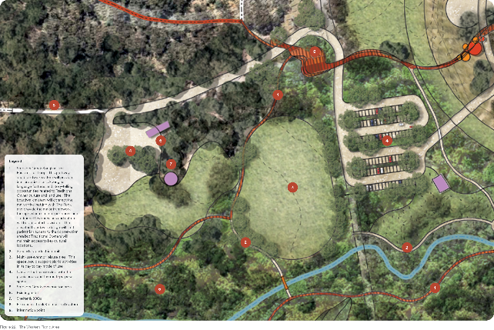

Hanging Rock
Hanging Rock with its unique geological forms, spectacular views and cultural stories is a focal point for visitors, as well as Traditional Owners, who maintain a particular cultural relationship to The Rock.
This area is substantially unchanged by the Master Plan, with the exception of additional environmental protection measures and two additional trail segments at lower levels that will allow for a summit walk, a base walk and a site perimeter walk. Providing more trail options creates additional walking options and potentially spreads people out to reduce wear on key sites.
Subject to environmental monitoring, sections of the trail system may be temporarily closed at times to allow for environmental regeneration or for Traditional Owner cultural activities.
The final location and design of these new trail sections and decisions on any seasonal or permanent trail restrictions related to cultural heritage values or environmental management will be subject to a separate detailed design process involving a range of stakeholders, including Traditional Owner groups.
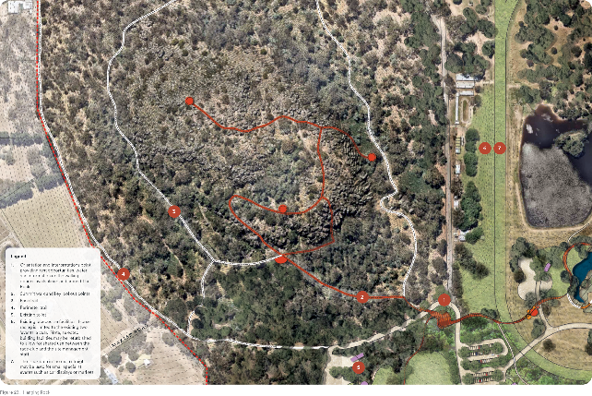

The Northern Woodland
The Northern Woodland is an existing conservation zone that will be subject to additional environmental rehabilitation works.
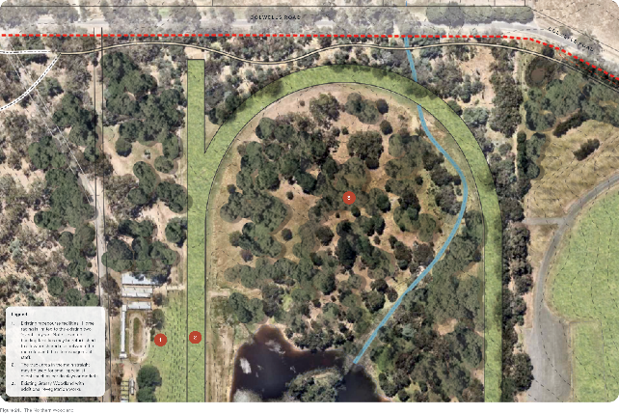

The East Paddock Event Space
Special events link the community to the Hanging Rock site and raise revenue that contributes to ongoing site maintenance and development. Major events within the East Paddock area will be limited in number and to certain times of the year. The frequency and nature of events will be determined after consideration of possible impacts on the environment, local fauna and infrastructure; will be subject to a separate management plan.
Event management will continue to require offsite transport and parking solutions. The existing southern section of the site will be dedicated to park use and will no longer be available for event support parking.
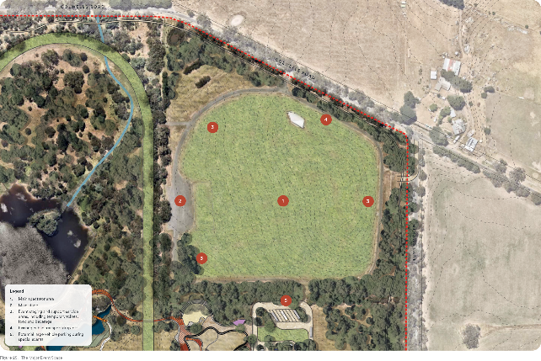
  - Master Plan Systems
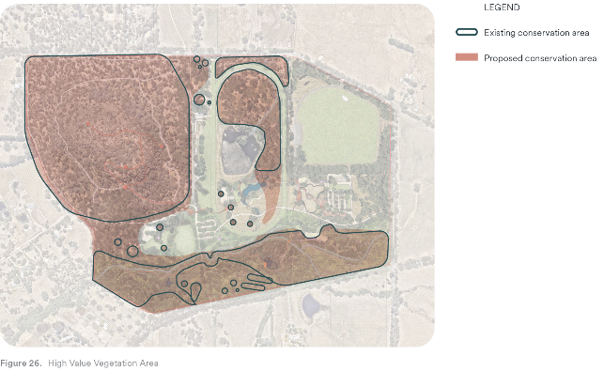

Vegetation
The existing high value vegetation within the Hanging Rock Precinct will be retained and expanded to create a connected and improved biodiversity and ecological link. This improved environment will provide additional habitat for Indigenous flora and fauna, increase the carrying capacity of the land and improve the environmental resilience in times of climate stress.
The improved environmental quality will contribute to the Cobaw Biolink that provides enhanced connections for habitat between Mount Macedon and the Cobaw Ranges.
The improved amenity will also contribute to the unique Hanging Rock landscape setting, which can be environmentally contributed to through private land ownership.
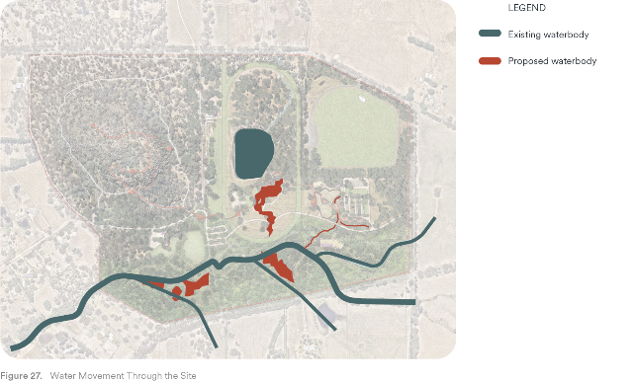

Water
The existing watercourses and patterns across the land will be retained, with improved ecological corridors increasing the resilience of the waterway flora and fauna. Remediation of the altered Smokers Creek watercourse to better facilitate seasonal inundation and amend the waterbodies created in the 19th century will allow the creek and tributaries to flow as they were originally intended.
The visitor centre will produce a significant amount of waste water from cooking, toilets and taps, in addition to rainwater captured and harvested – all of which can be re-used and recycled through the landscape. Primarily, this will feed into the ephemeral waterbody, in the centre of the racecourse. Limiting pumping water from Smokers Creek will be an aspiration of the project.
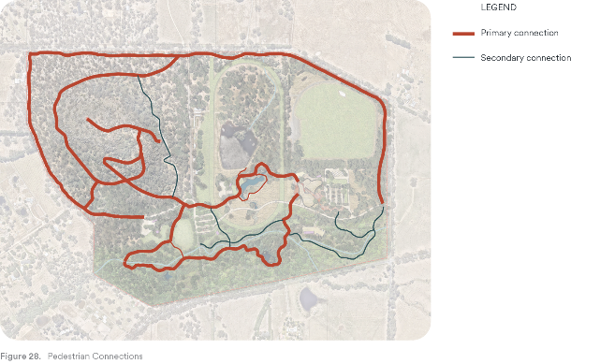

Pedestrian and Infrastructure
Pedestrian movement is the primary mode of travel through the site, in which visitors can experience all that the Hanging Rock precinct has to offer.
Pedestrian trails follow the routes of three Indigenous ‘song lines’, exploring the site whilst also exploring an interpretive story of seasonality between Smokers Creek, the central grassland and The Rocky outcrop that is the Hanging Rock formation.
Additional walking loops provide alternate route configurations and additional trails across The Rock expose different possibilities for views, experiences and interpretations of the Rock and the broader landscape in which it sits.
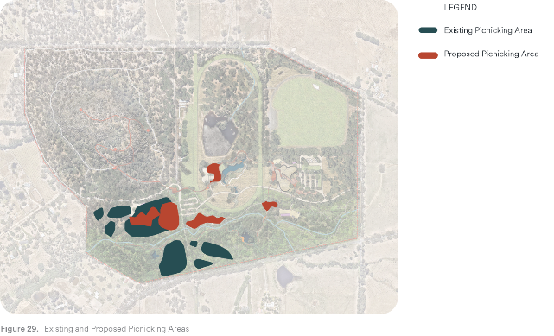

Picnicking
The opportunity to gather with friends and family and have a relaxing experience in a unique location is what makes Hanging Rock special.
Whilst the Master Plan removes some existing picnic areas for the protection of the creek conservation areas, additional areas have been located proximate to new facilities. A majority of the new picnic areas have key views to the Hanging Rock formation, providing that unique connection to place that is not evident in a majority of the current picnicking locations.
Existing areas out of the conservation corridor have been retained, and where possible, amenity upgrades may further improve the area.
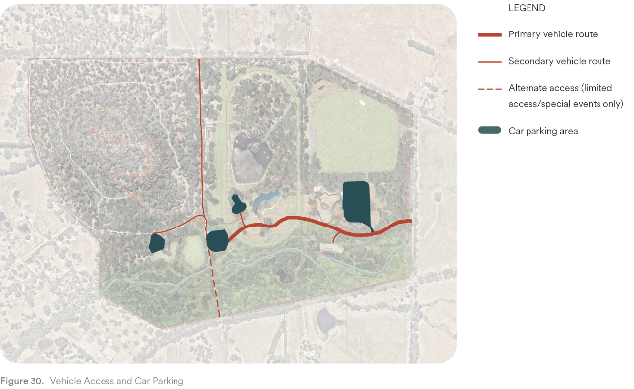

Vehicle Access and Parking
Vehicle access will change significantly through the central and eastern portion of the site. Access to the Hanging Rock Precinct will be via Straws Lane in the east, where the new road alignment will provide long views to the Hanging Rock formation, providing immediate connection to The Rock and the surrounding landscape.
The new entry road will connect users to the new Visitor Centre in the East Paddock. It will further connect vehicles to the central parkland within the racecourse and further to the west, where there are multiple parking opportunities.
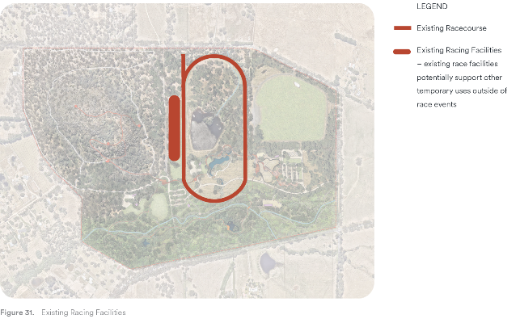

Racing
The current racing facilities will be upgraded to better reflect a space that can be used for multi-purpose events by groups other than the racing club.
The existing track will be retained, with the inner and outer railing removed for non-race times to allow better east-west pedestrian connectivity.
Whilst racing takes up a large portion of the site, the ambition is for a multi-use space that can be booked for events, or utilised day-to-day as a place for pedestrians to walk and enjoy.
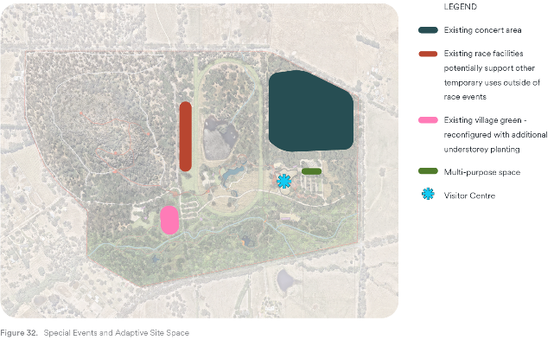

Special Event and an Adaptive Site Spaces
A number of locations at Hanging Rock are currently used for events, both large and small. The large events can be maintained in their current format, with small changes to traffic management and staging procedures.
Concerts in the East Paddock and farmers' markets on the village green will operate as they do currently. Smaller event spaces that do not require as much infrastructure can utilise the open area at the entry along Straws Lane, whilst smaller events that may benefit from shelter can utilise the visitor centre, or the upgraded racing facilities.
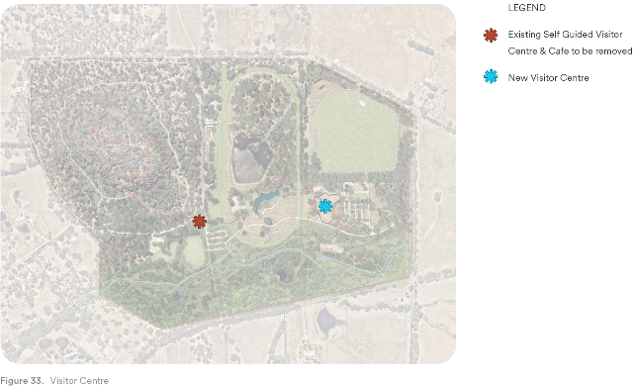

Visitor Centre
The existing visitor centre will be removed and relocated to the eastern portion of the site, allowing panoramic views of the Hanging Rock formation and its unique landscape setting.
The centre will provide a landing point for visitors to the site, providing face-to-face interaction with customer service staff and an opportunity to engage with local art displays and information on the Indigenous groups and their history. The centre will also accommodate a small multi-purpose room that can facilitate educational tours, small functions and Traditional Owner led tours.
A café will be incorporated into the building that can provide a similar level of service as is currently provided.
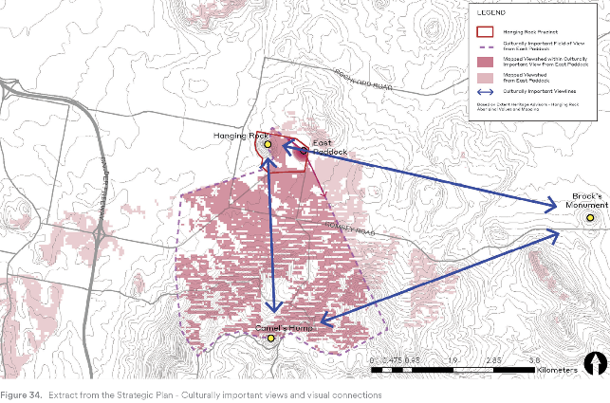

Potential Changes to Visual Character
The Hanging Rock Strategic Plan identifies key views to and from the Rock and highlights the importance of visual character as an important site quality. It is an essential and defining part of the visitor experience. Refer to Figure 34 for the key views as identified in the Strategic Plan.
Specific questions have been raised through the consultation process about the potential visual impact of site changes proposed within the Master Plan. The main areas of concern are:
- That the development of a new visitor centre in the eastern part of the site may impact views of the Hanging Rock formation from the Straws Lane area.
- That views east from the Rock to the site and the wider rural setting may be adversely affected by site developments, particularly the proposed visitor centre.
That land use changes, including the new visitor centre, may generally create an overall appearance of more ‘intensive’ development that does not suit the character of the Hanging Rock reserve.
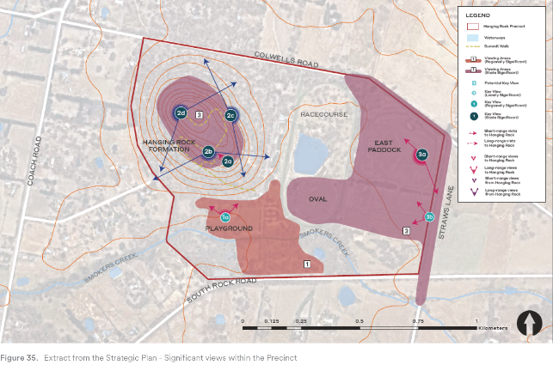

Existing Visual Character
The Master Plan approach is guided by a framework of thinking that specifically relates to landscape character and visual change:
- Visual quality and impact does not just relate to key view-points. But rather, it is generated across the whole site and experienced in different ways by different users at different times. The collective impact of change must be considered as well as individual reference points.
The existing site has a range of land uses that already present visual impacts (a visual baseline). There is an existing visitor centre and service facilities, including a network of roads and carparks in a range of locations. There are a variety of buildings, shelters, pathways, fences, picnic facilities and landscape changes that each present an image of a highly developed and intensively used site. It is a place that is often dominated by vehicles rather than people.
In peak periods of use there is frequently mass car parking on the central oval and East Paddock areas as well as market facilities in the western picnic areas. In seasonal event mode there are racing activities and major music events that dominate large parts of the site. This is a site whose functional character is based on changes in land use and visual character.

A Visual Management Approach to Site Planning
The Hanging Rock formation and its immediate landscape setting, along with the Smokers Creek environmental corridor will remain unchanged as the Master Plan is implemented. These areas are critical visual references to place, landscape and enduring cultural heritage values. Under the Master Plan, the visual impact of activities will be changed, and in some areas, be substantially reduced. In summary, expected visual changes include:
- A substantial increase in native woodland planting and more visually ‘connected’ environmental systems. The precinct will transform into a woodland with clearings rather than cleared farmland with remnant environmental areas.
- There will be no mass parking within the reserve and no parking within the Smokers Creek corridor.
Less building and development close to the base of the Rock.
Key views have been considered in relation to creating more diverse immersive experiences. These experiences include:
- Intimate bush pathways to creek environments and panoramic views of the rock formation and the surrounding regional landscape.
New and more engaging visitor arrival experience from the east which will provide a series of major views to the Rock formation and a greater understanding of the Precinct.

Testing the Master Plan design
Two major viewing points were chosen in order to test the effects of the master plan design on the landscape character and visual qualities of the site, particularly the nature and magnitude of visual changes.

The Eastern Rock Lookout
Existing View (Figure 37)
This view was selected because it best represents elevated views of the Hanging Rock/ East Paddock site and the iconic views of the surrounding regional landscape. Key aspects to note:
- Views west of the racetrack are obscured by trees.
- There are clear views of grassed areas inside the track and areas to the east, including the cricket pavilion and toilet structures. By implication, there are also clear views of parking and any other activities that occur within those areas.
- The existing eastern view shows a patterned rural landscape in an undulating terrain with a combination of windrow plantations and remnant bushland separated by paddocks with occasional farmhouses and dams. There are clear views to surrounding landforms and more distant views to rural landscapes and these are an important component of the view.
This a high-quality view that represents the best of the Woodend/Macedon region cultural landscape.
New View (Figure 38)
This view represents an established but not fully mature version of the landscape after development. Less mature vegetation would reveal more of the ground plane.
The artist’s rendering of the landscape view after master plan changes have taken effect are:
- The site has more of an overall woodland character, but with wetland features, pathways and other elements that relate to new site uses and interpretations features.
- The new visitor centre is a visually discernible but not dominant element within the landscape.
- The view beyond the site boundaries is unchanged and is still a visually dominant element within the overall view.
- This remains a high-quality view that represents the best of the Woodend / Macedon region cultural landscape. The changes that have occurred are modest in scale and do not diminish the overall character or quality of the view.
The Master Plan development eliminates mass parking from the centre of the site and the visual impact of those uses. This is a major positive effect of the Master Plan changes.
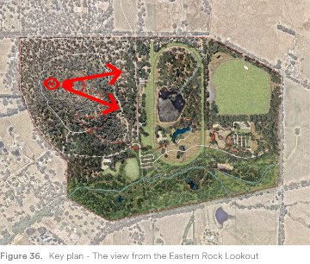
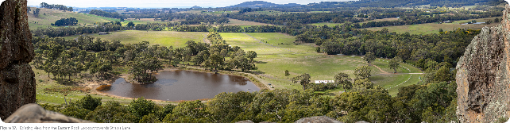
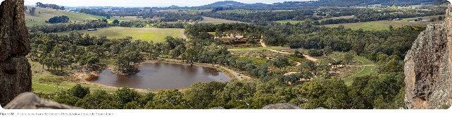

The New Site Entry
This view was selected because it represents the new site arrival experience for visitors and their first view of the Hanging Rock formation. This location is currently only accessible when the site is used for event parking and as such, does not form part of standard visitor views. Straws Lane views are available, but this area does not form part of the normal visitor movement patterns.
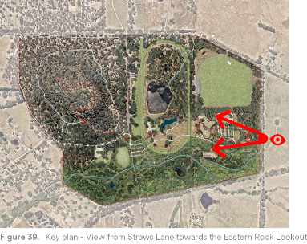
Existing View (Figure 40)
The view is taken inside the eastern site boundary. As the current land use is an open grassed paddock, the location provides clear views of the western face of the rock formation and its wooded base slopes.
Key aspects to note:
- A small part of the racetrack and minor structures, including the racetrack tower, toilet block and cricket pavilion are evident but not dominant.
- There is a continuous connection between the base of the rock and the Smokers Creek corridor.
There are no off-site views from this location.
New View (Figure 41)
This view represents an established version of the landscape after development. Less mature vegetation would reveal more of the ground plane, including the rear elevation of the Visitor Centre green roof and building entry. This remains a high-quality view that maintains the essential view to the rock. The changes that have occurred are modest in scale and do not diminish the overall character or quality of the view.
The artist’s rendering of the landscape view after Master Plan changes have taken effect are:
- The site changes from an open paddock to an open grassy woodland with a clear view of the rock formation. The intention is for this initial view to act as a point of recognition. Major extended views of the rock formation appear later in the entry experience (further to the west).
- The new visitor centre is barely visually discernible as it is designed to form part of the grassy woodland landscape.
- Sitting lower than the landscape of the viewing point, the new visitor centre carpark cannot be seen. However there is potential for some parked cars or moving vehicles to be a partially seen but not visually dominant element. These views are likely to be mitigated by further landform and landscape changes that are developed within the detailed design phase.
Site planning has eliminated mass parking from the eastern end of the site and the visual impact of those uses.

Overall Findings
The Master Plan changes existing land uses within central and south-eastern parts of the site and on that basis, changes the nature of a part of existing views, but those future uses are more compatible with the major site values than existing land uses – open paddocks with temporary effects related to mass parking.
Changes within the site are likely to be visually evident, but not dominant components of the view from all key viewpoints. Environmental systems (ecological and wetland systems) will become more dominant and visually connected elements. They will create a visual framework within which other uses will develop. Cars and parking will become less intrusive and pedestrian movement more dominant within the site, with a more complex pattern of pathways and activity areas.
Overall, the precinct is likely to become a clearer and more visually coherent version of itself than what it currently is – part park and part paddock and event space.
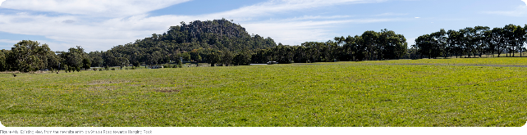
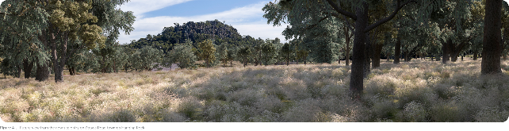
- Delivering the Master Plan
  - Consultation Strategy Summary

Consultation Strategy Summary
The draft Master Plan was developed over the past 12 months in close collaboration with DELWP, the three Traditional Owner groups, and multiple community groups and local and state government representative stakeholders. The draft Hanging Rock Precinct Master Plan takes direction from the Strategic Plan (2018) and builds on the recommendations of the updated 2015 Environmental Management Plan (endorsed 2021) and the Aboriginal Cultural Heritage Landscape Conservation Management Plan (endorsed 2021).
Given the extensive body of work that has informed the Master Plan, the project team prioritised ongoing engagement with the three Traditional Owner groups, community representatives, multiple stakeholders, and past consultants, throughout the development of the Master Plan, building on the extensive body of evidence that has been developed to date to resolve future site uses.
Broadly there was support for the draft Master Plan, however it was clear from some feedback received that certain aspects of the plan require further details and clarity. The following list outlines the key themes and how the final Master Plan responds:
- Different interpretations on the Strategic Plan intentions – refer to Section 1.3
- General perceptions around the size of the precinct and the current and future level of activities – refer to diagrams in Section 4.3
- Misunderstanding around the level and type of development proposed – refer to Sections 4.1 and 4.2.
Concern around rate of visitor growth and potential resulting impacts – refer to Section 2.3.

The Purpose of the Engagement
The key objective of the Hanging Rock Precinct Master Plan is around preservation of the place and the long-term recognition of the Precinct’s significant cultural heritage, biodiversity, and tourism values. To successfully achieve this objective, it was critical to reach shared agreement around the medium to long term activities to be supported within the Precinct.
The Strategic Plan, Environmental Management Plan (EMP) and the Aboriginal Cultural Heritage Landscape Conservation Management Plan (ACHLCMP) identified the cultural and environmental values as the key values to be protected. Noting the ACHLCMP was not made publicly available due to the sensitive nature of the information.
In some cases, the identified values are conflicting, so one of the key roles of the Master Plan is to resolve these conflicts, including negotiating:
- Long term use of the Precinct as a local sporting venue (for cricket, tennis and pétanque) versus the state and national significance of the site.
- Visitor access to the top of Hanging Rock versus the impact that increased visitation may have on the cultural heritage and environmental values.
- Legacy recreational areas versus the opportunity to re-vegetate and reinstate ecological corridors.
- The approach was to facilitate active engagement throughout the master planning process to ensure the plan:
- Acknowledges the elements in the precinct that are valued.
Addresses the specific needs of affected stakeholders, and represents a balance of stakeholder interests across the precinct.

Engagement Framework
Engagement with Traditional Owners, stakeholders and community representatives was undertaken to inform each stage of the development of the Master Plan. The purpose of the engagement was to:
- Involve Traditional Owners and all key stakeholders in the development of the Master Plan to ensure that a wide range of aspirations, opportunities and constraints are understood and considered. The project team have worked directly with the Traditional Owner groups, community representatives and key state and local government stakeholders, keeping them informed as the Master Plan was developed. All feedback has been considered and used to inform the development of the Master Plan design and implementation and, in some cases, the brief for the Management Plan.
- Inform the public about the principles, objectives and details of the Master Plan and invite broad feedback. All feedback received from the public was reviewed and considered by the project team.
A summary of the key messages heard through the public exhibition and how the ideas and concerns have been addressed, is included in this chapter.
The following key stakeholders were consulted as part of the development of the Master Plan:
Traditional Owner Groups
The Wurundjeri Woi-wurrung Cultural Heritage Aboriginal Corporation (WWWCHAC), Dja Dja Wurrung Clans Aboriginal Corporation (DDWCAC) and Taungurung Land and Water Council (TLaWC) Traditional Owners have continued their involvement as key partners in the development of the precinct. Each group has been actively involved in an iterative design development process, and the testing of potential future scenarios. The project team have worked closely with each group as the Traditional Custodians of the Land to embed intrinsic cultural and place values into the Master Plan. Representatives from each Traditional Owner group sit on the Ministerial Advisory Group.
Macedon Ranges Shire Council (MRSC)
The project team have engaged with MRSC officers including representatives from the following teams: Sport and Recreation, Planning and Environment, Economic Development and Hanging Rock Operations, along with the MRSC Executive team and Councillors. Consultation with MRSC was facilitated through multiple team workshops, site visits and on-site meetings with the park rangers. MRSC was kept informed on the project progress and officers provided information and expertise around how the precinct functions and the operational and management needs. MRSC were also involved in discussing the long-term future of local sports clubs.
MRSC Executive is also represented on the Project Control Board, and the CEO holds an ex-officio position on the Ministerial Advisory Group.
Sports Clubs
The project team met with representatives from each of the three sporting clubs currently located within the precinct:
- The Hanging Rock Cricket Club,
- The Hanging Rock Tennis Club and,
The Woodend Hanging Rock Pétanque Club.
Conversations focused on understanding each of the club’s long-term aspirations, facility upgrades and their connection to the broader Hanging Rock region. The Master Plan does not provide facilities for the sporting clubs in their current capacity over the longer term, however the clubs collectively expressed their preference for remaining within the precinct. Given that the provision and management of sporting facilities, along with supporting clubs is carried out by local government, relocation scenarios for the three sporting clubs are being investigated by the MRSC with support from DELWP.
Project Control Board (PCB)
The PCB was established to ensure relevant state government bodies had executive level oversight of the project. In their advisory role, the PCB provided strategic review and advice throughout the Master Plan development. The PCB representatives:
- Regional Director Loddon Mallee DELWP,
- Executive Director Planning Implementation and Heritage,
- Executive Director Land Management Policy,
- Director First Peoples Self Determination,
- Regional Director Western Region Parks Victoria,
- Regional Director Loddon Mallee RDV,
- CEO Macedon Ranges Shire Council, and
Director Planning and Environment MRSC.
Ministerial Advisory Group (MAG)
The MAG was established to ensure that Traditional Owners and community interests are considered in decision-making process. The role of the MAG is to provide advice on future governance, management and development of the Hanging Rock Precinct and endorsement recommendations to the Minister for Environment.
The MAG is made up of representatives from:
- Each of the Traditional Owner groups,
- Three community representatives,
- CEO of MRSC,
- DELWP Loddon Mallee Regional Director, and the
DELWP Hanging Rock Senior Project Manager.
  - Summary of Engagement Activities and Outcomes

Stage 1 Engagement Summary
Purpose of Engagement
Engagement with the Traditional Owner groups was sought from project commencement in July 2021. In the preliminary stage of the project conversations with each Traditional Owner group focused on:
- Understanding if the proposed master planning approach would enable ongoing Traditional Owner input.
Seeking advice from the groups around the guiding principles developed in response to the objectives and recommendations of the Hanging Rock Environmental Management Plan (EMP) and the draft Hanging Rock Aboriginal Cultural Heritage Landscape Conservation Management Plan (ACHLCMP).
Engagement Outcomes
- Early conversations with the Traditional Owners established a collaborative working relationship from the project outset which resulted in the project team gaining invaluable cultural insights and understandings in relation to the Hanging Rock site.
- Key insights included an understanding of the importance of the Precinct as a place for gathering and insights into the significance of natural elements and their representation through storytelling.
The groups discussed a range of visitor experiences the Precinct offers, and suggested that some, particularly major events, provide the opportunity through increased Traditional Owner participation, for the community to experience cultural ceremonies.

Stage 2 Engagement Summary
Purpose of Engagement
The second stage in the project involved developing a set of guiding design principles as a decision-making framework. The principles build on the values and aspirations outlined in the foundational work undertaken to date. Investigations were undertaken to explore how the relevant ACHLCMP and EMP recommendations could be applied across the Precinct with consideration of best practice site planning principles.
At this stage the purpose of engagement was to:
Test and refine the guiding design principles with the key stakeholders to ensure a holistic set of evaluation criteria.
Engagement Outcomes
The feedback received on the draft principles included:
- Ensure that sustainability and climate change considerations can be meaningfully evaluated, with consideration of aspects including the importance of water.
Embed intangible cultural experiences such as storytelling and the importance of gathering.

Stage 3 Engagement Summary
Purpose of Engagement
Stage three focused on developing scenarios that explored possible design approaches across a spectrum of change to the precinct. Ultimately a range of high level scenarios were developed that achieved the agreed principles to different extents through a range of site planning responses. In summary, the scenarios explored a range of considerations across a spectrum of change, from minimal to a maximum level of intervention.
The minimal change scenario focused on allowing existing activity in the western area of the precinct to remain. The key moves supporting a light touch approach included:
- Maintaining the existing South Rock Road main entry road.
- Leisure activities remaining around the arrival carpark precinct.
- Changes to the arrangement of picnic and parking areas located in the Smokers Creek conservation area
Relocating sport facilities off-site.
The high change scenario aimed to reconfigure site infrastructure to achieve a balance of uses across the Precinct to deal more effectively with increasing visitor numbers and support enhanced environmental values. The intent of the revised site configuration was to create an even distribution of activities and supporting infrastructure across the Precinct.
The key interventions supporting this scenario include:
- Shifting the main site access point from South Rock Road to Smokers Creek to improve the arrival experience.
Relocating the Visitor Discovery Centre from its current position below the Rock, to East Paddock that presents panoramic views of the Hanging Rock formation.
At this stage of the project multiple workshops were facilitated with the Traditional Owners, PCB and MAG groups. The purpose of the workshops was to test scenario feasibility and determine the preferred option for refinement. The guiding design principles were used as the assessment criteria to evaluate the design scenarios and assisted in negotiating conflicting future land uses.
Meetings with MRSC and local sports groups were facilitated during the drafting of the Master Plan. The purpose of this engagement was to discuss the sports clubs’ long-term aspirations and plans. The clubs were advised on the timing of the release of the draft Master Plan and encouraged to provide a formal submission to outline their plans and feedback to DELWP.
Engagement Outcomes
The outcomes of the workshops with the PCB and MAG included:
- Collective agreement on the advantages and disadvantages of each scenario.
- Direction on specific areas where further clarity would be beneficial.
Ultimately the PCB and MAG agreed that the preferred solution should be based on a balance of uses across the site

Stage 4 Engagement Summary
Purpose of Engagement
Stage four focused on the development and refinement of the draft Master Plan with stakeholder input. Stakeholder input was sought prior to the draft Master Plan going on public exhibition. Feedback from the workshops assisting with refinement of the draft plan and report. Support was given for the refined document to be publicly released. Planned engagement activities were outlined to the stakeholders and approved.
Meetings with MRSC and local sports groups were facilitated prior to the draft Master Plan being released.
The draft Master Plan was released on the Engage Vic website for public comment on the 24th of December. The exhibition period ran until the 28th of February. A combined social and traditional media campaign was undertaken to raise awareness in the community around the release of the draft plan and encourage participation at the upcoming consultation activities.
Recognising the holiday period, multiple engagement forums were planned throughout January and February.
The community had the opportunity to seek further information and provide their feedback at the following activities:
- A pop-up event at the Australia Day Races at Hanging Rock in January.
- A pop-up stand at the Woodend Farmers' Market in early February.
Two open house drop-in sessions at the Woodend Library held over two weeks at the end of February.
Round table discussions were facilitated with a number of local community and interest groups, complementing the community engagement activities.
All involved parties were encouraged to provide formal submissions and feedback to DELWP via the Engage Victoria website or via email/letter. More than 1300 feedback comments were received during the public exhibition period, including thirty-six formal submissions. Key messages heard through conversations and submissions have been summarised below according to theme, along with an outline of how the feedback has influenced the finalisation of the Master Plan.
Engagement Outcomes
There was broad support for the draft Master Plan, however it was clear from some feedback that certain aspects of the plan required further clarity and refinement. The key messages heard are organised below. Overarching themes are highlighted first, followed by a stage-by-stage summary of the feedback provided.
Overarching Themes | Response
Role of the Strategic Plan | The 2018 Strategic Plan outlined the key objectives for the future Precinct. As such it is the foundation for the Master Plan. The specific objectives that are addressed within the scope of the Master Plan are outlined in Section 2.1.2 – The Strategic Plan
Role of the Master Plan | The Strategic Plan outlines the role of the Master Plan as “Implementing a detailed plan that ensures the long-term development and management of Hanging Rock is sustainable”. As such, the Master Plan establishes a design framework for the Precinct.  The Master Plan does not address design and management standards, or day to day and event management or operational issues.  Subsequent stages of work will include the detailed design and the development of a series of management plans that control site design, maintenance, and use. This suite of management plans is likely to include, but not be limited to the following:  - Cultural Heritage, ecological and environmental management and monitoring.  - Facilities and site/Operational management and maintenance.  - Event management and programming, including traffic management  - Integrated environmental management, including building systems, water management etc.  Further details on what the plan does and doesn’t address is outlined in Section 1.3 – The Role of the Master Plan
Precinct capacity to accommodate the level of proposed development | The core site values are cultural heritage, ecological integrity, and visitor experience. Site planning seeks to create a place that is interpreted through story, landscape, and activities. As a result, facilities and infrastructure are planned to be located in the most optimum areas to allow for the protection and enhancement of cultural heritage assets and conservation areas and connection of ecological corridors.  Sections 4.1 and 4.2 outlines how the precinct can accommodate future activities without comprising environmental and cultural values. Before and after floor area comparison diagrams for the existing and proposed visitor centre and existing and proposed car parking areas are included. Noting that the revised design has reduced the building and car park footprints in size and refined in shape.
Impact on increased visitation | Visitation management is beyond the scope of the Master Plan. It is recommended that future management plan(s) consider monitoring systems to enable ongoing evaluation of any impacts on visitor experience, as well as impacts on environmental and cultural heritage values.
Impact on views | The visual quality of the precinct contributes to the visitor experience, therefore views throughout the precinct have been considered when making changes to the site layout. The revised design establishes a pattern of viewing by creating a sequence of curated viewing experiences for visitors.  Section 4.3 includes:  - A plan highlighting the key views in the precinct.  - Details on the viewing sequence throughout the Precinct.  - Artist’s impressions demonstrating the level of change visible on the key view line between the Rock summit and the Straws Lane entrance.
East Paddock Ownership | Long standing negotiations around the tenure of East Paddock have led to some confusion and frustration in the community. It is recognised that the community tend to associate MRSC ownership of East Paddock with resulting in no change to current land use and state government ownership with maximum change and potential commercial activity. This perception was compounded by the graphic representation of the events area in the draft Master Plan. Highlighting the staging areas was understood by some to indicate development in East Paddock and the provision of permanent event infrastructure.  This is not the case. The event area will remain operating as it currently does. There are no plans to extend or develop the area used for events. The Master Plan has been updated confirming this.

Theme 1 — Environmental Sustainability and Ecological Integrity
There was broad support for increased emphasis on environmental values and the proposed supporting interventions, including the rehabilitation of Smokers Creek, connection to bio-links and the expansion and linking of the conservation areas.
More specific feedback is listed below.
Design Related Comments | Response
Concern the proposed Visitor Discovery Centre and vehicle parking areas will impact important view lines | - Inclusion of artist’s impressions that demonstrate the level of anticipated change that is likely to occur on the key view between the rock summit view and the new entrance on Straws Lane.  - Inclusion of a plan identifying the important view lines to and from the Rock to reinforce their significance.

General Comments
The following comments received are out of the scope of this Master Plan however will be considered as part of the subsequent project stages, specifically the development of a management/operational plans:
- Outline a vision for how the Precinct will be managed, funded and specific operational considerations.
- Address potential impacts on local fauna.
Confirmation of maximum visitor capacity numbers to limit environmental impacts.

Theme 2 — Cultural Heritage as a Foundation
There was general agreement with cultural heritage as the primary rationale and foundational principle for the precinct, and widespread support for the protection of Aboriginal cultural heritage values.
Common suggestions included increased cultural heritage educational and engagement opportunities such as on-site guided tours, workshops, and inclusion of Traditional Owner participation in events.
Design Related Comments | Response
No specific design related comments

General Comments
The following comments received are out of the scope of this Master Plan however it is recommended that they be considered as part of subsequent projects addressing detailed design, governance, and management/operational plans:
- Recognise the precinct as a starting point for an Indigenous tourism experience in the Macedon region.
- Revert to the Traditional Owner name (in consultation with the Traditional Owner Groups)
Enable Traditional Owner management of access to the Rock

Theme 3 — Leisure, Tourism and Recreation
There was general support from regional business and tourism associations for the plan, however some concerns around potential impacts of increased visitation on the Precinct.
Design Related Comments | Response
No specific design related comments

General Comments
The following comments received are out of the scope of this Master Plan however it is recommended that they be considered as part of subsequent projects addressing detailed design, governance, and management/operational plans:
- Provision of accommodation options in the wider region.
- Recognising tour operators as key stakeholders.
Advocacy and support for increased transport options from key local destinations to the precinct.

Theme 4 — Major Events
Generally, there was concern around what was perceived to be proposed by the Master Plan. The increased intensity of use, particularly related to commercial development in the events area, and the new visitor centre, was raised by both stakeholders and the community.
We also heard some concerns around the Master Plan prioritising the long-term future of horse racing at the Precinct, over local sports.
Design Related Comments | Response
Concerns around potential future development of the events area in East Paddock. | The graphic representation of the events area in the draft Master Plan has been refined to provide confirmation that there is no intention to increase the event/commercial capacity of this land.
Concern the Songline Trail network and removal of fences may not be compatible with operational and safety requirements. | Removing the barrier created by the racecourse fencing is critical to enabling visitors to start their visitor experience from arrival at Staws Lane and be immersed in the cultural and environmental experience.  There are multiple examples of racing tracks with access points. The most appropriate path treatment will be determined through the detailed design phase of works.  Kangaroo management strategies are to be resolved by future management plan(s).

General Comments
Racing is seen as a major event because it’s a twice-yearly special event. There was support from the Kyneton and Hanging Rock Racing Club for the core values and principles, and for the consolidation of Crown land, racecourse area and the Eastern paddock into a single land holding. However, the club has specific design related concerns.
The following comments received are out of the scope of this Master Plan however it is recommended that they be considered as part of subsequent projects addressing detailed design, governance, and management/operational plans:
- The Master Plan does not reflect the history and tradition of racing at the Reserve.
Ongoing support for racing events and improvements to racing infrastructure to meet the club’s operational and safety requirements.

Theme 5 — Local Sport
A range of opinions were voiced regarding the long-term future of local sports within the Precinct. Opinions varied from support for the transition of local sport to an alternative location, to strong opposition for its removal.
The overwhelming focus on this aspect of the Master Plan was the removal of the Hanging Rock Cricket Club from its current location. However, it should also be recognised that tennis and pétanque are played on site and would also prefer to remain so over the longer term.
Cricket Club Related Comments | Response
Suggestion that the clubs can be accommodated on site whilst still achieving cultural and environmental objectives. | Hanging Rock is a small site with very limited access and range. The Master Plan recognises the increase in visitor numbers, and with the increased visitor demand, there will be more competition for how the various spaces within the reserve should be used. Some uses are intrinsically associated with the Rock and some are not. As the Precinct becomes busier, those uses that do not need the Rock should move elsewhere. The pressure of continual growth in visitation will result in the increased demand for space to facilitate a range of activities. Site specific activities will be prioritised.
Suggestion that cricket be relocated to the East Paddock events area. | High level design investigations were undertaken to determine the feasibility of a multi-use events area with inclusion of a cricket oval. It was determined to have an overwhelmingly negative effect on the functionality and visitor appeal of the events setting based on:  - The East Paddock landscape has Traditional Owner cultural heritage values that would be lost through major ground disturbance.  - The event space is changed from a semi natural rural setting that has a specific visual relationship to Hanging Rock Reserve and the rock formation, to a constructed and unnatural form that will look out of place within this setting.  - The lower elevation areas (the oval) will not allow spectator views of the Hanging Rock formation and change the visual relationship between spectators and the stage.  - The shared use of the site would not allow for night lighting of the oval if this was a consideration (pole locations).  - Events and cricket will occupy the same summer period.  - Construction costs are likely to be very high.

General Comments | Response
The Hanging Rock Cricket Club mounted a case for their continued presence on site based on:  - The perception that the Strategic Plan supports cricket on site “the heritage and historical associations of long-established activities (i.e., Over 100 years) are supported.”  - The Club’s history of activity at Hanging Rock since the mid-1800s.  - Concern that visitors/commercial development (events) are being prioritised over the local community.  - Concern around loss of identity if sports clubs are relocated.  - Concern that volunteers who have historically contributed to the club will feel undervalued.  - Prioritisation of support for horse racing on site which does not support the local community. | The Master Plan supports the transition of local sports to alternative locations within the region because:  - The role of the Master Plan is to implement the directions for the Precinct as established in the Strategic Plan. The Strategic Plan outlines the aspiration for sports activities to transition off site in the medium to long term.  - The agreed core site values are cultural heritage, ecological integrity, and visitor experience. Site planning seeks to create a place that is interpreted through story, landscape, and activities. As a result, facilities and infrastructure are planned to be in the most optimum areas to allow for the protection of cultural heritage assets and conservation areas, connection of ecological corridors and improved visitor experience.  For these reasons it is recommended that relocation of the three sports clubs that are currently located on site is supported as part of the implementation of this Master Plan. Preference should be given to a relocation scenario that involves acquisition of land located within close proximity to the Hanging Rock Precinct.

Theme 6 — Access and Movement
Access to the Precinct and movement within the Precinct were highlighted as concerns. Traffic congestion and safety were suggested as potential impacts of increased visitation on the area, with some local residents highlighting specific traffic management issues.
The focus on private vehicle access to the Precinct was raised, with suggestions around the need to advocate for alternative access options/modes of transport to be considered.
Internal movements, specifically the provision and location of new walking trails were commented on. Opinions ranged from support for the inclusion of new walking trails within the Precinct to concerns around increased visitor numbers and potential environmental impact.
Design Related Comments | Response
Concern relocating the main Precinct access from South Rock Road to Straws Lane could affect traffic flows | Recommendation that as part of the detailed design stage of works, local access movement plans are undertaken in conjunction with Council
Opportunities for pedestrian and cycling connections to local destinations, particularly via the proposed Daylesford Macedon Ranges Rail Trail are not clear | Development of an Active Transport plan to complement the Master Plan will highlight connections to the surrounding walking and cycling networks
Proposed walking trail alignments will impact on undisturbed conservation areas | Walking trail alignments have been adjusted however it should be recognised the high-level nature of the Master Plan. Trail alignments are indicative as they have been determined by desktop analysis and site visits.  At the detailed design phase, a review of proposed trail alignments is recommended based on a feature and level survey and review through the EMP.

General Comments
The following comments received are out of the scope of this Master Plan however it is recommended that they be considered as part of subsequent projects addressing detailed design, governance, and management/operational plans:
- Concern around management of parking on busy days and during major events as visitation increases.
- Suggestions around the need for increased transport options to be provided between local town centres and the precinct.
Concern that existing road conditions are not suitable for increased traffic volumes.
  - Delivering the Master Plan

Additional Works
The Master Plan is intended to establish an overall land use and design framework for the Hanging Rock site, based on the principles, values and directions established within the Hanging Rock Strategic Plan. Additional phases of work will be required in order to implement the Master Plan. These works will include, but not be limited to the following:
Detailed design plans dealing with key design systems such as:
- Visitor centre design and performance
- Utilities and infrastructure services
- Trail and boardwalk alignments and design standards
- Park infrastructure design standards and level of service
Site interpretations systems
Management Plans dealing with systems such as:
- Ecological and environmental rehabilitation
- Cultural Heritage management
- Visitor capacity limitations across the site
- Monitoring and management of visitor impacts
- Specialist tours and on-site tourism services
- Construction management requirements
- Operational responsibilities and capacity building
Event and special use management
Additional work and decision making related to:
- The venue(s) for relocated sports facilities
- The design of new sports facilities
Upgrades to regional parks that may form part of a wider network of premium leisure destinations

Construction Stages
The Hanging Rock Precinct Master Plan aims to commence the delivery of the 50-year vision set out in the Hanging Rock Strategic Plan. Whilst the vision is for an extended duration, the lifespan of this Master Plan is approximately 20 years. This timeframe allows for the outcomes in the Master Plan to be implemented.
Throughout this 20-year period, a review of the Master Plan should occur every five years, to allow for updates in technology, planning policy and a revised implementation schedule based on works that have been completed. These reviews may also consider how changes to the tourism sector, local community expectations, new technology and future visitor experience expectations, may influence the Master Plan and there will be opportunity to update some aspects of the plan in that regard.
This long term approach to site planning and management allows for the vision to set the aspirations for the Master Plan, whilst allowing practical updates to the plan that ensure it is relevant and up to date.
Implementing a project of this scale and complexity cannot happen all at once. Selective projects will need to be chosen to enable the park to function whilst construction works are undertaken to implement elements of the plan.
The construction related stages could possibly be broken down to include:
Stage 1
- Work in partnership with the affected sporting clubs to develop a transition plan, enabling the sporting facilities to be relocated over a period of approximately five years
- Civil infrastructure and servicing to East Paddock
- New entry road and car park construction
- Visitor Centre and surrounding landscape construction works
Smokers Creek and tributary re-vegetation work
Stage 2
- Central park construction (inside racecourse)
- Removal of picnic area south of Smokers Creek
- Re-vegetation work along Smokers Creek and the western boundary of the precinct
- New trails across the precinct
Civil construction work to re-define western car parking areas
Stage 3
- New trails and upgrades on the Hanging Rock formation
New shelters/facilities in a common palette

Next Steps
Once funded, the Victorian Government will work with Traditional Owners, Macedon Ranges Shire Council, interest groups and the local community to begin implementing the Master Plan.
To implement the Master Plan the next stage will be the detailed design, followed by undertaking the necessary permits and approvals process in order to begin works. Alongside the detailed design stage, a series of management documents will be developed to address a range of operational and site management concerns for the Precinct.
We acknowledge and respect Victorian Traditional Owners as the original custodians of Victoria’s land and waters, their unique ability to care for Country and deep spiritual connection to it.
We honour Elders past and present whose knowledge and wisdom has ensured the continuation of culture and traditional practices.
DEECA is committed to genuinely partnering with Victorian Traditional Owners and Victoria’s Aboriginal community to progress their aspirations.
© The State of Victoria Department of Energy, Environment and Climate Action August 2023
Creative Commons
This work is licensed under a Creative Commons Attribution 4.0 International licence, visit the Creative Commons website (http://creativecommons.org/licenses/by/4.0/).
You are free to re-use the work under that licence, on the condition that you credit the State of Victoria as author. The licence does not apply to any images, photographs or branding, including the Victorian Coat of Arms, and the Victorian Government and Department logos.
ISBN 978-1-76136-399-3 (Print)
ISBN 978-1-76136-400-6 (pdf/online/MS word)
Disclaimer
This publication may be of assistance to you but the State of Victoria and its employees do not guarantee that the publication is without flaw of any kind or is wholly appropriate for your particular purposes and therefore disclaims all liability for any error, loss or other consequence which may arise from you relying on any information in this publication.
Accessibility
To receive this document in an alternative format, phone the Customer Service Centre on 136 186, email Customer Service, or contact National Relay Service on 133 677. Available at DEECA website.
Prepared by Tract
Level 6, 6 Riverside Quay,
Southbank VIC 3006
(03) 9429 6133.
Tract website

