Who is the Land Manager of Lake Tyrrell?
The land managers of the Crown land are the Department of Environment Land Water and Planning (DELWP) and Parks Victoria. One of DELWPs roles is to issue leases and licences to groups and organisations for particular types of use and access on certain sections of the Crown land. Both Buloke Shire Council and Swan Hill Rural City Council are the relevant local government agencies with responsibilities for management of public land including roads and road reserves and infrastructure. Other agencies have responsibilities for management of assets on land including water, infrastructure and environment (for example, Mallee Catchment Management Authority, Grampians Wimmera Mallee Rural Water Corporation).

What area does the Direl (Lake Tyrrell) Conservation Management Plan cover?
Map: Direl (VAHR 7427-0187) location and extent
(Dr Vincent Clarke & Assoc., Direl (Lake Tyrrell) Cultural Landscape Conservation Management Plan, 2021)
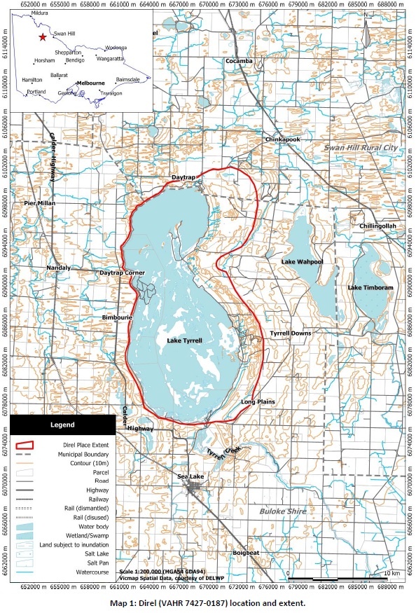

What is a Conservation Management Plan?
A Conservation Management Plan (CMP) is the principal guiding document for the conservation and management of a heritage place. It is a tool that provides a strategy through which conservation policies will be put into action, allowing owners, managers and approval authorities to make sound decisions about managing and protecting heritage places.
A CMP identifies the heritage values of a place to provide an understanding of the significance of a heritage place and define the actions needed to protect that place. When used to assess Aboriginal Cultural Heritage it can include many types of places – land, water, natural features, objects, buildings, and structures - associated with Aboriginal occupation, history, culture and peoples.

What will a Conservation Management Plan do at Direl (Lake Tyrrell)?
The Direl (Lake Tyrrell) CMP will help decide the best way to manage activities at the Lake into the future. The CMP assessment work carried out identified heritage values, existing and potential impacts to natural and cultural values and the cultural heritage significance of the Lake.
The CMP provides conservation policies to protect the Lake’s significant values and strategies to put those policies into action. It will be used by land managers and local government to decide on appropriate management and protection measures, and to determine what future activities and uses should be allowed at Direl (Lake Tyrrell).

What impact will the Conservation Management Plan have on adjoining/nearby landholders?
The CMP will be used by land managers and local government but will also contain guidance for both private landowners and occupiers along with public land licence and lease holders when planning to undertake activities on land at Direl (Lake Tyrrell).
The CMP will also provide information to landholders and users about management and protection of Aboriginal places and objects that are known or may be present at and around the Lake. It will provide steps for reporting new heritage discoveries and provide clear rules that everyone can follow. Generally, the owner, occupier or other landholder can continue the use and enjoy the land and avoid harming Aboriginal cultural heritage.
The CMP does not provide any consent or authorisation to allow activities that impact or pose threats to Aboriginal cultural heritage at Direl (Lake Tyrrell). It will help guide land use (including existing and proposed activities) to meet the requirements of the Aboriginal Heritage Act 2006 at Direl (Lake Tyrrell).

Will the Conservation Management Plan mean that available land may be purchased?

The CMP includes recommended strategies for management to reduce the impacts of agricultural activities at Direl. One of these strategies considers opportunities that arise for a full or partial land purchase if land with significant conservation value becomes available. This strategy seeks consideration of land purchase where, for example, land containing significant Aboriginal cultural heritage is available, that is best managed by public authorities or an appointed Registered Aboriginal Party.

Now that the Conservation Management Plan is complete, will the Mallee Rally be allowed to go ahead?
The Mallee Rally route goes around the entire lake, including the south east area. If the Mallee Rally continues at the lake significant Aboriginal cultural heritage and environmental values of the ancient landscape of Lake Tyrrell will continue to be increasingly impacted and harmed. The CMP has assessed the Mallee Rally route and makes the recommendation to cease the event on this route and reduce the impacts of associated vehicular uses of tracks around the lake.

The Sea Lake Mallee Rally ran successfully for almost fifty years without an issue. Why stop it now?
The Victorian government acknowledges that the Mallee Rally has a long and proud history and is important to the local economy. We also respect the rights and decisions of Traditional Owners to protect cultural and environmental values. The Victoria Government has a responsibility to make sure that Aboriginal cultural heritage and environmental values are protected and managed.
The CMP field assessments carried out on sections of the Mallee Rally track clearly identified impacts on Aboriginal places including artefact scatters and hearths at several locations. These objects and features of these places are significant and part of the ancient occupation of the lake. Exposure and harm to these places will continue unless effective management strategies can be put in place to protect the cultural heritage and reduce ongoing erosion.
The Victorian Government has funded the CMP to guide the future conservation and management of Lake Tyrrell. The CMP will help decide the best way to manage activities at the Lake into the future.

Were other sites considered for the Mallee Rally?
The area around Sea Lake was explored by officers from the Department of Environment, Land, Water and Planning (DELWP) to see if alternative sites for the Mallee Rally could be identified. One possible alternate route along the rail reserve near Sea Lake Township was investigated by both DELWP staff and a representative from Sea Lake Off Road Club but a rally held on this site would impact native vegetation and other environmental values.
In the short term, and with limited Crown land in the area, a safe alternative site for the Mallee Rally that avoided environmental or cultural heritage impacts could not be found.
The closest existing off-road racing track is approximately 150kms from Sea Lake near the township of Rainbow.

The Mallee Rally brings visitors and money into the local area. What is the government going to do to compensate for this financial loss?
The government will continue to work with the Sea Lake community to identify other ways to attract visitors to the area that will support the local economy, including discussions about another event in the town.
The Victorian Government has funded construction of a viewing platform, carpark and other facilities so visitors can visit the Lake with less impact. It also provided funding for the recently completed redevelopment of the Sea Lake streetscape and creation of the Sea Lake Visitor Information Centre.

Why could the Sky Lounge and other visitor facilities be built at the lake, but the Mallee Rally cannot go ahead?
Over the last several years, Direl (Lake Tyrrell) has attracted an increasing number of visitors who want to view and photograph the reflective highlights of Lake Tyrrell. The Sky Lounge is a facility that allows people to visit the lake with less impact on the site, specifically the environment and Aboriginal cultural heritage. Having a designated visitor location aims to stop visitors driving all around the lake and creating new tracks and paths that could impact the environment and cultural heritage.
The Aboriginal Heritage Act 2006 requires an approved Cultural Heritage Management Plan for this type of work to go ahead. In this case, a cultural heritage management plan was prepared by Buloke Shire Council and approved by Barengi Gadjin Land Council Aboriginal Corporation, the Registered Aboriginal Party for the south east area of the lake where the new facility was planned. This approval authorised the construction of the new facility.
The Mallee Rally route goes around the entire lake, including the south east area, and this means that highly significant Aboriginal cultural heritage and the environmental values of the ancient landscape of Lake Tyrrell will be impacted if the rally is allowed to continue.

