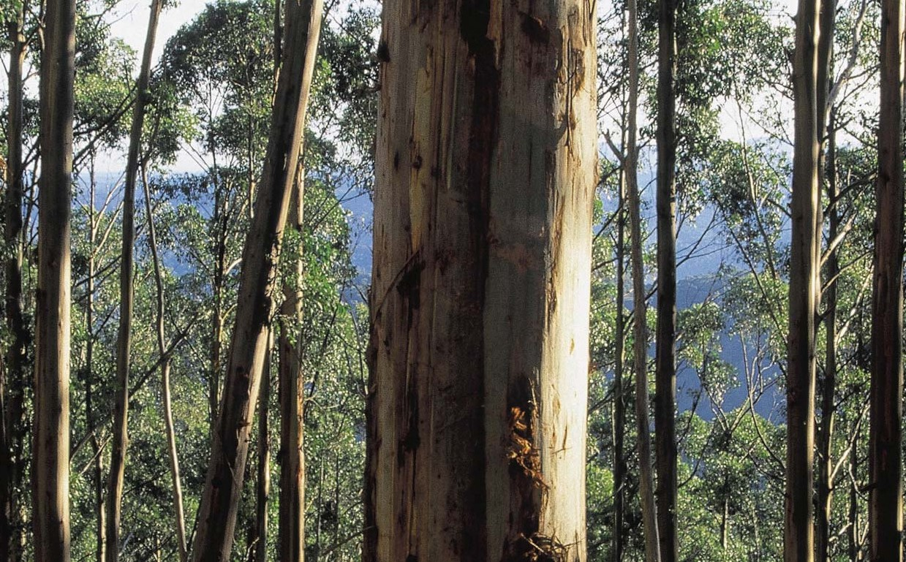

Criteria and Indicators
for Sustainable Forest Management in Victoria

A Victorian Government initiative

Criteria and Indicators for Sustainable Forest Management in Victoria - Summary Document

Foreword

Victoria’s State forests are an important part of our environment. They are the origin of many of our creeks and rivers, and are some of our favourite places to explore, learn and enjoy. State forests contain diverse and outstanding natural values. They contribute to scenic landscapes and provide habitat for a wide range of plants and animals. State forests are important contributors to regional employment and provide the Victorian community with a wide range of products, including timber, firewood and honey.

The policy initiatives Growing Victoria Together (2005), Our Forests, Our Future (2002) and Our Environment, Our Future
- Victoria’s Environmental Sustainability Framework (2005), combined with the Sustainable Forests (Timber) Act 2004 and the Sustainability Charter for Victoria’s State forests (2006), demonstrate and strengthen the Victorian Government’s commitment to regional communities and the sustainable management of Victoria’s State forests.

To meet the requirements of the Sustainable Forests (Timber) Act 2004, criteria and indicators for the sustainable management of Victoria’s State forests have been developed by the Department of Sustainability and Environment with the assistance of key experts, Government partners, and in consultation with the community.

The community and industry are entitled to scientifically robust and transparent information about Victoria’s State forests. Victoria’s sustainable forest management indicators will provide a framework for the forest-related monitoring and information reporting activities undertaken by the Department of Sustainability and Environment. The outcomes will complement and inform other sustainability initiatives currently operating at various scales within Victoria and Australia.

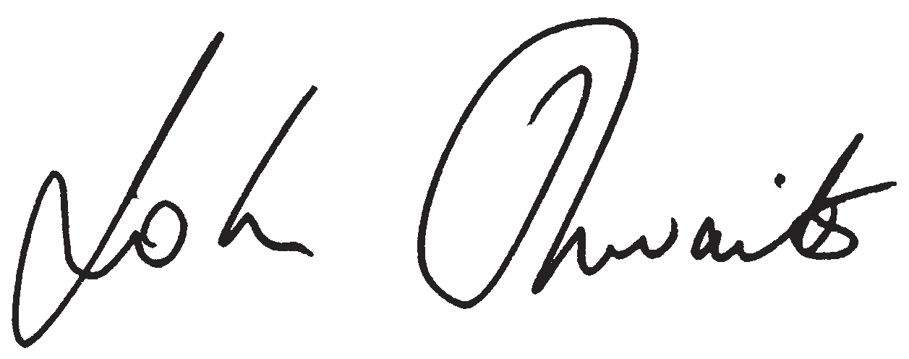
Hon. John Thwaites
Minister for Water, Environment and Climate Change

Sustainability Criteria and Indicators
Victoria’s criteria and indicators for sustainable forest management are consistent with the Montreal Process (1995), and complement the Framework of Regional (Sub-National) Level Criteria and Indicators of Sustainable Forest Management in Australia. The 45 indicators will inform Victorians on progress toward sustainable forest management. Performance against each indicator will be reported on a five-yearly basis through Victoria’s State of the Forests Report.

Further information can be found in the Criteria and Indicators for Sustainable Forest Management in Victoria
- Guidance Document (2007).

Criterion 1: Conservation of Biological Diversity

Element 1.1 Ecosystem diversity
Indicator 1.1a Area of forest by type and tenure Indicator 1.1b Area of forest type by growth stage
Indicator 1.1c Area of forest type by growth stage distribution in protected zones Indicator 1.1d Fragmentation of native forest cover

Element 1.2 Species diversity
Indicator 1.2a The status of forest dependent species at risk of not maintaining viable breeding populations, as determined by legislation or scientific assessment

Criteria and Indicators for Sustainable Forest Management in Victoria - Summary Document

Indicator 1.2b Area of habitat available for forest dependent indicator species

Indicator 1.2c Representative indicator species from a range of habitats monitored at scales relevant to regional forest management
Indicator 1.2d Degree of disturbance to native forest species caused by invasive species

Element 1.3 Genetic diversity
Indicator 1.3a The number of forest dependent species at risk from isolation that may lead to loss of genetic variation Indicator 1.3b Number of in situ and ex situ conservation efforts for forest dependent species

Criterion 2: Maintenance of Productive Capacity of Forest Ecosystems
Indicator 2.1 Area and percentage of forest land and net area of forest available and suitable for timber production Indicator 2.2 Volume of wood by forest type in State forest that is available and suitable for timber production Indicator 2.3 Annual production of wood products from State forest compared to sustainable harvest levels Indicator 2.4 Annual production of non-wood forest products
Indicator 2.5 Proportion of timber harvest area successfully regenerated by forest type

Criterion 3: Maintenance of Ecosystem Health and Vitality
Indicator 3.1 Scale and impact of agents and processes affecting forest health and vitality Indicator 3.2 Area and type of human-induced disturbance

Criterion 4: Conservation and Maintenance of Soil and Water Resources
Indicator 4.1 Area and percentage of forest by activity type systematically assessed for risk to soil attributes Indicator 4.2 Change in forested catchment water yield characteristics through time
Indicator 4.3 Change in forested catchment river health characteristics through time

Criterion 5: Maintenance of Forest Contribution to Global Carbon Cycles
Indicator 5.1 Total forest ecosystem biomass and carbon pool by forest type, age class, and successional stages Indicator 5.2 Contribution of forest ecosystems to the global greenhouse gas balance

Criterion 6: Maintenance and Enhancement of Long Term Multiple Socio-Economic Benefits to Meet the Needs of Societies

Element 6.1 Production and consumption
Indicator 6.1a Value ($) of wood and wood products

Indicator 6.1b Value ($) and yield of non-wood forest products Indicator 6.1c Value ($) of forest derived ecosystem services Indicator 6.1d Degree of reuse and recycling of wood products

Element 6.2 Investment in the forest sector
Indicator 6.2a Investment and expenditure in forest management Indicator 6.2b Investment in research and development, and education Indicator 6.2c Extension and use of new and improved technologies

Criteria and Indicators for Sustainable Forest Management in Victoria - Summary Document

Element 6.3 Recreation and tourism
Indicator 6.3a Area and quality of forest actively utilised for recreation and tourism

Indicator 6.3b Range and use of recreation and tourism opportunities that are available within forests Indicator 6.3c Number of visits per annum

Element 6.4 Indigenous and non-Indigenous cultural, social, and spiritual needs and values
Indicator 6.4a Area of forest to which Indigenous people have access and rights that protect their cultural heritage and are recognised through formal and informal management regimes
Indicator 6.4b Proportion of places of Indigenous and non-Indigenous cultural values in forests formally managed to protect those values

Element 6.5 Employment and community needs
Indicator 6.5a Direct and indirect employment in the forest sector and forest sector employment as a proportion of total employment
Indicator 6.5b Average wage rates and injury rates in major employment categories within the forest sector Indicator 6.5c Resilience of forest dependent communities to changing social and economic conditions
Indicator 6.5d Resilience of forest dependent Indigenous communities to changing social and economic conditions Indicator 6.5e Area of forest available and accessible for Indigenous people to exercise their inherent rights to meet
subsistence or individual and family cultural and spiritual needs

Element 6.6 Indigenous participation
Indicator 6.6a Extent to which the management framework includes the exercise of customary, custodial, traditional and native title rights as an essential component in achieving sustainable forest management

Criterion 7: Legal, Institutional and Economic Framework for Forest Conservation and Sustainable Management
Indicator 7.1 Extent to which the legal framework (laws, regulations, guidelines) supports the conservation and sustainable management of forests
Indicator 7.2 Extent to which the institutional framework supports the conservation and sustainable management of forests
Indicator 7.3 Extent to which the economic framework supports the conservation and sustainable management of forests
Indicator 7.4 Capacity to measure and monitor changes in the conservation and sustainable management of forests Indicator 7.5 Capacity to conduct and apply research and development aimed at improving forest management,
including development of scientific understanding of forest ecosystem characteristics and functions

This is the logo of the Montreal Process Working Group on Criteria and Indicators for the Conservation and Sustainable Management of Temperate and Boreal Forests. Victoria’s criteria and indicators for sustainable forest management are consistent with this process.

Printed on 100% recycled paper.
Published by the Victorian Government Department of Sustainability and Environment, Melbourne, June 2007
© The State of Victoria Department of Sustainability and Environment 2007
This publication is copyright. No part may be reproduced by any process except in accordance with the provisions of the Copyright Act 1968. Authorised by the Victorian Government, 8 Nicholson Street, East Melbourne, Victoria, Australia.
Printed by CMA 2/47 Wangara Rd Cheltenham Vic 3192 ISBN 978-1-74152-823-7 (Internet)
ISBN 978-1-74152-805-3 (Print)
For more information contact the DSE Customer Service Centre 136 186 or visit www.dse.vic.gov.au/sfm
Disclaimer
This publication may be of assistance to you but the State of Victoria and its employees do not guarantee that the publication is without flaw of any kind or is wholly appropriate for your particular purposes and therefore disclaims all liability for any error, loss, or other consequence which may arise from you relying on any information in this publication.

