|  |
| --- |
| Crown Land Caravan Parks  Policy Update 2019 |
|  |

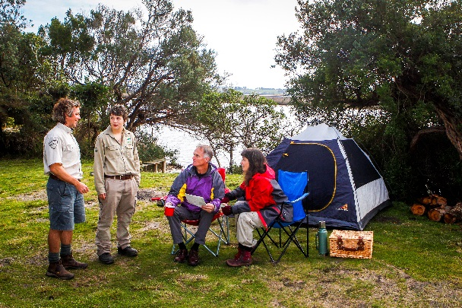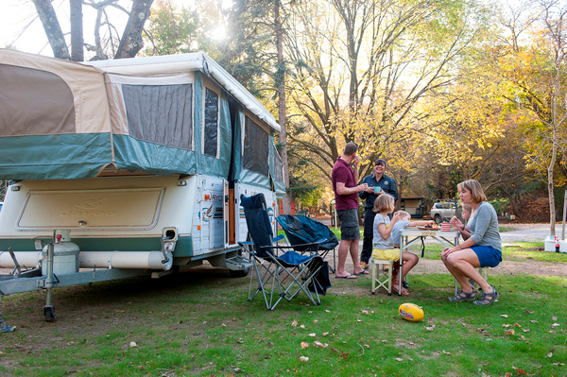

**Context**

To address growing demand for access to Crown land caravan parks the ‘Improving Equity of Access to Crown Land Caravan and Camping Parks’ 2011 Policy Statement was released.

It aimed to give all Victorians access to the affordable holiday opportunities the parks offer. It also aimed to boost tourism opportunities and local economies by providing more short-term access to sites in these parks.

The 2011 policy has been a success. However, there were some areas it didn’t address including:

* managing existing park residents
* allowing itinerant workers to stay at the parks while working in regional areas where affordable accommodation is scarce
* the differences in selling caravans in high and low demand parks.

This policy update provides direction to park managers and committees of management and to people who stay or would like to stay in Crown land caravan parks.

**Objectives**

This policy update explains:

1. How some existing residents who are currently living in parks may be granted Accommodation Permits
2. How some parks can accommodate itinerant workers employed temporarily in the area (e.g. fruit pickers and construction workers) by granting them Temporary Itinerant Worker Accommodation Permits
3. New and fairer rules for selling on-site caravans in low-demand parks.

|  |
| --- |
| This policy updates:   * ‘Improving Equity of Access to Crown Land Caravan and Camping Parks’ 2011 Policy Statement * 2012 ‘Best Practice Management Guidelines for Committees of Management Managing Caravan and Camping Parks on Crown Land’ (the guidelines)   These can be found at:  https://www.forestsandreserves.vic.gov.au/land-management/managing-crown-land/crown-land-caravan-and-camping-parks |

1. **Managing existing residents**
   1. **Background**

The purpose of Crown land caravan parks is to give Victorians access to short term, affordable holidays.

Crown land caravan parks are usually managed by a committee of management. These committees may manage the park directly or lease it to a private operator (i.e. the lessee). All visitors, including those with 12-month permits, can stay for a maximum of 59 consecutive nights and a total of 180 days per calendar year. Despite this, some people have been accommodated at parks for lengthier periods.

This policy update clarifies the way forward for these long-term park residents and how the Department of Environment, Land, Water and Environment (DELWP), committees of management and lessees can ensure fair access for everyone to Crown land caravan and camping parks.

|  |
| --- |
| Crown land is a public resource and cannot be owned by an individual. While people who have stayed at the same Crown land caravan park for an extended period do not have a right to remain there indefinitely, this policy update provides equitable options for those who find themselves in this situation and for park managers, committees of management and lessees.  These options only apply to existing long-term residents as described in 1.3. Any other visitors wishing to stay beyond the specified period will not be permitted unless under certain circumstances described in 3.2. |

* 1. **Register of residents**

DELWP has established the Register of Existing Residents of Crown Land Caravan Parks (the register) which includes existing long-term park occupants only.

Committees of management and lessees must give DELWP a list of people who have occupied a site in a park for more than 59 consecutive nights as their only or main address prior to 1 October 2019.

This list must be given to DELWP by 1 December 2019. People not listed on the register will not be considered an existing resident.

* 1. **Accommodation Permits**

People currently living at Crown land caravan parks need certainty about their accommodation arrangements. Park managers can now issue Accommodation Permits to existing residents who are listed on the register. No one else is eligible for these long-term permits.

|  |
| --- |
| Park managers can offer existing residents, who are on the register, an Accommodation Permit. Park managers who are leasing the park cannot issue permits that extend beyond the term of their lease. For example, if the park manager’s lease ends in two years, the Accommodation Permit must end in two years or less. |

Once a new lease begins, existing, registered residents can apply for a new Accommodation Permit. The committee of management and where applicable, the lessee, then decide whether to grant the permit based on local circumstances.

Residents should not assume a new permit will be granted once the existing one has expired.

Residents must comply with the park rules and the requirements of the *Residential Tenancies Act 1997*.



|  |
| --- |
| Existing park residents have residency rights under the *Residential Tenancies Act 1997* (the Act).  They, and park managers, must comply with the Act, regardless of whether an Accommodation Permit has been granted.  If an Accommodation Permit isn’t granted, the park manager must give the resident the required minimum amount of notice to leave, as outlined in the Act.  Residents who want to leave the park can give the park manager seven days’ notice of their intention to move at any time. |

1. **How will Accommodation Permits be introduced?** 
   1. **Parks directly managed by committees of ma****nagement**

As of 1 October 2019, committees of management that directly manage parks can issue Accommodation Permits to residents.

A committee of management:

* can issue Accommodation Permits to registered residents
* must keep records of residents’ names, birth dates, site numbers and arrival dates in line with Victorian privacy laws and give this data to DELWP if requested
* must comply with the *Residential Tenancies Act 1997*
* must ensure that no new, long term occupants move into the park.
  1. **Parks managed by a lessee**

As of 1 October 2019, parks that have been leased to a private operator (the lessee) by committees of management can issue Accommodation Permits to registered residents under certain conditions.

* A lessee needs the committee of management’s written consent to issue Accommodation Permits.
* The lease between the lessee and committee of management may need to be varied to provide for Accommodation Permits.
* Either the lessee or committee of management can ask for the lease to be varied. DELWP can facilitate this so the lessee can issue Accommodation Permits to residents.
* Any variation of the lease must be negotiated between the lessee and the committee of management. This means neither can force the other to vary the lease conditions.
* If a lease variation agreement is reached and approved by the Minister or delegate (DELWP), the lessee can only issue Accommodation Permits to existing residents who are on the DELWP register.
* An Accommodation Permit cannot exceed the length of the lessee’s lease of the park. For example, if the lease ends in two years, an Accommodation Permit can only be issued for a maximum of two years, when the lease ends.
* The lessee must keep records of residents’ names, birth dates, site numbers and arrival dates in line with Victorian privacy laws and provide them to DELWP on request.
* The lessee and the Accommodation Permit holder must comply with the *Residential Tenancies Act 1997*.
* The lessee must ensure no new long term occupants move in to the park.

|  |
| --- |
| DELWP follows Victorian privacy laws when collecting, using and protecting personal information for the register  See <https://www2.delwp.vic.gov.au/privacy> |

* 1. **New leases**

As of 1 October 2019, when a committee of management and lessee issue or renew a lease, the committee can allow the lessee to issue Accommodation Permits to existing, registered residents as part of that lease agreement.

This needs to be negotiated between the two parties and have the Minister’s or delegate’s (DELWP’s) approval.

There is no obligation for the committee of management or lessee to grant Accommodation Permits to existing registered residents. New occupants will not be allowed to have an Accommodation Permit.

1. **Temporary Itinerant Worker Accommodation Permits**
   1. **Background**

Sometimes itinerant workers, such as fruit pickers and construction workers, stay at parks in rural Victoria for the duration of their employment when there are few available, or affordable, alternatives.



* 1. **Some parks can issue Temporary Itinerant Worker Accommodation Permits**

|  |
| --- |
| As of 1 October 2019, in certain circumstances, park managers may be authorised to set aside a limited number of sites for itinerant workers. Eligible itinerant workers must work within the region of the park and require temporary accommodation. |

The committee of management or lessee must have written authorisation from DELWP to offer Temporary Itinerant Worker Accommodation Permits at parks.

To get this authorisation, the committee or lessee must give DELWP the following information:

* the number of sites in the park
* 12-month permit site vacancy rates for the past 12 months
* the proposed number of sites to be set aside for itinerant workers.

The length of a Temporary Itinerant Worker Permit should match the duration of the worker’s employment. Itinerant workers can stay at a park for up to two years.

Before permits for itinerant workers can be issued, DELWP must be satisfied there is a genuine demand for this type of accommodation and at least 10 per cent of the park’s 12-month permit sites will be available to holidaymakers.

A lessee must have the committee of management’s written agreement before requesting authorisation from DELWP to issue Temporary Itinerant Worker Accommodation Permits.

The authorisation from DELWP will last five years. Park managers will need to reapply to the committee of management and DELWP for permission to issue these permits every five years if they wish to continue having itinerant workers stay in their park.

|  |
| --- |
| Park managers and committees of management should consider implications of any additional obligations under the *Residential Tenancies Act 1997* and its Regulations before agreeing to issue Temporary Itinerant Worker Accommodation Permits |

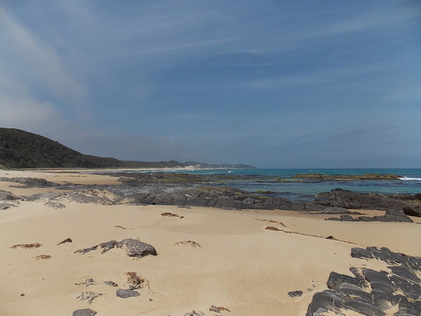

* 1. **Temporary Itinerant Worker Accommodation Permit conditions**

Temporary Itinerant Worker Accommodation Permits are for employed itinerant workers. These permits are not to be used for residential, holiday or other purposes.

Permitted itinerant workers can stay at a park for a maximum of two years. After this, they must leave the park for at least three months before applying for a new permit.

1. **Sales of on-site caravans in Crown land caravan parks**
   1. **Background**

Caravan parks on Crown land are for all Victorians to enjoy. The intent of the 2011 policy was to balance access to the parks between regular and new campers. Its aims included addressing issues resulting from a lack of guidance and monitoring of on-site caravan sales which resulted in:

* vendors and purchasers incorrectly assuming a sense of ownership of caravan sites on public land
* sale prices that were higher than the true market value of a caravan and accessories had they been sold off-site
* vendors holding out for higher prices, reducing permit holder turnover
* people who wanted a 12-month permit site without the on-site caravan often missed out because there were limited vacant sites available.

For example, before the 2011 policy, vendors sometimes profiteered by selling a caravan on a prime beachfront site for a much higher price than they would have received had the caravan been sold off-site. Buyers had no option if they wanted a site in the park and often believed they were entitled to ongoing indefinite use of the site.

The 2011 policy introduced a process for managing on-site caravan sales to ensure affordable and equitable access to parks.

Stakeholder feedback suggests the policy has effectively addressed the issue in popular parks, which are typically located on the coast and river and lake frontages.

However, requiring caravans to be independently valued prior to sale was an unnecessary burden on parks with large numbers of vacant 12-month permit sites that were available year-round.

* 1. **Managing on-site caravan sales**

|  |
| --- |
| Two categories for on-site caravan sales will be introduced on 1 October 2019. |



Under a new framework for on-site caravan sales, parks with annual vacancy rates of 15 per cent or below for 12-month permit sites will be considered ‘standard’ parks. Those with an annual vacancy rate above 15 per cent will be considered ‘surplus vacancy’ parks.

Park managers must give DELWP evidence of their vacancy rate to be classified as a ‘surplus vacancy’ park.

DELWP classification of a ‘surplus vacancy’ park lasts for five years. Park managers who want the classification continued must contact DELWP to seek a review.

On-site caravans at ‘standard parks’ will need an independent valuation before going up for sale but caravans at ‘surplus vacancy’ parks will not. This will cut red tape and reduce costs while still giving more people access to affordable holidays at Crown land caravan parks.

In ‘standard parks’, committees of management and lessees will be required to ensure valuations are conducted before sale.

In ‘surplus vacancy’ parks, if an on-site caravan is not sold before the permit expires, the park manager can allow the owner to keep the caravan on-site.

In ‘standard parks’, if a caravan owner puts an on-site caravan up for sale but it fails to sell before their 12-month permit expires, it must be removed from the park. The caravan owner cannot get a new permit to keep the caravan in the park, even if they change their mind about selling.

* 1. **Managing on-site caravan sales in parks**

Written permission must be obtained from the lessee or committee of management before an on-site caravan can be sold.

The park manager must give a ‘Notice to Prospective Buyers’ to anyone who wants to purchase an on-site caravan, so they fully understand the purpose of parks. This notice is available here on page 10 of the ‘Improving Equity of Access to Crown Land Caravan and Camping Parks’ 2011 Policy Statement: <https://www.forestsandreserves.vic.gov.au/__data/assets/pdf_file/0025/29671/Policy-Statement-Improving-Equity-of-Access-to-Crown-Land-Caravan-and-Camping-Parks-2011.pdf>

Park managers must maintain a waiting list of prospective buyers, with those waiting the longest given the first option to purchase a caravan.

**Definitions for the purposes of this Policy Update**

**Accommodation Permit:** A site permit which can only be issued to those who occupied a site as their only or main residence for more than 59 consecutive nights prior to 1 October 2019 and whose name is on the Register of Existing Residents of Crown Land Caravan Parks.

**Committee of management:** A committee of management is appointed under the *Crown Land (Reserves) Act 1978*. It can be a local council, a skills-based group or local volunteer group. It can manage a park directly by employing a manager or by leasing the park to a private operator (a lessee).

|  |  |
| --- | --- |
| © The State of Victoria Department of Environment, Land, Water and Planning 2019  LogoThis work is licensed under a Creative Commons Attribution 4.0 International licence. You are free to re-use the work under that licence, on the condition that you credit the State of Victoria as author. The licence does not apply to any images, photographs or branding, including the Victorian Coat of Arms, the Victorian Government logo and the Department of Environment, Land, Water and Planning (DELWP) logo. To view a copy of this licence, visit http://creativecommons.org/licenses/by/4.0/  **ISBN** 978-1-76077-705-0  Disclaimer  This publication may be of assistance to you but the State of Victoria and its employees do not guarantee that the publication is without flaw of any kind or is wholly appropriate for your particular purposes and therefore disclaims all liability for any error, loss or other consequence which may arise from you relying on any information in this publication.  *\*All Images: Parks Victoria (copyright reserved)* | Accessibility  If you would like to receive this publication in an alternative format, please telephone the DELWP Customer Service Centre on 136186 or email [customer.service@delwp.vic.gov.au](mailto:customer.service@delwp.vic.gov.au) or via the National Relay Service on 133 677 [www.relayservice.com.au](http://www.relayservice.com.au). This document is also available on the internet at [www.delwp.vic.gov.au](http://www.delwp.vic.gov.au). |

**Itinerant worker:** A person employed in seasonal or temporary work (e.g. agricultural or construction worker) in the region of the park.

**Park manager:** The lessee or committee of management directly managing a park.

**Register of Existing Residents of Crown Land Caravan Parks (register):** The register, established by DELWP, lists people who have occupied a site in a park for more than 59 consecutive nights prior to 1 October 2019 as their only or main residence.

**Resident:** A person who has lived at a Crown land caravan park as their only or main residence for more than 59 consecutive nights prior to 1 October 2019.

**Standard parks:** Parks with an annual vacancy rate of 15 per cent or less of their 12-month permit sites.

**Surplus vacancy parks:** Parks which have more than 15 percent year-round vacancy rates of 12-month permit sites.

**Temporary Itinerant Worker Accommodation Permit:** A site permit (which can be issued for a maximum of two years) to itinerant workers employed in seasonal employment or other temporary work, such as construction or fruit picking, within the region of the park.

**DELWP contact information**

For further information contact the Department of Environment, Land, Water and Planning (DELWP) on 136 186 or <https://www.forestsandreserves.vic.gov.au/land-management/managing-crown-land/crown-land-caravan-and-camping-parks>

