Five years and 629 ground plots later, the Victorian Forest Monitoring Program (VFMP) is now fully installed. To mark the occasion, the Department of Environment, Land, Water and Planning (DELWP) hosted an open day at a VFMP ground plot in Kurth Kiln Regional Park, Gembrook, Victoria, Australia.

The purpose of the day was to not only celebrate the achievements of the VFMP after 5 years of hard work designing, implementing and refining the program, but to educate those involved in the use of the information on the finer details of forest data collection.

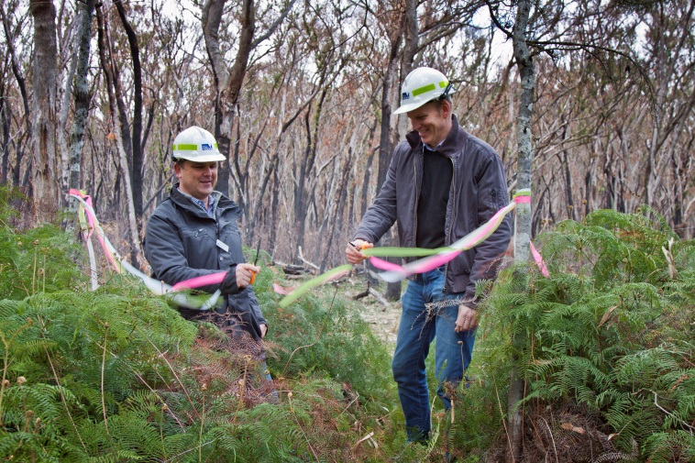

**Will Guthrie and Mick Hodder opening the final plot.***Photo: Sal Ahmad*

Speakers included Lee Miezis, DELWP Executive Director of Fire and Emergency Management and one of the VFMP’s original architects; Andrew Clark, Ground Plot Operations Manager, who outlined the ground plot measurement and auditing process; and Barry Denham, Manager of Monitoring, Evaluation and Research Unit, who discussed the future of the program.

Lee Miezis articulated how the VFMP has evolved from a desktop design, to an East Gippsland pilot program, to a full scale statewide public land monitoring program with electronic data capture connected to an online database, and with more than 700 pages of standard operating procedures:

“The genesis of the program was a lack of reliable and defensible information to write the 2007 Victorian State of the Forests Report, and to endorse key government policy.

In response to this, the VFMP was developed to assess and monitor the extent, state and sustainable development of Victoria’s forests in a timely and accurate manner.

More than 50 people have been involved in the implementation of the VFMP, hundreds of thousands of measurements have been taken. Some 11,000 large trees have been individually measured.

An independent panel of experts have described the VFMP as Australia’s most comprehensive statewide public forest monitoring program, that is consistent with best practice elsewhere in the OECD countries.”

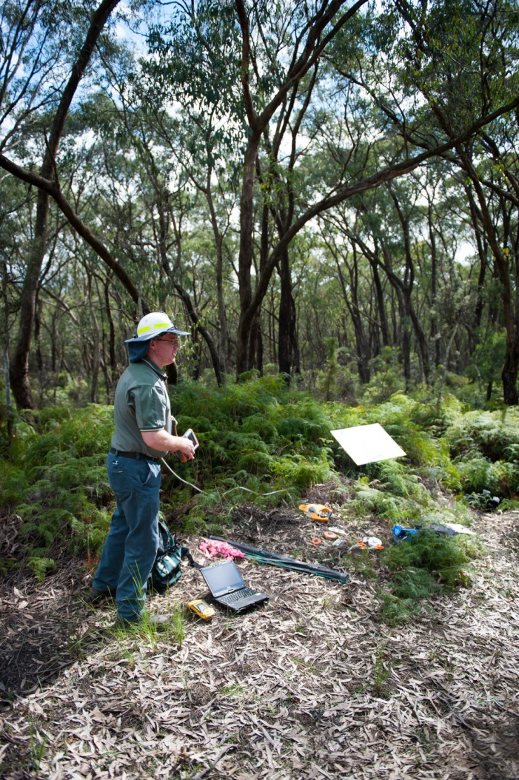

**Andrew Clark discussing electronic data capture.** *Photo Steve Colquitt.*

Barry Denham noted that “As with all monitoring programs its value will grow with age. Now established, we look forward to seeing what the re-measurement will tells us about trends in the various values that we are monitoring.”

Andrew Mellor, former VFMP Manager, added that “the beauty of this program is its flexibility. It was not established to answer just one question and its adaptability will allow it to assist Victoria and Australia with their major real-time land management and policy challenges.”

What is the VFMP?

The VFMP is the Victoria’s state-wide public land monitoring system. It has been developed to provide baseline data for long term trend detection and prediction of type and severity of future changes, so that management options can be developed and evaluated in time to be effective. It provides a platform to meet statutory reporting obligations, support forest policy and management decisions and assess Victoria’s performance towards sustainable forest management.

To meet these requirements and information needs, it is imperative that the VFMP provide monitoring results that are defensible, transparent and repeatable. To ensure these aims are met, a comprehensive suite of standard operating procedures, including quality assurance procedures have been compiled and are regularly reviewed to ensure best practice is maintained.

The VFMP was initiated in 2010 and consists of three tiers of data collection:

1. Permanent ground plot network
2. Remote sensing - aerial imagery
3. Remote sensing - satellite imagery.

For more information please contact [shaun.suitor@delwp.vic.gov.au](mailto:shaun.suitor@delwp.vic.gov.au) or visit the [VFMP webpage](http://www.depi.vic.gov.au/forestry-and-land-use/forest-management/forest-sustainability/victorian-forest-monitoring-program).

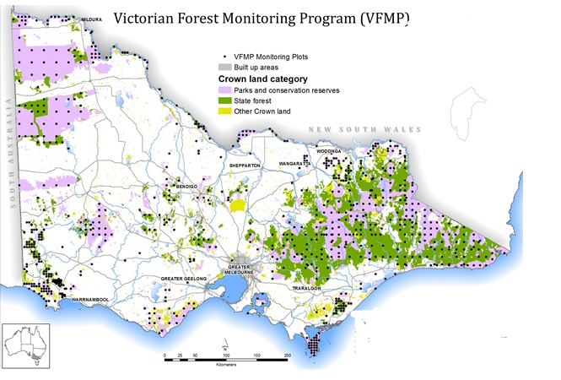

|  |  |
| --- | --- |
| © The State of Victoria Department of Environment, Land, Water and  Planning 2015  byThis work is licensed under a [Creative Commons Attribution 4.0 International licence](http://creativecommons.org/licenses/by/4.0/). You are free to re-use the work under that licence, on the condition that you credit the State of Victoria as author. The licence does not apply to any images, photographs or branding, including the Victorian Coat of Arms, the Victorian Government logo and the Department of Environment, Land, Water and Planning (DELWP) logo. To view a copy of this licence, visit <http://creativecommons.org/licenses/by/4.0/>  **Disclaimer** This publication may be of assistance to you but the State of Victoria and its employees do not guarantee that the publication is without flaw of any kind or is wholly appropriate for your particular purposes and therefore disclaims all liability for any error, loss or other consequence which may arise from you relying on any information in this publication. | **Accessibility**  If you would like to receive this publication in an alternative format, please telephone DELWP Customer Service Centre 136 186, email [customer.service@delwp.vic.gov.au](mailto:customer.service@delwp.vic.gov.au), via the National Relay Service on 133 677 [www.relayservice.com.au](http://www.relayservice.com.au). This document is also available on the internet at [www.delwp.vic.gov.au](http://www.delwp.vic.gov.au) |