Crown land water
frontage licences

A Crown land water frontage is any strip of Crown land that runs alongside designated rivers and streams. Crown land water frontage widths can vary considerably from 20 to 100 metres or more in some cases.
Approximately 30,000 kilometres of Victoria's 170,000 kilometres of water frontage is Crown land. The remainder is generally private land, parks or state forests.
The Department of Environment, Land, Water and Planning (DELWP), catchment management authorities (CMAs) and Melbourne Water work closely with landholders to protect and improve Crown land water frontages.

Licensing of Crown land water frontages
The administration of most Crown land water frontages is the responsibility of DELWP. In some cases Parks Victoria has a management role. Management responsibility is typically assigned to another person or body (licensee), often through the issue of a licence. DELWP may issue a licence for a Crown land water frontage to an owner/occupier of the adjoining private land for grazing and/or riparian management purposes. The conditions listed on the licence recognise the responsibilities of the licensee and DELWP. Licences over Crown land water frontages are generally issued for five years.
A licence over a Crown land water frontage authorises the licensee to enter and use the land for a specified purpose but does not give the licensee exclusive use of the land. When a Crown land water frontage is licensed, the public retains the right to enter and remain on the land for certain recreational purposes such as walking, fishing or bird watching. Members of the public should not interfere with the purpose of the licence and are not permitted to camp or light camp fires on licensed Crown land water frontages. Public access may be restricted to protect revegetation areas or erosion control sites. Pedestrian access must be provided at any fence that crosses the frontage by providing a stile or unlocked gate.

Riparian management licences
Water frontage licences were traditionally issued for purposes such as grazing. However, a licence can now be issued or amended to recognise that all or part of the frontage is being managed to protect and improve the riparian environment (e.g. fenced out and supporting native vegetation). These licences typically attract a reduced licence fee.
Fencing water frontages can improve water quality, control erosion, improve stock management and boost farm productivity. CMAs offer financial incentives for riparian fencing, revegetation and off-stream watering infrastructure. Contact your local CMA for more information.
For more information, see DELWP’s ‘Riparian management licences fact sheet’.
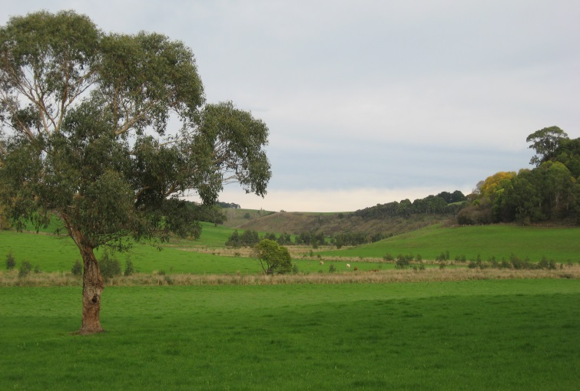
Fenced Crown water frontage and farmland, Curdies River, Timboon. Photographer: Claire Tesselaar, DELWP.
Amendment of a grazing licence to a riparian management licence
If you have a Crown land water frontage licence for grazing purposes and have undertaken riparian management works such as fencing or revegetation, your licence should be changed to a riparian management licence to reflect the outcomes of the work and long-term management responsibilities. This amendment will recognise the reduced grazing area and you may be eligible for reduced licence fees.
A riparian management licence will ensure access to water is continued through the issue of a take and use licence from your local water corporation. You may be eligible for reduced take and use licence fees. For more information, see DELWP’s ‘Cutting the cost of take and use licences fact sheet’ at www.delwp.vic.gov.au.
In some cases, controlled grazing of fenced Crown land water frontages may be allowed under a riparian management licence, if agreed to by DELWP and your local CMA.
No fees apply to amending the purpose of an existing Crown land water frontage licence to riparian management. Please contact your local DELWP office for further details.
Unauthorised use of Crown land water frontage
Crown land is occasionally used by an adjoining owner/occupier without a current Crown land water frontage licence. This is referred to as “unauthorised use of Crown land water frontage”. If you are in occupation of Crown land water frontage without authorisation, you must apply for an appropriate licence from DELWP.
Obtaining a licence
To apply for a licence, contact your local DELWP regional office by calling the Customer Service Centre on 136 186.
Crown land used for agricultural purposes will attract a licence rental fee determined by the carrying capacity of the land expressed in Dry Sheep Equivalents (a Dry Sheep is a two-year old wether weighing 45 kilograms and maintaining its present weight). Crown land water frontage licences issued for riparian management purposes only generally attract a reduced licence fee (typically $1 payable on demand). Contact your local DELWP office regarding fees.
Under the conditions of the licence, the licensee must pay all council rates and charges applicable. Please contact your local council for further details.
DELWP may also decline applications, or if a licence is issued it may be cancelled if licence conditions are not met. When considering an application to use a Crown land water frontage, DELWP must ensure that public land values are protected. Examples of public land values include environmental, historic, recreation, natural resource and cultural significance.
If a licensee does not agree with the proposed rental they may only lodge an appeal against the productive rental on the basis of the assessed carrying capacity, or the area considered to be productive or both. Any appeals must be lodged in writing within 30 days of an account or offer being issued.
Sale of land and licence transfer
Prospective purchasers of land along rivers and streams can enquire about Crown land water frontage and existing licences via the DELWP Customer Service Centre 136 186.
Those selling property with an attached licence need to ensure that it is transferred. If you decide to sell all or part of your property and that section adjoins the Crown land held under licence, the licence will need to be transferred to the new owner of the property. Please advise your solicitor/selling agent of any licences existing for Crown land adjoining your property that may need to be transferred in part or full to the new owners.
Licence transfers are subject to approval by DELWP. A form to transfer the licence should be completed and a transfer fee is to be paid to DELWP. For more information, contact the DELWP Customer Service Centre 136 186.
Privacy
DELWP is committed to protecting information provided in accordance with the principles of the Information Privacy Act 2000. Information collected, including personal information, will be used for the purpose of issuing and administering the licence and for the management of Crown lands. DELWP may disclose the information in this licence, including personal information, to the local municipality or other relevant government agencies or statutory authorities for these purposes or if required by law. DELWP also uses and discloses the information for the purpose of the resolution of applications for determination of native title and for meeting its obligations under the Native Title Act 1993 (Cth).
If you wish to access this information please contact the Manager, Privacy, DELWP, PO Box 500, East Melbourne.

