|  |
| --- |
| Policy Update - May 2018 Licensing System for Tour Operators and Activity Providers on Public Land in Victoria |
| Long licence terms and competitive allocation of licences process |

## Objectives of the policy update

The existing ‘Licensing System for Tour Operators and Activity Providers on Public Land in Victoria’ policy statement is being updated to:

1. Provide more opportunities to obtain long term licences; and
2. Set standard rules and limits for competitive allocation of licences.

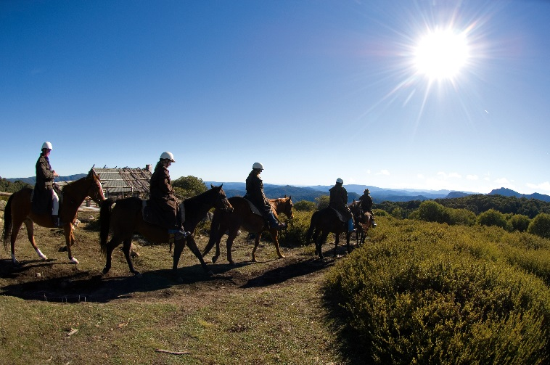

## Updates to the existing policy

The updates to the existing Policy Statement ‘Licensing System for Tour Operators and Activity Providers on Public Land in Victoria’ are:

* A new way for operators with a good compliance history to obtain a long term licence and an extension to the maximum licence period for accredited operators; and
* Additional guidance for land managers to use for competitive allocation of licences including notice periods, provision of specific information about the licences available and the expression of interest process, and setting application limits.

## Background to the licensing system and policy update

### The current licensing system for tour operators and activity providers on public land

A person or business conducting organised tours or recreational activities for profit on public land are required by legislation to be licensed. Tour Operator Licences are issued under the Act the land is managed.

The legislation states:

* Public land managers may grant a tour operator licence for a period of up to 10 years;
* Public land managers must charge regulated state-wide fees (annual and usage) for a tour operator licence; and
* Penalties apply for operating without a tour operator licence or for breaching conditions of a licence.

|  |
| --- |
| Role of agencies  The Department of Environment, Land, Water and Planning (DELWP) has the overarching policy responsibility for the public land estate (including Victorian State waters). Responsibility for the day to day management of public land can reside with DELWP or other agencies such as Parks Victoria or local councils.  Land managers are responsible for issuing and administering tour operator licensing. Parks Victoria administers this on behalf of DELWP for activities in State forest and in marine areas.  In addition to parks, reserves and forests managed by Parks Victoria and DELWP, hundreds of other areas of public land across Victoria are managed by Committees of Management, such as local Councils. |

### Why are the changes being made?

This policy update aims to reduce the administrative burden and costs for small businesses, provide greater future certainty and build on the learnings from past competitive allocation processes.

|  |
| --- |
| **Regulation updates**  The Victorian Government’s broad regulation reform program has developed a number of improvements to reduce the administrative burden and costs for small businesses, provide greater future certainty and recognise the non-financial costs of competing for licences.  These reforms will make it easier to get longer tour operator licence terms and will set standard rules and limits for an expression of interest process, applied to the competitive allocation of licences. |

## 2018 Policy update

### 1. Providing more opportunities to obtain long term licences

#### Context

For businesses to obtain licences for longer than one year, they must meet standards set out in specified external accreditation programs. This approach uses the certainty from a longer licence as an incentive to encourage higher operating standards across the industry through take-up of accreditation programs.

For some operators, accreditation is not directly relevant to their business. These businesses must re-apply for a new licence every year. Some of these are small operators who have been in business for a long time and have significant experience operating at a consistently high standard.

The policy reforms recognise that a good business compliance history is evidence of achieving environmental, cultural protection and safety standards set out in a licence and that this is worthy of the security of a longer licence. They also recognise the continued value of endorsed certification as a way of encouraging higher operational standards by increasing the maximum length of licence for accredited operators.

|  |
| --- |
| *New policy*  Land managers may now offer licences for the following terms:   * A standard licence will continue to be granted for a one year period; * A licence for up to three years can now be granted to operators with three years of full compliance (who have provided their insurance details, trip returns and paid invoices on time, and have a record of meeting all their compliance obligations under the licence); * A new licence for up to five years (extended from three years) can be granted subject to relevant endorsed tourism certification; and * A premium licence for up to ten years will continue to be granted subject to relevant endorsed tourism certification. |

Note: obtaining industry certification is the preferred basis for considering longer term licences as it enables public land managers to recognise and reward an evolving suite of industry-developed and reviewed operating standards.

Recognised accreditation programs for longer term licences

|  |  |
| --- | --- |
| Licence term of up to 5 years | Licence term of up to 10 years |
| Nature Tourism – EcoCertification IV | Advanced Ecotourism - EcoCertification IV |
| Australian Tourism Accreditation Program (formerly Better Business Tourism Accreditation Program) | Ecotourism - EcoCertification IV |
| Respecting Our Culture | EarthCheck Benchmarking and Certification (formerly GreenGlobe Company Standard) |

### 2. Setting standard rules and limits for competitive allocation of licences

#### Context

Most tour operator licences in Victoria are issued on a non-competitive basis. A limit to the number of licences available for a site or activity is generally not considered necessary. However, there are circumstances where a public land manager may consider it necessary to restrict the number of licences operating at a site or area, to protect natural or cultural values or visitor safety.

In these circumstances, public land managers are required to issue licences through a competitive public process (expression of interest), to ensure commercial access to public resources is allocated fairly and in accordance with government policy. The policy framework for competitive allocation includes guiding principles set out in the 2008 policy statement and an associated document, ‘Competitive Allocation of Tour Operator Licences Guidelines 2018’.

The competitive allocation process can be stressful for businesses applying, as failure to obtain a licence can have significant financial implications. Getting the right information in the expression of interest process helps small business understand what they are competing for and make informed decisions. Setting a maximum size for applications can avoid small businesses spending too much time and money on overly long submissions.

The revised competitive allocation guidelines will make the expression of interest process simpler and more transparent for applicants.

|  |
| --- |
| *New policy*  DELWP has revised its guidance for land managers competitively allocating tour operator licences. The ‘Competitive Allocation of Tour Operator Licences, 2018’ guidelines have now been released.  As a minimum, land managers are required to:   * Inform incumbent licensees of the upcoming process; * State the licence fee that will apply for successful applicants; * State how many licences will be issued; * State the timing for applications, consideration and decision making; * Include the process for appeals; and * Set a maximum page count for applications. |

## Information and process for transitioning to new policy

Tour operator licensing occurs on a financial year basis, from July 1 to June 30. Land managers should aim to make system and process adjustments to implement the new policy for the next licence season.

Operators who want to make enquiries about their compliance history should contact the land manager(s) for where they operate.

For further information or clarification, you can call the Department of Environment, Land, Water and Planning Customer Contact Centre on 136 186.

*Photo credit: Parks Victoria (copyright reserved).*

|  |  |
| --- | --- |
| © The State of Victoria Department of Environment, Land, Water and Planning 2018  LogoThis work is licensed under a Creative Commons Attribution 4.0 International licence. You are free to re-use the work under that licence, on the condition that you credit the State of Victoria as author. The licence does not apply to any images, photographs or branding, including the Victorian Coat of Arms, the Victorian Government logo and the Department of Environment, Land, Water and Planning (DELWP) logo. To view a copy of this licence, visit http://creativecommons.org/licenses/by/4.0/  ISBN 978-1-76077-058-7 (pdf/online/MS word)  Disclaimer  This publication may be of assistance to you but the State of Victoria and its employees do not guarantee that the publication is without flaw of any kind or is wholly appropriate for your particular purposes and therefore disclaims all liability for any error, loss or other consequence which may arise from you relying on any information in this publication. | Accessibility  If you would like to receive this publication in an alternative format, please telephone the DELWP Customer Service Centre on 136186, email [customer.service@delwp.vic.gov.au](mailto:customer.service@delwp.vic.gov.au), or via the National Relay Service on 133 677 [www.relayservice.com.au](http://www.relayservice.com.au). This document is also available on the internet at [www.delwp.vic.gov.au](http://www.delwp.vic.gov.au). |