Managing Crown
water frontages
  - For better farms and waterways
There are several ways landholders can improve Crown and private river frontages to provide benefits for their property, as well as for the broader community and the environment.

What is a Crown frontage licence?
- It is a licence that authorises the licensee to enter and use a Crown water frontage for a specified purpose such as grazing or riparian management. The conditions of the licence describe the responsibilities of the licensee and the licensor.
- A licence is normally issued to the owner/occupier of private land adjoining a Crown water frontage. The Department of Energy, Environment and Climate Action (DEECA) has the power to check licence compliance. In some areas Parks Victoria shares these responsibilities.
- If you have a Crown water frontage licence for grazing and have undertaken riparian management works such as fencing or revegetation, your licence may be changed to a riparian management licence to reflect changes in both grazing management and long-term management responsibilities.
- Riparian management licences recognise that all or some of the Crown frontage is being maintained to protect the riparian environment, typically by fencing to manage stock access to the waterway. Licence fees are generally reduced.
- A licence is not a lease. It does not give the licensee exclusive use of the Crown frontage. The public retains the right to enter and remain on the Crown frontage for certain recreational purposes such as walking, fishing or bird watching.
- The public should not interfere with the licence purpose. Public access may be restricted to protect revegetation areas or erosion control sites.
- Pedestrian access must be provided at any fence that crosses the frontage by providing a stile or unlocked gate. Signs indicating private property or seeking to prevent public access may not be put on Crown frontages.
- Members of the public are not permitted to camp on licensed Crown frontages unless they have been designated as camp sites.
- Fires are also not permitted on Crown frontages except on some of the camp sites (not all designated campsites permit campfires).
Customer Contact Centre 136 186
Figure 1: John and Jenny McDonald. (Photographer: Christine Glassford)
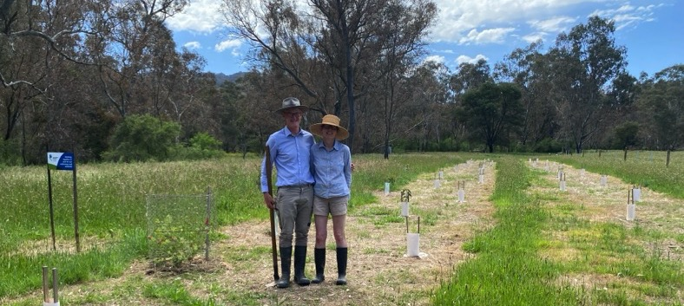
“We established a 30 metre buffer, fenced off and planted native seedlings along 500 metres of frontage. While the 2022 floods inundated the plants, we had remarkable survival and they’re now thriving.”
“We aim to do our bit by protecting and enhancing the creek environment for future generations.”
John McDonald, Crown water frontage licensee, King Parrot Creek.
Figure 2: Revegetation and a stock management fence along a Crown frontage on the Mitchell River (Photographer: Clint Bain)
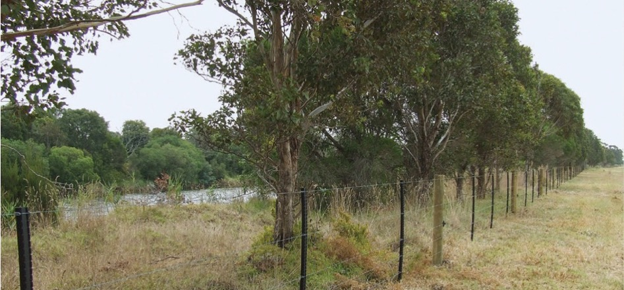
“In this flat country with cold south westerly winds, the riparian vegetation provides protection for cattle. It’s a very good windbreak.”
Dennis Matthews, Crown water frontage licensee, Mitchell River.
Options include fencing, revegetation, controlled grazing, off-stream watering and weed management. River frontage, also known as riparian land, is land that runs alongside a waterway.
Figure 3: Established revegetation and stock management fencing along the Loddon River (Photo courtesy of North Central Catchment Management Authority)
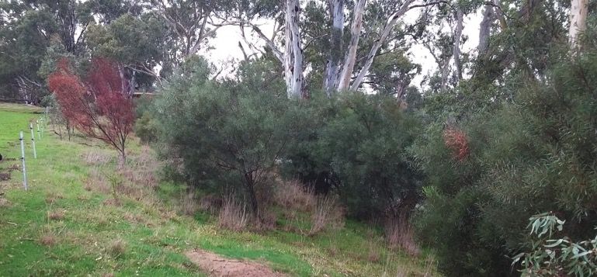
“We are happy with the increased stock control the fencing provides and the environmental outcome is good too”
Anthony and Virginia Holland, Crown water frontage licensees, Loddon River.
Figure 4: Graeme and Justin Weaver. (Photographer: Rob Addinsall)
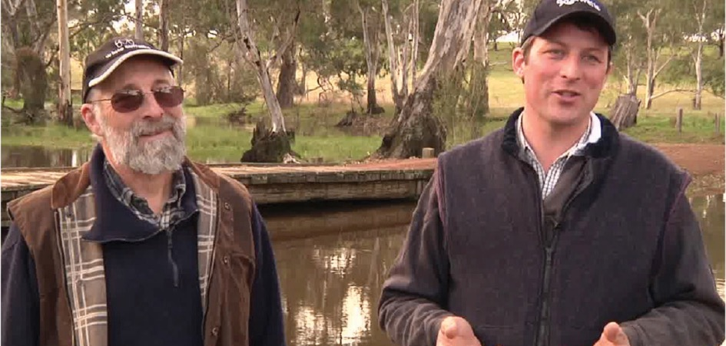
“Putting in the fencing improves the manageability of the property, it improves your ability to move stock around.”
“It improves the land value because of the structural improvements as well as the aesthetic value, the environment values”`
Justin Weaver, Crown water frontage licensee, Glenelg River.

What is a Crown water frontage?
- It is a strip of Crown land that runs alongside a waterway and is typically located between the waterway and a private land boundary. It can vary in width from 20 to 100 metres or more.
- Crown water frontages run alongside about 17% of Victoria’s waterways. Private land, parks and state forests cover the remaining frontages.
- The Department of Energy, Environment and Climate Action (DEECA) is responsible for the administration of Crown water frontage. In some cases, Parks Victoria has a management role.

On farm benefits of frontage management
Fencing, off-stream watering and revegetation works on water frontages lead to:

Better stock management
- Fencing prevents stock falling down banks, getting stuck in the waterway or wandering on to other properties.
- Fencing reduces time and costs of mustering.
- Keeping stock out of waterways reduces risk factors for stock disease including mastitis.

Enhanced productivity and capital value
- Stock have easy access to higher quality water when using an off-stream trough, leading to increased weight gain or milk production.
- The presence of on-farm native vegetation increases the land value of the property.
- Riparian shelter belts improve stock health and increase stock productivity.

Erosion control
- Riparian vegetation reduces soil erosion and helps reduce the impact of floods.

Improved water quality
- Riparian vegetation and stock management helps improve water quality in waterways.

Environmental benefits
- Riparian vegetation improves habitat for birds, animals and fish.

Landholder wellbeing
- The presence of healthy riparian land leads to an increased sense of farmer wellbeing.

More information
Landholders may be eligible for funding for riparian works such as fencing, revegetation and off-stream stock watering in areas considered a priority by the local catchment management authority (CMA) or Melbourne Water.
These incentives are available for Crown water frontages when landholders take out a riparian management licence.
For more information contact your local CMA or Melbourne Water.
Table 1: Contact information for Catchment Management Authority (CMA) and Melbourne Water.
Region | Telephone Number
Corangamite CMAT | 1800 002 262
East Gippsland CMA | 03 5152 1184
Glenelg Hopkins CMA | 03 5571 2526
Goulburn Broken CMA | 03 5822 7700
Mallee CMA | 03 5001 8600
Melbourne Water | 131 722
North Central CMA | 03 5448 7124
North East CMA | 1300 216 513
West Gippsland CMA | 1300 094 262
Wimmera CMA | 03 5382 1544

© The State of Victoria Department of Energy, Environment and Climate Action, 2024
ISBN 979-1-76136-586-7 (Print)
ISBN 978-1-76136-587-4 (pdf/online/MS word)
Disclaimer
This publication may be of assistance to you, but the State of Victoria and its employees do not guarantee that the publication is without flaw of any kind or is wholly appropriate for your particular purposes and therefore disclaims all liability for any error, loss or other consequence which may arise from you relying on any information in this publication.
Accessibility
If you would like to receive this publication in an alternative format, please telephone the DEECA Customer Contact Centre on 136 186, email customer.service@delwp.vic.gov.au or via the National Relay Service on 133 677, www.relayservice.com.au. This document is also available online at deeca.vic.gov.au

