Victoria’s Great Outdoors
Camping and Caravan Grants

Funding Guidelines Round 3: 2021 – 2022
Camping and Caravan Grants support Crown land managers to provide quality and affordable visitor accommodation for visitors to Victoria’s coastline and inland regions.

Introduction
Camping and Caravan Grants is a $7.1 million funding package that is part of the Victoria’s Great Outdoors $105.6 million investment to help Victorians enjoy the great outdoors.
The annual grant program is delivered over three rounds - Round 1: 2019-20; Round 2: 2020-21; and Round 3: 2021-22. Round one provided a total allocation of $2.5 million, round 2 a further $2.05 million, with $2.04 million available for Round 3.

Who can apply?
The grants are open to Crown land caravan and campground managers to improve the quality and capacity of natural and built assets within their reserves.
This refers to committees of management appointed under the Crown Land (Reserves) Act, including councils, and Traditional Owner groups managing Crown land in conjunction with Joint Management Plans.

Project location | Crown land, as defined in the Crown land (Reserves) Act 1978, where the use for camping and caravan activities is consistent with the reservation purpose.
Applicant | Current Crown land committees of management (Including council and Traditional Owner groups) with established camping or a caravan park within their reserve
Finance | Completed 2019-2020 annual return (this does not apply to councils)

For more information on Camping and Caravan Grants and to apply online visit:

https://www.forestsandreserves.vic.gov.au/grants/caravan-and-camping-grant
Available funding
Grants of between $5,000 and $200,000 are available to successful applicants in Round 3.
Committee category (1, 2, 3 or 4) and the financial and socio-economic status of the local government area will be considered by the grant assessment panel when determining the level of financial contribution that will be provided to projects.
Applications that include a contribution from the applicant (cash and/or in-kind) will be considered favourably, particularly for projects of high cost or applications requesting a large program contribution.
In-kind contributions will be assessed at $40 per hour.

Applicant (see Appendix B) | Maximum grant  contribution
Category 2 & 3 community volunteer committees of management | 100% of project cost
Category 4 Lower resourced councils
All other committees of management | 70% of project cost

Projects that may be funded

Projects that can demonstrate:
- Improved visitor experience through upgrades to natural and built assets in caravan and camping grounds.
- A positive impact on tourism and recreational activities.
Examples of projects that will improve visitor experience
Accessibility improvements
Signage and visitor experience information about local Aboriginal history and culture
Culturally and linguistically diverse communities (CALD) signage
Amenity block upgrades
Revegetation and landscaping
Increased powered sites
Formalisation of powered/unpowered sites
New sites developed within reserve
Installation and/or upgrade of recreational facilities

Projects that will not be funded
- Activities that are expressly referenced in a current lease agreement between a lessee and a committee of management that are the responsibility of the lessee.
- Maintenance that should be part of the day-to-day management of the reserve (including operating costs such as salaries and utilities).
- Works required to meet current building and waste regulations (e.g. septic tanks).
- Projects on reserves where the assets subject to the application are not retained by the committee of management.
- Projects supported by other government funding programs and initiatives.
- Projects better suited to other existing grants programs.
- Projects that have already commenced or completed.
- Installation of solar panels.

Assessment Criteria
40% | What are you going to do?  - Demonstrated project outcomes that will improve quality, accessibility and capacity of natural and built assets within caravan park and campground while enriching the visitor experience.
40% | What difference will it make?  - Demonstrated significance of proposed improvements to the local community, tourism, and recreational activities.  - Local/regional job creation.
10% | What can you offer?  - Applicant co-contribution.  - Project management capacity (or access to appropriate resources) to deliver the project outcomes on time and to budget.  - Compliance with program requirements and conditions where projects have been funded in the past, including acquittals.  - Investment in partnerships and other forms of collaboration.
10% | Will you address risk management and environmental sustainability?  - Demonstrated consideration of potential risks to the project and adequate actions to remove risk.  - Consideration of Universal Design Principles and environmental sustainability.  - Will it be safe? See next table
Yes/No | Will it be safe?  Project is consistent with regulations:  - A guide to the Victorian Caravan Park Regulations 2010  - Residential Tenancies (Caravan Parks and Movable Dwellings Registration and Standards) Regulations 2010  - Victorian Caravan Parks Road Design Guiding Principles Report  - Improving Equity of Access to Crown Land Caravan and Camping Parks 2011  - Best Practice Management Guidelines for Committees of Management: Managing Caravan and Camping Parks on Crown Land 2012.  - Relevant state and federal building codes and regulations.  - Standards defined by industry accredited bodies.

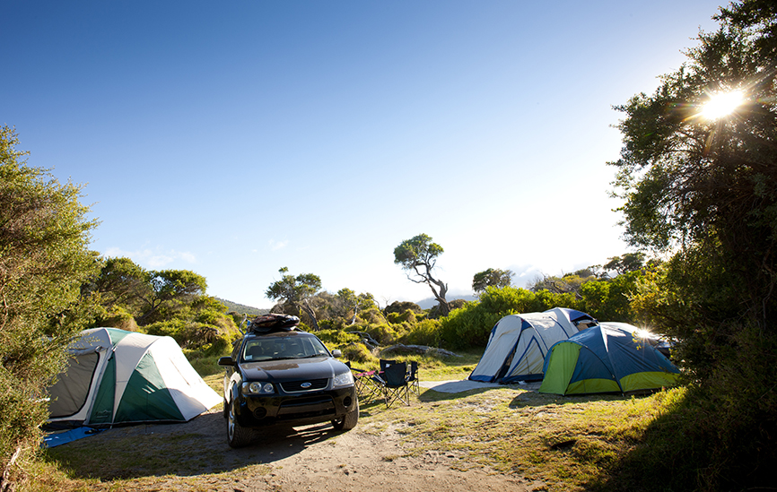
Funding conditions
Maximum program contributions are calculated as a
percentage of the total project cost. For successful
applications, the total project cost must be supported by written quotation(s) and details of in-kind contributions prior to payment of the grant.

The following conditions will apply to successful applicants:
- Enter into a standard form Funding Agreement. https://providers.dhhs.vic.gov.au/victorian-common-funding-agreement
- Successfully funded projects will be offered funding as a GST exclusive amount.
- Work on Crown land requires landowner consent under the Crown Land (Reserves) Act 1978. In principle support can be given based on discussions with your local DELWP officer. Recipients are responsible for obtaining all necessary permits, approvals and consents prior to the commencement of any works.
- Project must commence within six (6) months of entering into the Funding Agreement with the Department of Environment, Land, Water and Planning (DELWP). Projects that have not commenced within this timeframe must contact the program team to explain the delays and negotiate an appropriate commencement date. Grant recipients that fail to provide this advice may risk voiding the Funding Agreement and may have to return any funds provided.
- Projects must be completed within 12 months from signing the funding agreement.
- Funds must be spent on the project as described in the application and any unspent funds must be returned to DELWP, as per the Funding Agreement.
- Additional project costs to funds granted must be funded by the applicant.
- Any variation to the approved project must be submitted to DELWP for approval prior to implementation.
- Acknowledgement of the Victorian Government’s support: Promotional guidelines will form part of the funding agreement as outlined in the DELWP Acknowledgement and Publicity Guidelines: https://www2.delwp.vic.gov.au/grants
Successful applicants must:
- Liaise with the program team to coordinate any public events or announcements related to the project.
- Be responsible for arranging and preparing specifications for tender and signing project agreements or contracts.
- Receive a Letter of Consent from DELWP prior to commencing any works.
- Where applicable, complete tender works in accordance with Victorian Government requirements, including procurement guidelines.
- Contribute information on activity outcomes for use in program evaluation reviews or the department’s marketing materials.
- Submit reports detailing the progress and outcomes of the funding as per the Funding Agreement.
- Complete and provide a project acquittal and any other completion reports required.

Make an application

Apply online:
https://www.forestsandreserves.vic.gov.au/grants/caravan-and-camping-grant
Prior to applying, please discuss your project and seek written endorsement from your local DELWP contact.
To apply, submit your application through the Grants Online Portal (available when round 3 opens on Thursday 29 April 2021).
Separate applications are required for each site-specific project in Crown land caravan and camping parks managed by the same park manager or CoM/Council.
Applications must be submitted through the Grants Online Portal by Friday 11 June 2021 at 4.00pm. Late or incomplete applications will not be considered. When you apply online you will receive an acknowledgement email with an application number. Please quote your application number in all future correspondence relating to your application.
You can attach documents to your online application provided they are in an acceptable file type (e.g. Word, Excel, PDF, or JPEG). Please note:
- Attached files must not be larger than 5MB
- When you submit your application online check carefully to ensure all your attachments have been uploaded
If you have documents to submit that cannot be attached to your online application you can email them to Victorias.Great.Outdoors@delwp.vic.gov.au quoting your application number (number provided upon application submission).
Attach all documents to one email, zipping the files if required.
The application must include at least two written quotes (GST exclusive) for each eligible component of works, totalling the estimated cost of the project. Quotes must be dated and have been obtained within the past six (6) months.

Important dates
Applications open | Thursday 29 APRIL 2021
Applications close | Friday 11 June 2021 4pm
Applications assessed | June to July 2021
Successful grants announced | September 2021
Unsuccessful applicants notified | September 2021
Recipients enter into Funding Agreement | September 2021

Application tips
- Describe how the project will improve the quality and capacity of natural and built assets within their reserves
- Include at least two contractor quotes
- Include detailed scoping and seek written support from DELWP before lodging an application
- Include evidence of public access to the structure or area
- Describe how the project will benefit the local area
- Include involvement of a suitably qualified project manager, if required
- Include all requested attachments
- Provide realistic project timelines
- Include letters of support from partners
- Preference of recycled infrastructure where appropriate, e.g. recycled plastic park benches
- Include photos of proposed project site to demonstrate need and which can be used in communication activities

Appendix A

By applying, the applicant acknowledges that:
- The Victoria’s Great Outdoors Camping and Caravan Grants Funding Guidelines 2021-22 (this document) has been read and understood.
- All information provided within your application is correct - providing any false or misleading information may result in the rejection of the grant application.
- DELWP may seek to confirm any information contained in your application and may request additional information. Failure to provide the information may mean that the application is unable to be assessed and result in the rejection of the application.
- If successful, details of the grant will be made public on the DELWP or other vic.gov.au websites.
- The applicant and lessee of the property agree to allow DELWP to use or publish any photographs supplied for the purposes of promotion on the DELWP website, intranet and social media accounts, or in any printed material or media.
- They recognise DELWP is collecting your personal information (such as your name and contact details) and supporting material in order to assess your eligibility for grant funding and contact you about your application. Your information will be held and managed in accordance with the Privacy and Data Protection Act 2014 and the Public Records Act 1973.
- Personal information about you or a third party in your application will be collected by DELWP for the purpose of grant administration. This information may be provided to other Victorian government bodies for the purposes of assessing your application. If you intend to include personal information about third parties in your application, please ensure they are aware of the contents of this privacy statement.
- Any personal information about your or a third party in your correspondence will be collected, held, managed, used, disclosed or transferred in accordance with the provisions of the Privacy and Data Protection Act 2014 and other applicable laws
- DELWP is committed to protecting the privacy of personal information. You can find the DELWP Privacy Policy online at http://delwp.vic.gov.au/privacy Requests for access to information about you held by DELWP should be sent to the Manager Privacy, P.O. Box 500 East Melbourne 3002 or made by phone on 03 9637 8697. Information and uploaded images and documentation in this application is stored on departmental systems.

Appendix B
All Committees of Management (CoM) appointed by DELWP under the Crown Land (Reserves) Act 1978 are assigned a category. The assessment panel will refer to each applicant CoM’s category to determine the maximum grant contribution (70% or 100%) to the total project cost.
In 2020, DELWP revised the Crown Land reserves Committee of Management (CoM) Categorisation Framework, with the following descriptions:
 | Voluntary CoMs |  |  | Other
 | Category 1 | Category 2 | Category 3 | Category 4
- Financial | >$1 million p.a. revenue; or  >$1 million cash balance | $250k - $1 million p.a. revenue; or  $250k - $1 million cash balance | <$250k p.a. revenue; or  < $250k cash balance | Local councils and statutory authorities appointed as CoMs
- Public land values | International / National / State significance | Regional significance | Local or no significance
- Built assets value | >$20 million estimated value or  current major infrastructure project | >$5 million to $20 million estimated value or  current infrastructure project | <$5 million estimated value
- Regional knowledge | Regional DELWP staff can elevate CoMs to higher categories based on knowledge of unique circumstances affecting CoM’s risk profile
Local councils (Category 4) eligible for 100% of project costs.
This list is based on data taken from local government performance reporting found at: https://knowyourcouncil.vic.gov.au/, and Socio-Economic Indexes for Areas 2016 (SEIFA) found at: https://www.abs.gov.au/websitedbs/censushome.nsf/home/seifa.
Councils eligible for 100% of project costs are non-metropolitan and are found to have both relative higher expenses per head of municipal population (≥$1900) and relative higher socio-economic disadvantage based on SEIFA score (≤ 1000). These thresholds have been chosen to create equitable access to capital investment across local government areas.
Alpine Shire | Gannawarra Shire | Southern Grampians Shire
Ararat Rural City | Glenelg Shire | Strathbogie Shire
Bass Coast Shire | Hindmarsh Shire | Swan Hill Rural City
Benalla Rural City | Horsham Rural City | Towong Shire
Buloke Shire | Loddon Shire | Warrnambool City
Campaspe Shire | Mildura Rural City | Wellington Shire
Central Goldfields Shire | Murrindindi Shire | West Wimmera Shire
Colac-Otway Shire | Northern Grampians Shire | Yarriambiack Shire
Corangamite Shire | Pyrenees Shire
East Gippsland Shire | South Gippsland Shire

© The State of Victoria Department of Environment, Land, Water and Planning 2021  This work is licensed under a Creative Commons Attribution 4.0 International licence. You are free to re-use the work under that licence, on the condition that you credit the State of Victoria as author. The licence does not apply to any images, photographs or branding, including the Victorian Coat of Arms, the Victorian Government logo and the Department of Environment, Land, Water and Planning (DELWP) logo. To view a copy of this licence, visit http://creativecommons.org/licenses/by/4.0/  ISBN 978-1-76077-875-0 (Print)  ISBN 978-1-76077-876-7 (pdf/online/MS word)  Disclaimer  This publication may be of assistance to you but the State of Victoria and its employees do not guarantee that the publication is without flaw of any kind or is wholly appropriate for your particular purposes and therefore disclaims all liability for any error, loss or other consequence which may arise from you relying on any information in this publication. | Accessibility  If you would like to receive this publication in an alternative format, please telephone the DELWP Customer Service Centre on 136186, email customer.service@delwp.vic.gov.au or via the National Relay Service on 133 677 www.relayservice.com.au. This document is also available on the internet at www.delwp.vic.gov.au.

